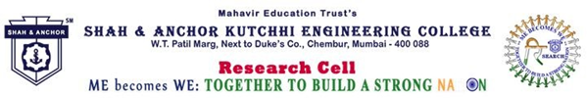

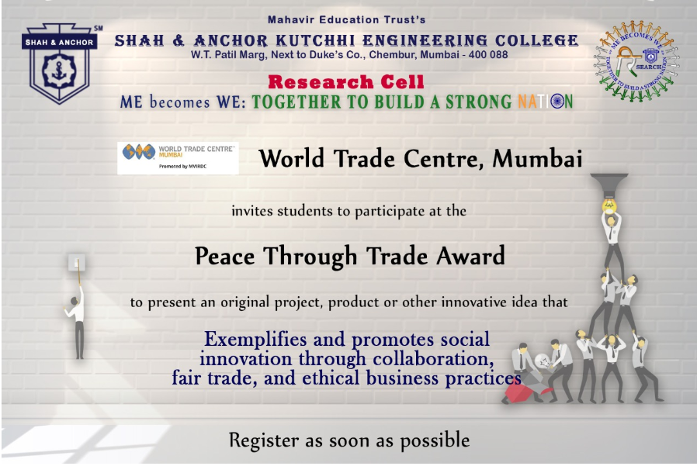

"Pre Event Publicity Message :
SAKEC Research Cell promotes, World Trade Center Mumbai, a not for-profit organization and a member of World Trade Center Association, New York, brings together government, industry and academia with a view to promote international trade and investment.
World Trade Center Mumbai is inviting the students to participate at the World Trade Centers Association Foundation (WTCAF) Peace through Trade Award.
Participants must be a team of at least 2 people (maximum 4). Teams are asked to present an original project, product or other innovative idea that “Exemplifies and promotes social innovation through collaboration, fair trade, and ethical business practices.”
The project also needs to address at least one of the 17 United Nations Sustainable Development Goals.
Participants must be present at their projects in PowerPoint or other similar format. They should be available to present their project via video conference to the WTCAF Board, if shortlisted.
Two team members from the winning submission will be invited to travel to Taipei in March 2020, to present their idea and receive award in front of our global community.

Registeration link : https://www.shahandanchor.com/home/8095-2/

Thanks and Regards Research Cell SAKEC

Post Event Publicity Message :

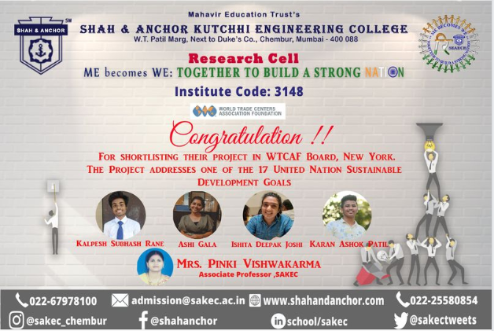

Congratulations to the SAKEC team for short listing at World Trade Centers Association Foundation (WTCAF) Peace through Trade Award.
Congratulations to the SAKEC team for shortlisting at World Trade Centers Association Foundation (WTCAF) Peace through Trade Award.

Post event publicity link : https://www.facebook.com/474323859413603/posts/1501470693365576/

