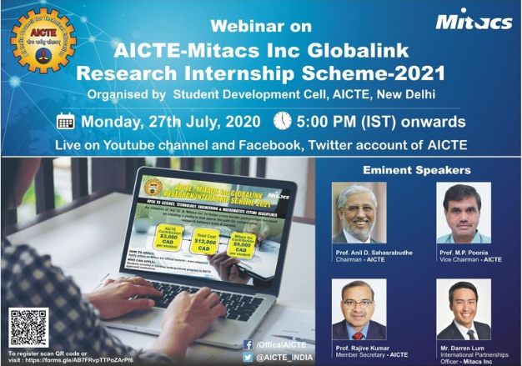

Pre Event Publicity Message:

SAKEC Research Cell promotes the AICTE-Mitacs Inc Globalink Research Internship (GRI)- 2021 scheme which is dedicated especially for third and final year students enrolled in full time undergraduate programs in AICTE approved institutions. In order to disseminate about the said scheme, a webinar is decided to be organized on 27th July, 2020 at 17:00 hrs wherein the Hon'ble Chairman, Vice-Chairman and Member Secretary, AICTE along with the International Partnerships Officer, Mitacs Inc will speak on the scheme.
Pre Event Publicity link : https://www.facebook.com/shahanchor/photos/a.485370131642309/1505561089623203/?type=3

Thanks and Regards Research Cell SAKEC

Post Event Publicity Message :

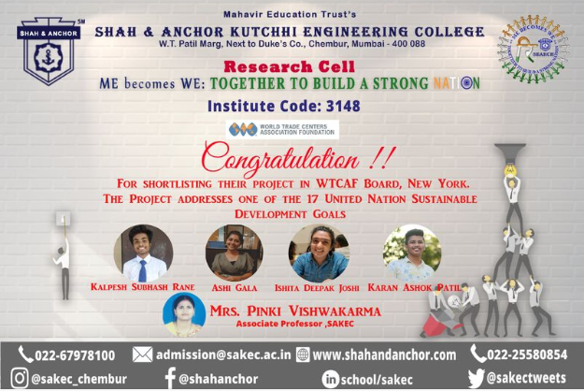

Congratulations to the SAKEC team for short listing at World Trade Centers Association Foundation (WTCAF) Peace through Trade Award.
Congratulations to the SAKEC team for shortlisting at World Trade Centers Association Foundation (WTCAF) Peace through Trade Award.

Post event publicity link : https://www.facebook.com/474323859413603/posts/1501470693365576/

