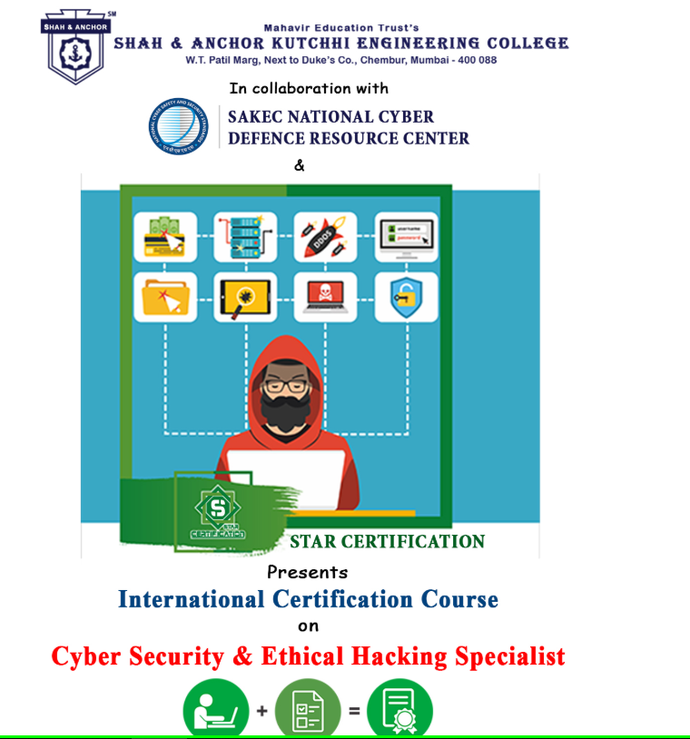

"Cyber Security And Ethical Hacking" was conducted on 21 April 2019 at SAKEC under the umbrella of "Research Cell".

Pre Event Publicity Message:

Education is not just about marks and exams its more about skills. Cyber Security with flavour of Digital Forensic and Ethical Hacking are one of booming demand in the industry.

SAKEC National Cyber Defense Resource Center in collaboration with Star Certification promotes an International certification course named as “Cyber Security and Ethical Hacking Specialist”.
Registeration link : https://www.shahandanchor.com/home/international-certification-course-cyber-security-and-ethical-hacking/

Thanks and Regards Research Cell SAKEC

Post Event Publicity Message :
Highlights of the course :
- Certification at International level
- Offering Study material at FREE of Cost
- Offering Hands on Training & Lectures FREE of Cost
- In house training as per your convenience
- Exams on the day you choose
- Four International Recognized Certificates*
- And Many More career building opportunities.
Attendees :

