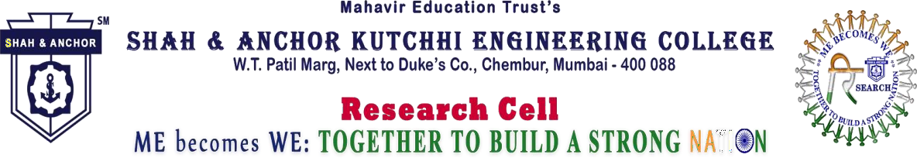

Free webinar for AI &ML
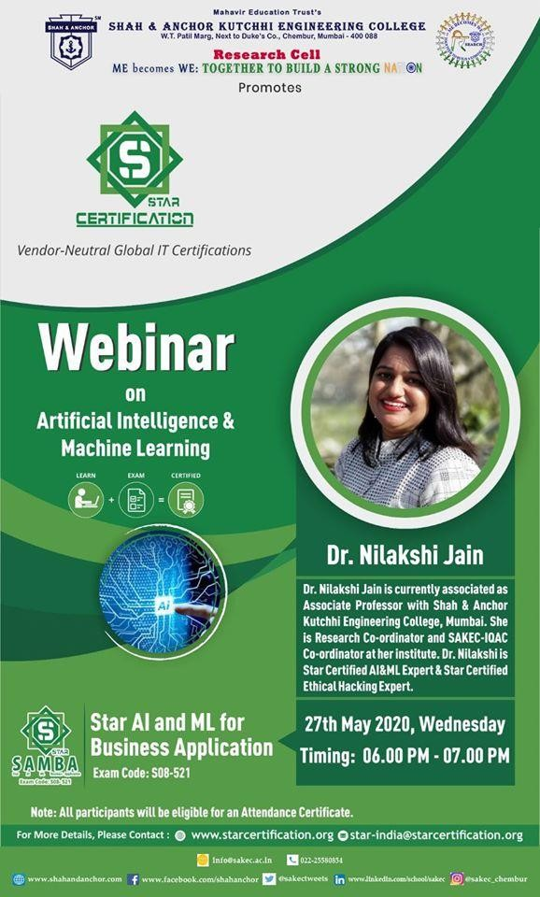

“Shah & Anchor Kutchhi Engineering College in Collaboration with SAKEC National Cyber Resource Defence Center & Star Certification Presented International Certification Course on Cyber Security and Ethical Hacking on 5th February, 2020 at SAKEC.”

- Pre Event Publicity Message:- SAKEC Research Cell promotes Free Webinar on “AI & ML for
Business Application ” by Dr.Nilakshi Jain organized by Star Certification.

- Pre Event Publicity Link : https://shahandanchor.com/research/index.php/Ctrl
_events

- Post Event Message :- Free webinar for AI &ML was conducted on 27 May 2020 by Dr. Nilakshi Jain.
Attendees :

