Free Webinar on Star Ethical Hacking Expert

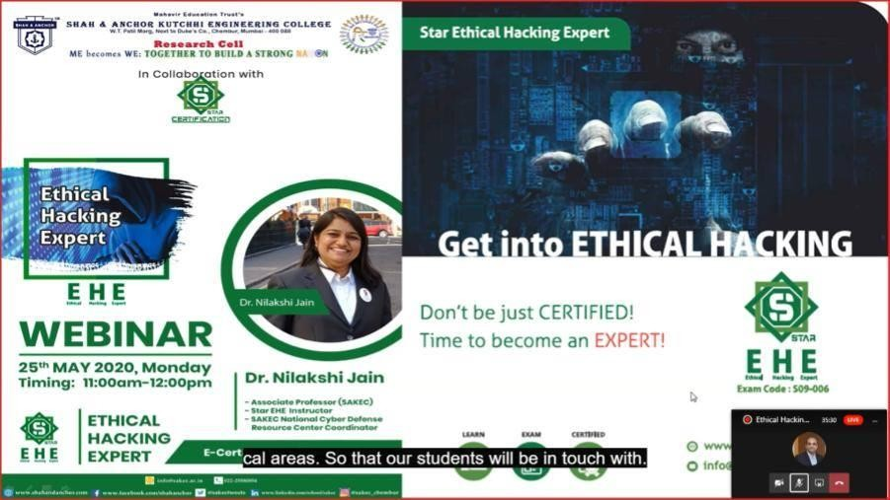

“ A free webinar on Star Ethical Hacking Expert was conducted on 25th May, 2020 by Research Cell, SAKEC in collaboration with Star Certification.”

Pre Event Publicity Message.
SAKEC research cell in collaboration with Star certification bring to you “Free Webinar on Star Ethical Hacking Expert ”
Date : 25th May 2020 Time : 11 Am to 12 PM
Star Ethical Hacking Expert is a comprehensive training program that helps learners acquire a fundamental understanding of concepts like information security, hacking, and ethical hacking, and is a must-have guide for any IT security professional. As they say, “Prevention is better than cure!”
Dr. Nilakshi Jain, Star EHE instructor will discuss:
- What is Cyber Security & It's Need ?
- What is Ethical hacking?
- Topics covered by the EHE certification.
- What are the job roles associated with Ethical Hacking?
- What are the Career path for a Certified Ethical Hacker?
- Ethical Hacking questions from live viewers
Fill out the form to watch the webinar on-demand and avail attendance certificate too. Registration Link :
https://www.shahandanchor.com/home/free-webinar-on-star-ethical-hacking-expert/

Post Event Publicity Message
Do not Hack but When you do It must be Ethical !!! The Webinar on Star Ethical Hacking Expert stands apart from the rest being an epitome of knowledge sharing, organized by SAKEC research cell in collaboration with Star certification on 25th May 2020 using Microsoft Team Tool. The Webinar has registered huge success with 218 Participants from various institutions and organizations. As an Academic Institution, the onus now is on us to bridge the gap between the supply and demand of cybersecurity and Ethical Hacking professionals In a bid to turn this vision into reality we collaborated with Star Certification for Webinar where we have representatives from SAKEC Dr.
Bhavesh Patel, Principal SAKEC & Mr. Amey Patankar, Mr. Bivin Jacob, Mr. Balaganesh from Star Certification as our thought leaders. The Webinar started with the welcoming all by Mr. Ansh Ved (President Student Council Research Cell), Dr. Bhavesh Patel, Principal SAKEC announced the Event open with welcoming Speech, and then Dr. Nilakshi Jain, Speaker started the presentation. The participants appreciated the content delivered by the speaker and were curious to know more and more information regarding Cyber Security and Ethical Hacking. In the Webinar Quiz out of 218 total of 44 Participants scored 10/10 and We are very glad to announce them as OUR SAKEC STAR EHE SUPERSTAR.

Post Event Publicity Link:
https://www.facebook.com/photo/?fbid=1454192654760047&set=a.14541924147600 71

No. of Participants : 218 Participants

Photos:
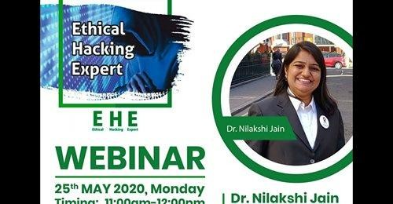

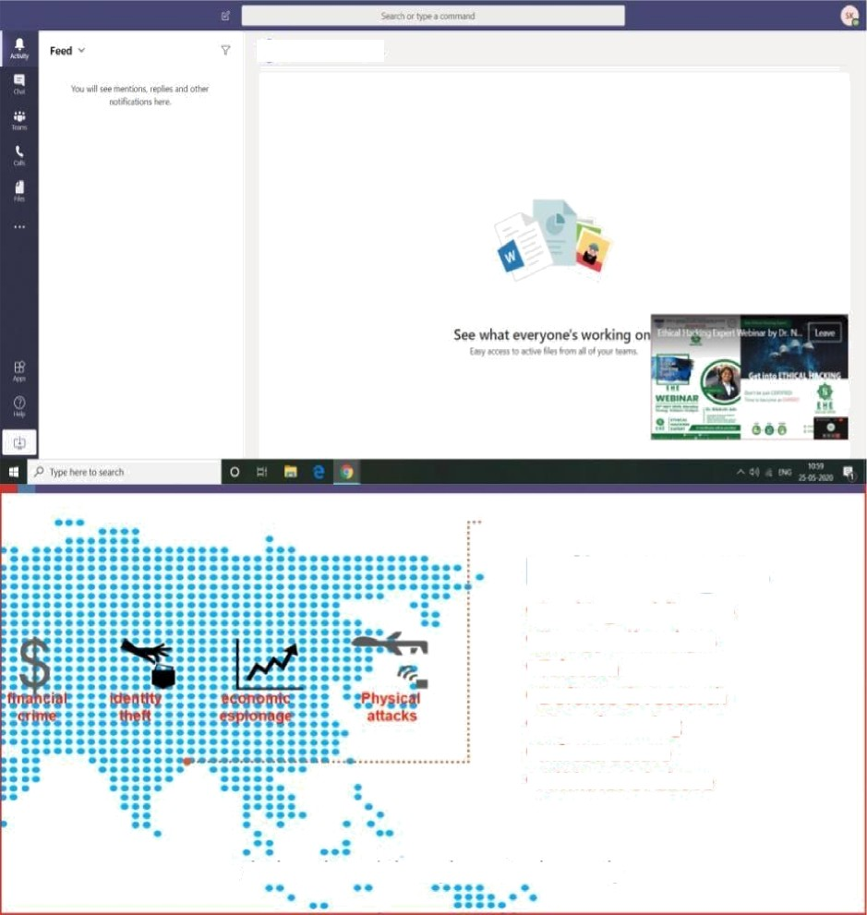
Indian targets
- Banking and finance
- Energy, oil and gas
- Telecom
* Defence & research
- Manufacturing
- Infrastructure
- Affiliates of above
dark web and the cyber attack mostly

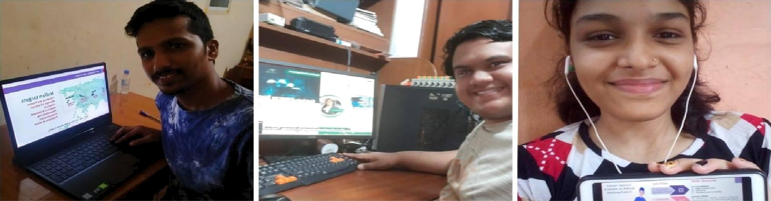
W.T. PaMI Marg, Next to Duka’a Co. , Ghembur, Mumbai - 400 OPB

BE becomes WE: TOGE T itE R TO BUILD A STRONG NA Off
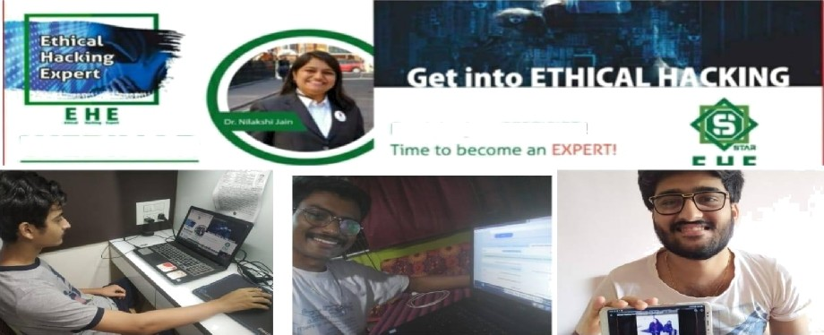
WEBII"dAR
Do n"t be just CE fYTlFl ED!

Nina Maru

MernangFJaNmana

Winners

Brian and nricrior K utcririi t=ingineerincj C:c›liecje Vincent
0 D
n n
0 0
:'3tudent

]O/]O
]O/]O
1 D / 1 O

]O/1O

Tern a -ni:jincoming Enf1tije
0
Faculty
]O/9O

DHA I RA CI-J HEDA

Sarika Paresh Rane
Vanita Mane
Shah and Anchor Kutchhi Engineering College Student Shah and Anchor Kutchhi Engineering College E2tudent scan anoonceor Kutchhi Engineering College Student
Faculty
0
SVOO

1O / 10
10 / 1 0
]O/1O
]O/]O
10 / 10

Me hevlr Ed uc etl o n Tru •t'•

W.T, Pall Mang. Next to Duke'a Co,, Chembur, Mumba-i

400 OBB

M E beco m e s W E: TO GE TBER TO B UI LD A ST RON G " O=N

srnR eoe weoi»nn urmnswna nwnRo
Winners

Manjul | Mumbai University | Student | 1O | / 1 O
Ree1ika Bhanushal i | Shah and Anchor Kutchhi Engineering College | S.tudent | 10 | / 10
Shaikh Nausheenbanu | Shah and Anchor Kutchhi Engineering College | Student | 10 | / 10
Vidya Arumugam | Shah and Anchor Kutchhi Engineering Ooifege | Student | 10 | / 1 O
Kajal Kishorshi Padhiyar | Shah and Anchor Kutchhi Engineering College | Student | 10 | / 10
Akash Kotak | Shah and Anchor Kutchhi Engineering College | Student | 10 | / 1 0
RAHUL KALE | Viva Institute Of Technology | Student | 10 | / 10
Rutuja Chaskar | VIVA Institute of Technology | Student | 10 | / 10
Mayur Pawar | Viva institute of technology | Student | 10 | / 10
Nikhil Hankare | Viva Institute of Technology | Student | 10 | / 10
LALIT JAIN | Shah and Anchor Kutchhi Engineering College | Student | 10 | / 1 0

€hubhama F avvaskar
Winners
KC college of engineering ancl Management

TIMSCDR

1O/1O

1O/dO

Rehit Kishore Bongera Scan and Anchor Kutcnhi I=ngineerrng Cc iiege Student
Tejasnri Anil F”atil I“acuIty

Minh:ssh Kore
Cash De=sai

I-1een a D acj d is Pi B h Oir
Oc. K. K-•ala n iarn rri at
TIMSCDR
TIMSCDR

Student
Faculty
1O / 10
1O/1O

]O/dO

]OZ]O
]O/9O
]O/]O

ME becomes BE. 3'OGg”gBgB To suz a a svaoxc NA IN

Vedant Gupta

VVinners

Sardar Patel Institute of Technology
0

Student

1O / '1 O

1 O / 10

Purva Patyane
Muskaan Dhar

Shah and Anchor Kutchhi Engineering College Student
1 O / 1 O

1 O / 1 O

Firasath nabi
0

I 4andini saini DIPS Chhatarpur f‘vTadhya Pradesh Student
Oevesnree Wanktime H.H.ñcindhale cc›llepe of Engineerint9, Ocimbivali -acutty
east
1 O / 1 O

1O 1 O
1 O / 10

h likhil Raje

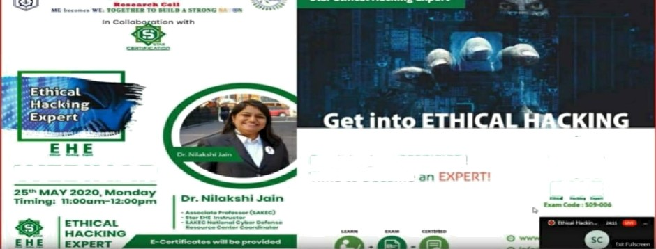Amisa Shikalgar
WEBINAR
Don't be just CERTIFIED! Time to become
E H E

Average

P-•i1lai HO£2 Cc›llege of H ngirneerint3 and Technc•lopy

Median
8 / IO points

Total points diMrtbutton
Faculty

Range
0 - 10 points
1 O / 10

1 O / 10

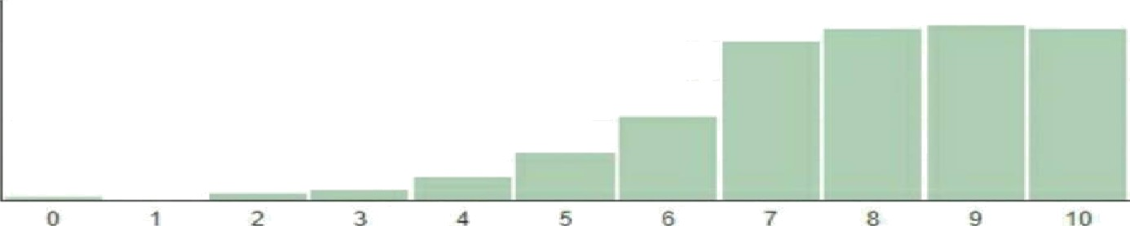

Do you plan to attend simila r kind of we bima r in future?
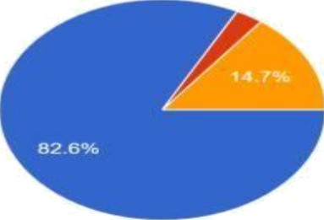
R IB responses

4fl Yes
0

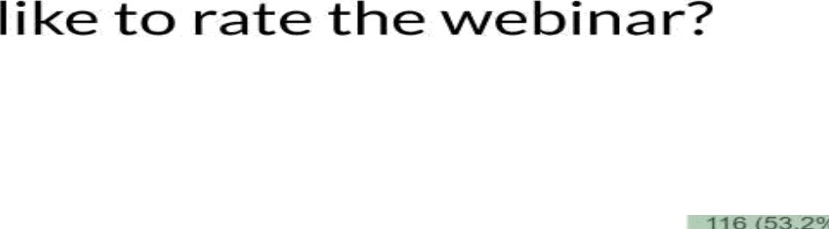

' Lowest is 1 and’ Highest is 5

FHas the s pea ker pot good efforts inn expIaimirqg the concepts to u r Oersta oOthe topic?

218responses

Lowest is 1 and Higtest is 5
Attendees :

