SAKEC - Star Certification Online Teaching

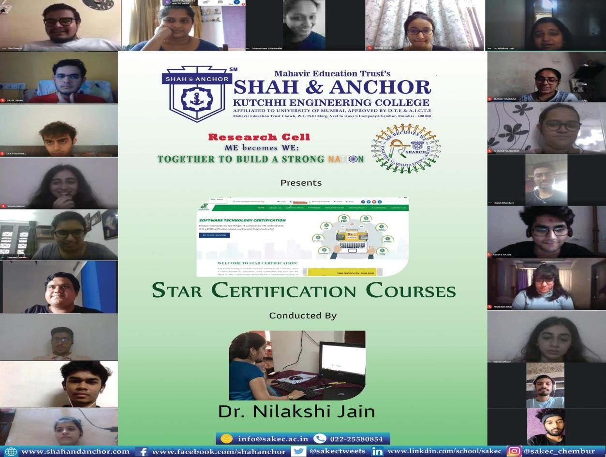

“ Online Teaching for Star Certification Courses were conducted on 19th May, 2020 by Dr. Nilakshi Jain. ”

Pre Event Publicity Message :-
SAKEC has taken initiation in these pandemic situations and is teaching Star certification courses online.
Dr. Nilakshi Jain (Star instructor & Research Coordinator) will be teaching “Star Cyber Secure User ”, “Ethical Hacking Expert”, “Star Artificial Intelligence & Machine Learning Business Application (SAMBA)” courses online from 19th MAY, 2020.
Learning is open for ALL & classes are free of cost. Registration Link :
https://shahandanchor.com/research/index.php/Ctrl_starcertierti

Post Event Publicity Message :-
Because today’s students are tomorrow’s engineers, researchers & entrepreneurs and teachers play vital role making them role model.
As a faculty we should not stop sharing knowledge, Faculties of SAKEC love teaching because every single day they make a difference in someone's life which goes far beyond knowledge. They inspire, support, mentor and get the chance to discover and share some of the best parts as human beings.”
In these pandemic situations SAKEC has taken initiation and teaching Star certification courses online.
Dr. Nilakshi Jain (Star instructor & Research Coordinator) is teaching “Star Cyber Secure User ”, “Ethical Hacking Expert”, “Star Artificial Intelligence & Machine Learning Business Application (SAMBA)” courses online .
Learning is open for ALL & classes are free of cost. More than 100+ students and faculties are giving certification exam by this month end in a unique way.
If you have missed the chance to register earlier you still have chance to register yourself:

https://shahandanchor.com/research/index.php/Ctrl_starcertierti

Post Event Publicity Link :-
https://www.facebook.com/media/set/?set=a.1447676365411676&type= 3& tn =%2CO

- No. of Participants :- 100+ Students and Faculties

Photos :-

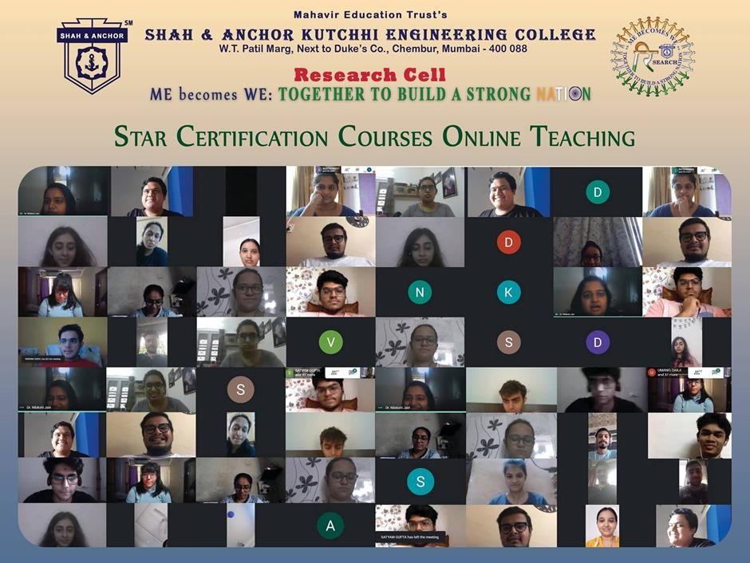

Attendees :

