Celebrating the Launch of Physics I and Physics II App

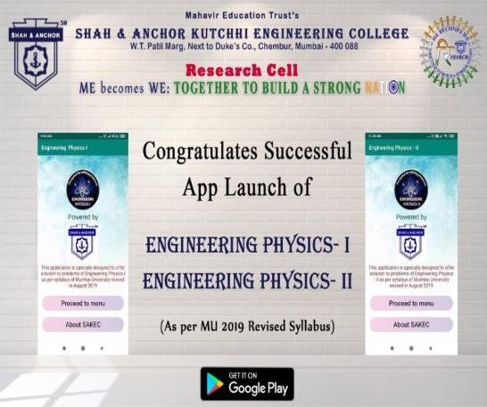

“ The Launch of Physics I and Physics II app was celebrated at SAKEC on 3rd February, 2020 under Research Cell, SAKEC.”

Pre Event Publicity Message:

*Congratulations to all!!*

Launch of the Physics App under the guidance of Dr.Namrata Manglani , has been confirmed for this Monday, 3rd February 2020.
Mentor : Dr. Namrata Manglani Developers : Ms. Shraddha Pawar
Ms. Priyanka
Assisting Students : Mr. Linesh Patil
Ms. Yashika Shetty Ms. Divya Jain
Mr. Yash Ughade

Post Event Publicity Message:-
SAKEC Research Cell Congratulates Dr.Namrata Manglani and their team for successful launch of two mobile applications named as Engineering Physics-I & Engineering Physics-II On Google Playstore respectively. Salient features of the applications:
-FREE of Cost.
-Offers solution of Engineering physics as per MU revised syllabus for academic year 2019-20.
-Student friendly Interface.
-Important questions according to Mumbai University are covered. Focus of the applications is not only helping students to solve physics problems on their fingertips but also verify the result and be used for referential purposes.
The Applications consists of:

- Physics calculator: Through this feature, students can calculate the result of the problem statement. This feature works best in case of direct problem statements. Formula used for calculation is displayed too.
- Solved examples: It consists of proper step wise solution for all types of problems.
- Formula list is provided for revision and reference.
- Well organized notes in question answer pattern for reference. Team: Mentor Dr.Namrata Manglani
Developers: Ms. Shraddha Pawar, Ms. Priyanka Singh
Assisting Students : Mr. Linesh Patil, Ms. Yashika Shetty, Ms. Divya Jain , Mr. Yash Ughade .
Apps can be downloaded from the link below:
EngineeringPhysics-I https://play.google.com/store/apps/details?id=com.physics.mu_applied_phy
EngineeringPhysics-II https://play.google.com/store/apps/details?id=com.muphy2.muappphy2

Post Event Publicity Link : -
https://www.facebook.com/media/set/?set=a.13560040412455 76&type=3

No. Of Participants : -

7 Participants ( 6 Students and 1 Faculty.)

- Photos:-

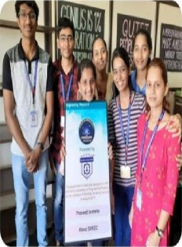
Bgt svli Eds cation Trxst’t
S8*8 A * CAOA KUTCM81E86IDEERI#6 COLLEGE
xe+e«i‹aceii •*’.' xy
M‹ i«›‹» ¥‹: foGiTHli To lfkai sinnc âi *'**"

C0agiatulatts Sxcctishl
App L1880t 0( *“'“
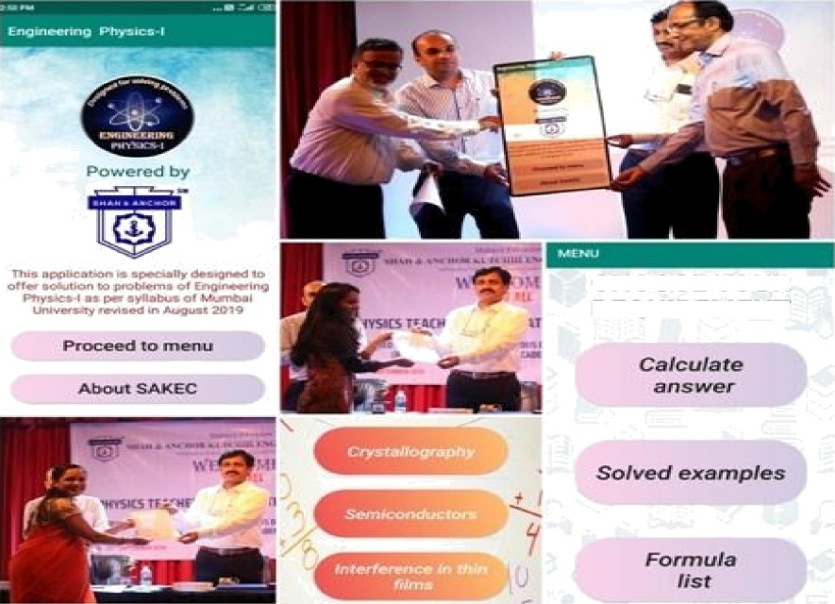
MGIIE§lIGPHf5 lCy” I
MGIytt§lIGPHf5lf5-II

Attendees :

