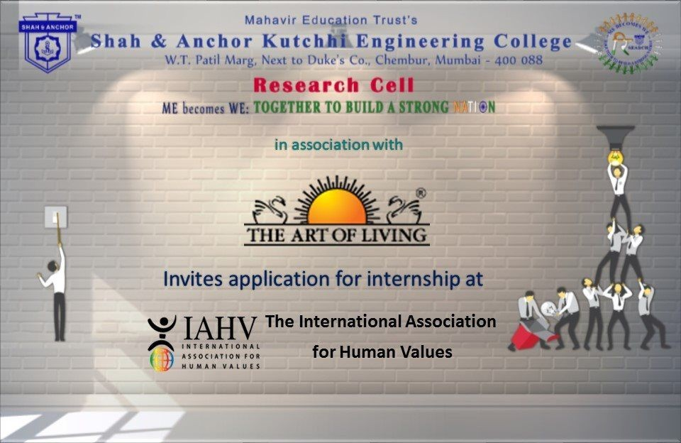

"Internship At Art Of Living" was conducted on 18 July 2019 at SAKEC under the umbrella of "ME becomes WE - together to build a strong Nation".

Pre Event Publicity Message:
*INTERNSHIP AT ART OF LIVING*

SAKEC Research Cell invites the application to intern with Art of Living.
The project details will be shared on *17th July 2019* from 12.30 pm onwards in 4th floor auditorium by representatives from Art of Living.

Students can register as an intern and faculty can register as Mentor.
*Registration Link* :

http://www.shahandanchor.com/home/?page_id=6651

Thanks and Regards Research Cell SAKEC

Post Event Publicity Message:-
SAKEC Research Cell Me becomes We: Together to Build a Strong Nation A new collaboration that will work for the purest element on earth…. A collaboration that will work for helping farmers….. A collaboration that will work for Building a Strong NATION….. A collaboration that will work for conserving ***WATER*** SAKEC has collaborated with ART of LIVING for providing Internship for the “Water Conservation Project” under The International Association of Human Values. Students and faculties were trained by Dr. Sandeep Sharad Shirkhedkar, Phd (Earthquake Engineering), Mr Manish Badiyani, Managing Director of Harihar Infrastructure Development Corporation Ltd.(HIDC) and Mr Ashish Parikh, CEO of Parikh Secretarial Support Pvt Ltd. The overwhelming response and the enthusiasm of students and faculty was remarkable. Another notable achievement was the completion of PHYSICS VIDEOS made by students from first year (now second year), under the guidance of Prof. Namrata Mangalani. These videos are available on SAKEC Youtube channel. The concepts of physics are explained for better understanding .This initiative of the students will be helpful to the students in remote locations who don’t have access to the necessary equipment.

Post Event Publicity Link :
https://www.facebook.com/pg/shahanchor/photos/?tab=album&album_id=1178536805658968& tn =-UC- R

No Of Participants: 81(78Students and 3 Faculties)

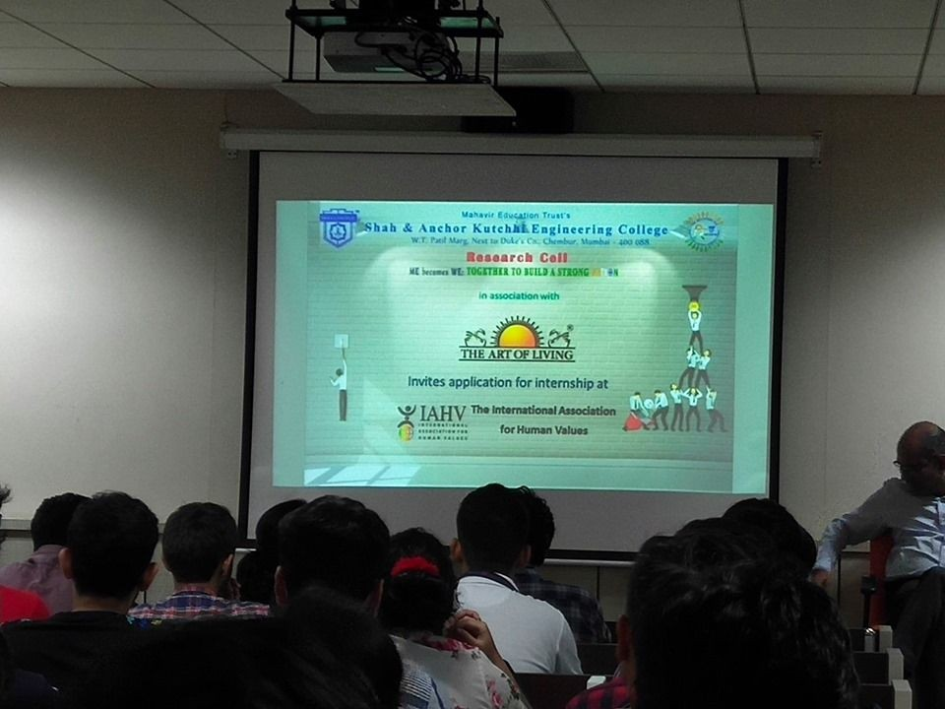
Photos:

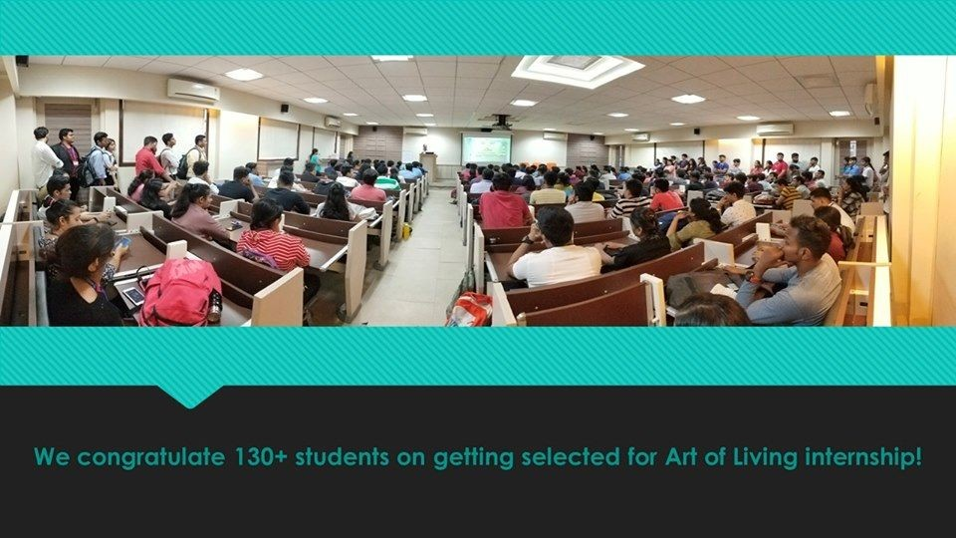

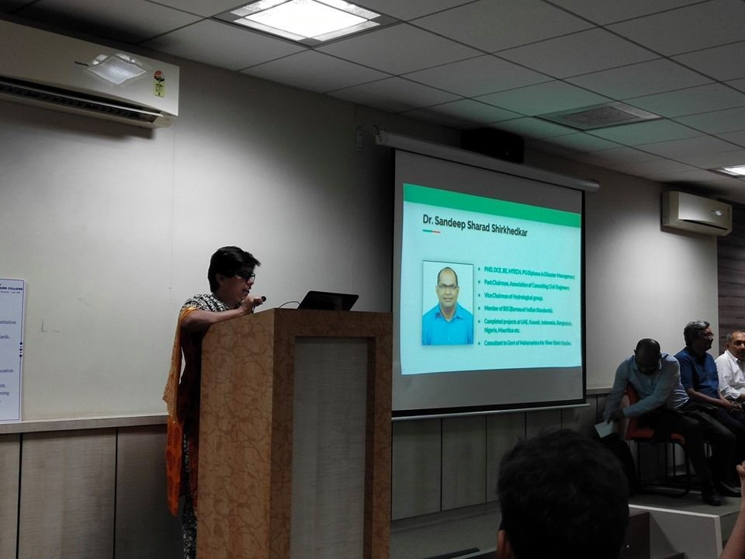

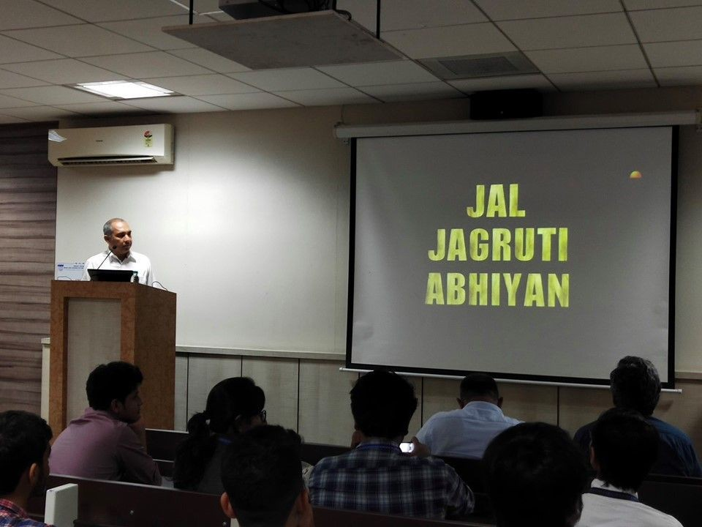

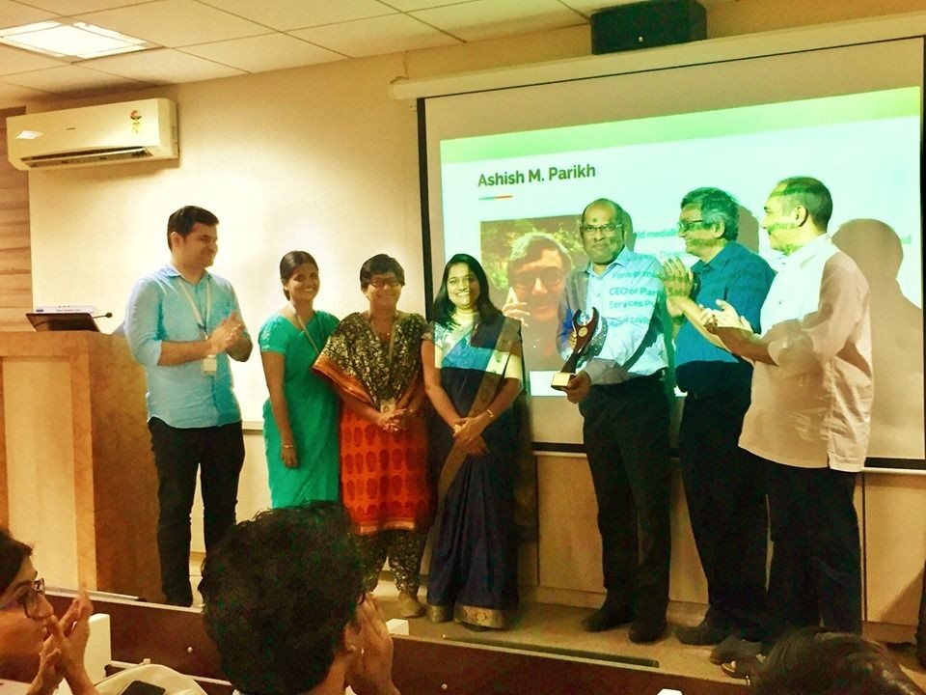

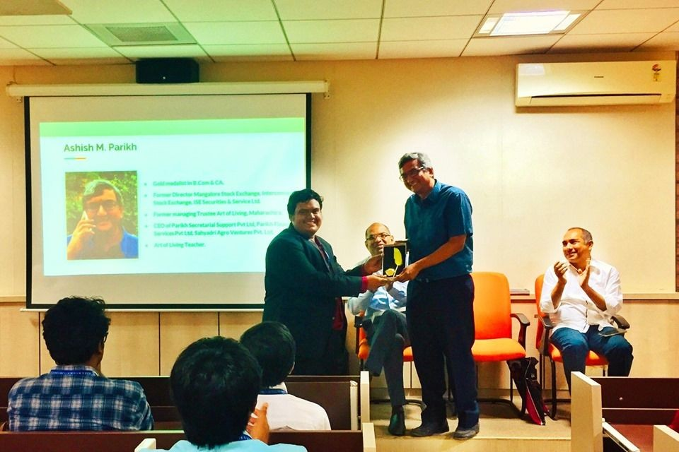

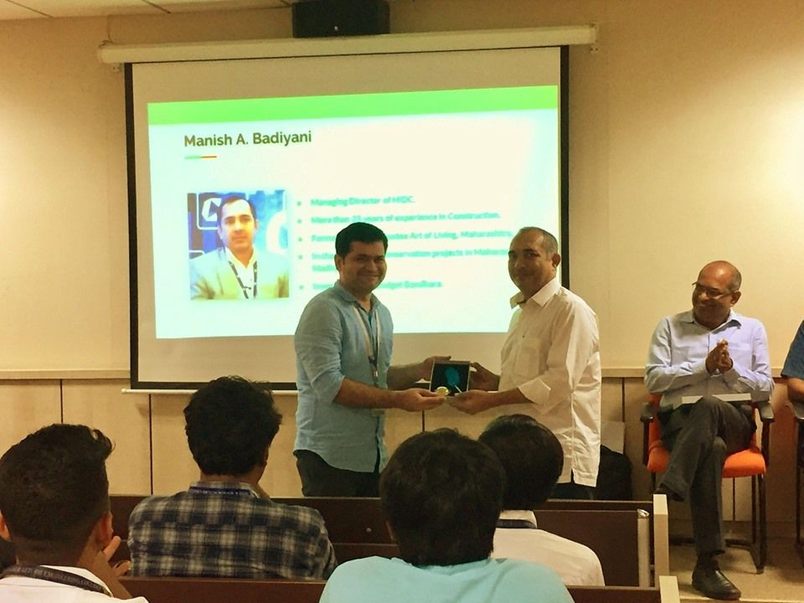

Attendees :

