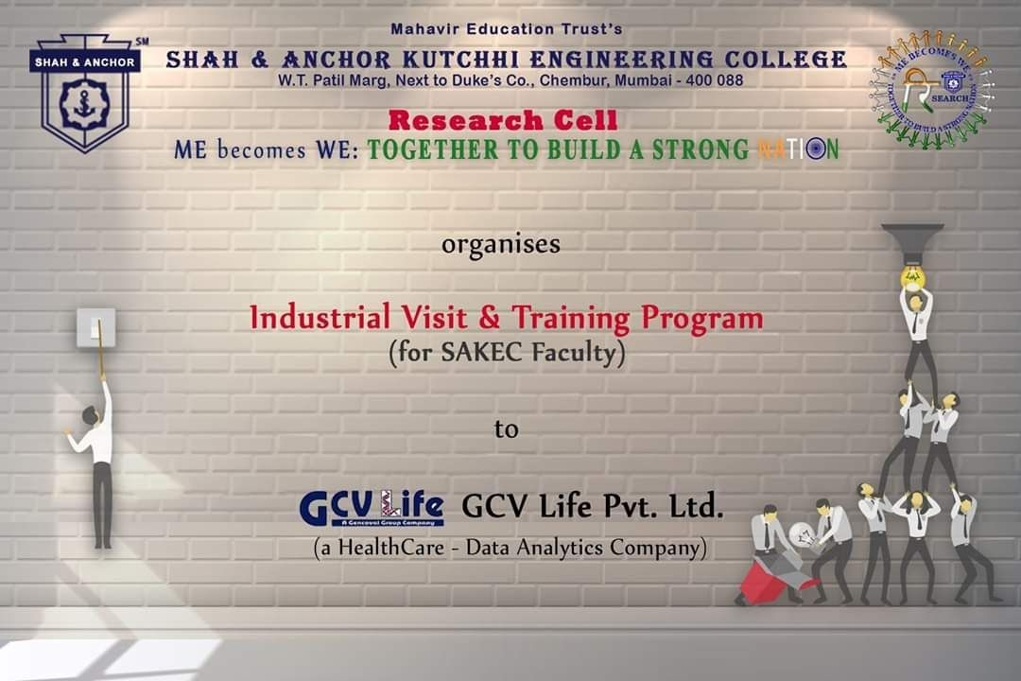

"Industrial visit and training program" was conducted on 4th December 2019 at SAKEC under the umbrella of "ME becomes WE - together to build a strong Nation".

Pre Event Publicity Message:
*Industrial Visit and Training Program to GCV Life Pvt. Ltd*

SAKEC Research Cell provides a golden opportunity for all the faculty members who are interested in this field and want to work in collaboration with GCV Life Pvt. Ltd. GCV Life Analytics is a data analytics vertical focused on building interactive analytical products to identify business opportunity and enhance business gain/productivity. GCV Life Analytics

integrates the advances in data sciences and visualisation techniques to build in data to action connect in its user-friendly analytical tools.

*Registration Link* :
: http://www.shahandanchor.com/home/?page_id=7675

Thanks and Regards Research Cell SAKEC

Post Event Publicity Message:-
SAKEC faculties visited GCV Life Pvt. Ltd and experienced the culture of the company. Ms.Rajashri Mokashi GCV Life Pvt. Ltd. , Partner at GCV Mr. Jaywant yewale Head – Operations GCV Life Pvt. Ltd. gave brief introduction about the company, tools with use cases available with the company and explained Projects to be initiated. Many real time problems were discussed. SAKEC thanks the GCV Life Pvt. Ltd and looks forward for fruitful relationship. As the outcome of the visit more opportunities were extended to the students and faculties , as published on website.

Post Event Publicity Link: https://m.facebook.com/story.php?story_fbid=1297954430383871&id=474323859413603&sfns n=wiwspwa&funlid=fWI2ScWcWRMDMp2Q

No Of Participants: 7 Faculty Members

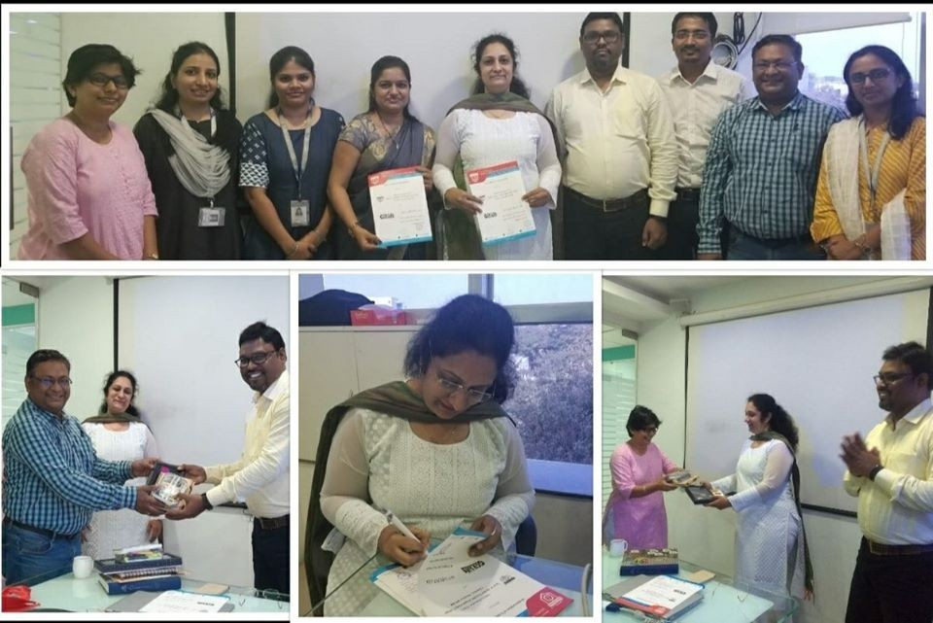
Photos:

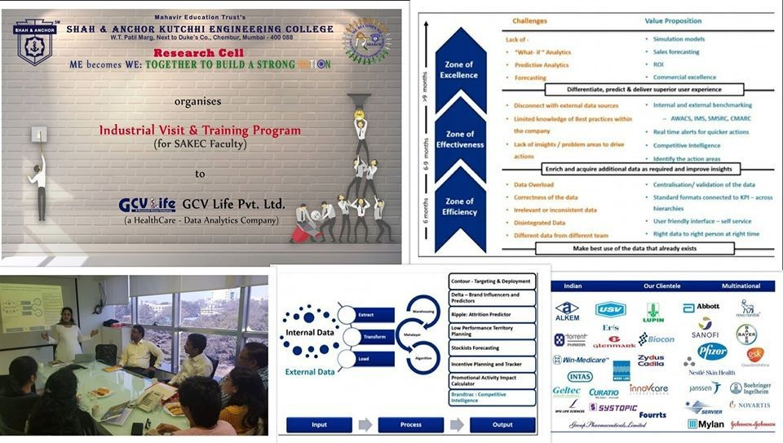

Attendees :

