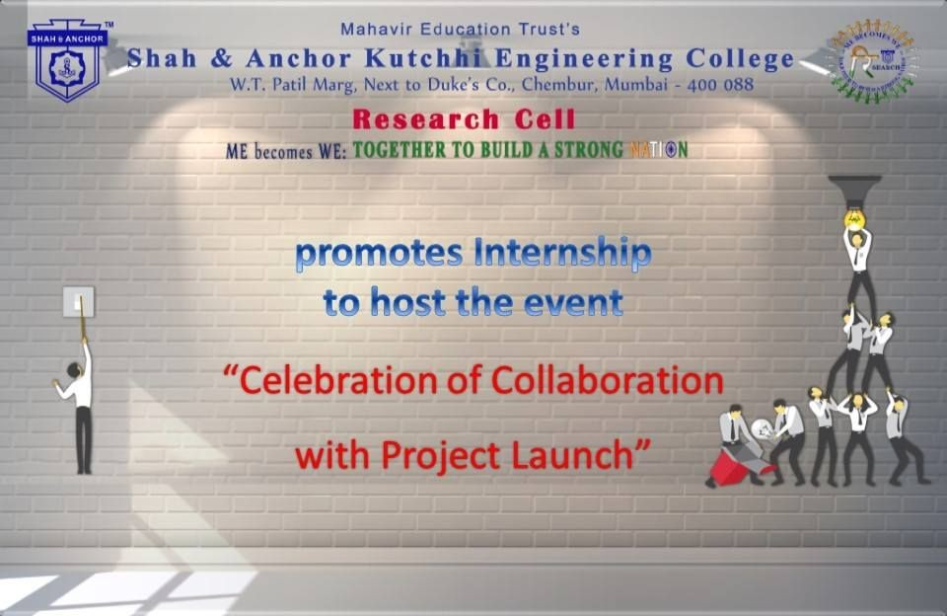

"Celebration of Collaboration with Project Launch" was conducted on 4th February 2019 at SAKEC under the umbrella of "ME becomes WE - together to build a strong Nation".

Pre Event Publicity Message:
SAKEC Research Cell, takes immense pleasure to announce *Celebration of Collaboration with Project Launch* under the banner of *ME BECOMES WE: Together to Build a Strong Nation*.

Agenda for the event:

*SAKEC has collaborated with renowned organizations and now it's time to celebrate the collaboration*.

*SAKEC is Launching various Projects, which are developed and deployed by our students & faculties*.
And Many more *Surprises*

Save Date: *2nd February 2019* Time: 10:00 AM onwards
Venue: 7th Floor Auditorium, SAKEC
Registration Link: http://www.shahandanchor.com/home/?page_id=5147

On this auspicious moment, your kind presence will make the event more glorious. If you could spare some precious time and grace the event, we shall be honored.

*Thanks and Regards*
*Research Cell*
*SAKEC*

Post Event Publicity Message:
Shah & Anchor Kutchhi Engineering College, Chembur has collaborated with Indian Development Foundation, Bennett University, Roti Bank Mumbai, Bombay Leprosy Project (BLP), Waggy Tails Private Limited and Digital Freedom Foundation (DFF) to let students develop ideas and work on real life projects which have the potential to benefit society in numerous ways. These projects were launched on 2nd February 2019, in the honorary presence of the Chief Guest, Mr. Boman Irani, widely acclaimed Indian actor.

The event began with Deep Prajwalan and a prayer. Mr. Irani was heartily welcomed and felicitated by the Chairman, Shri Keshavjibhai Chhadva, Principal Dr. Bhavesh Patel and Research Coordinator Dr Nilakshi Jain. Inspiring speech by Mr.Irani explaining the virtue of humility in one’s life, left the audience in deep thoughts. Dignitaries were felicitated and presented with tokens of appreciation.
The dignitaries included
Mr. Boman Irani, widely acclaimed Indian actor
Mr.D. Sivanandan, ex-DGP Maharashtra and convener of Roti Bank, Shri Sushil Jiwrajka, Trustee, Roti Bank,
Dr.Narayan Iyer, CEO & National Co-ordinator (Mumbai) IDF, Wg Cdr S Balasubramaniam, Retired IAF, Treasurer IDF
Dr.Ashish Kodke chief doctor at BLP, Ms Parul Negi, BLP
Mr. Rahul, BLP
Mr. Deshpande, BLP

Mr.Shashank Shetty, Hon. Director IDF Education Projects & Project Lead (Larsen & Toubro Infotech)
Mr. Abhishek Kateliya , Rotibank mumbai Mr. Anish Paliwal, IDF Social Ambassador Mr.Krishnakant Mane, Founder, DFF
Ms. Prajakta Patkar, Project Leader, DFF Mr. Abhijit Balan, Manager, DFF
Mr.Yash Sheth, Director Waggy Tails Private Limited

The dignitaries launched the projects live amongst great excitement and cheer. All dignitaries expressed joy over the hardwork and dedication shown by team of SAKEC.

A total of 7 projects were launched consisting of
- Roti Bank App
- Roti Bank Test before Taste
- IDF Web of Hope web application
- IDF Speed Ambulance App
- BLP Electronic Health Record Management System
- IDF Fire Fighter Robot
- IDF Breathe Clean Project

The celebration was complemented with a moving mix of songs performed by students of SAKEC.
A video for each project, explaining the concept and working of the same was showcased. The members of the teams i.e. students and mentors were congratulated and granted certificates by the dignitaries. It was a moment of pride for dignitaries and teams alike.
Yash Sheth, entrepreneur and alumnus of SAKEC inspired the students to do start-ups and presented an app, “Let It Wag” aimed at helping injured animals.
Dr. Nilakshi Jain, Research Coordinator gave a vote of thanks and motivated students to do research internships.
The event concluded with another round of music and the national anthem.
The project teams were left motivated and prepared for further project development.

Post Event Publicity Link :
https://www.facebook.com/events/1071632409685719/ No Of Participants: 146 ( 71 Faculties and 75 Students )

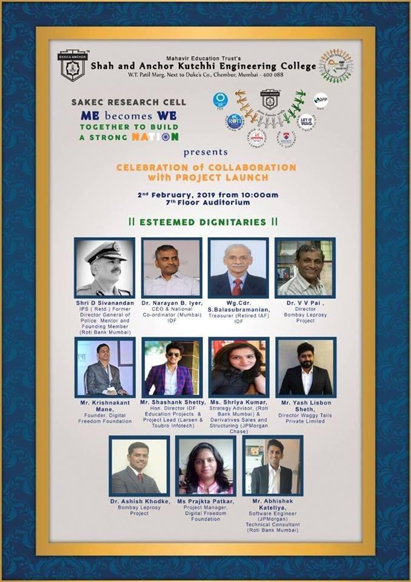
Photos

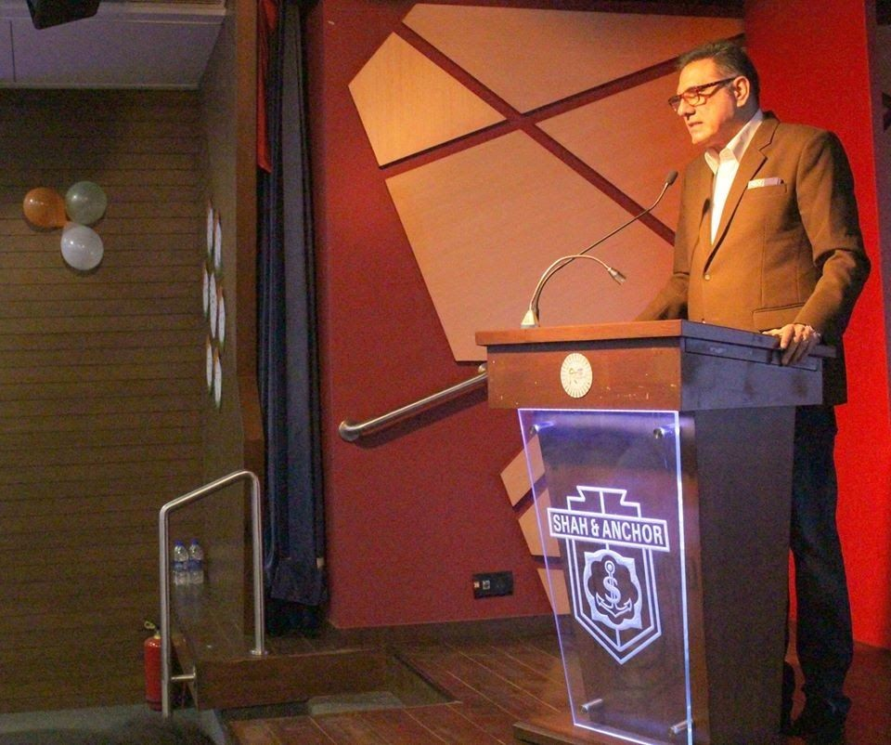

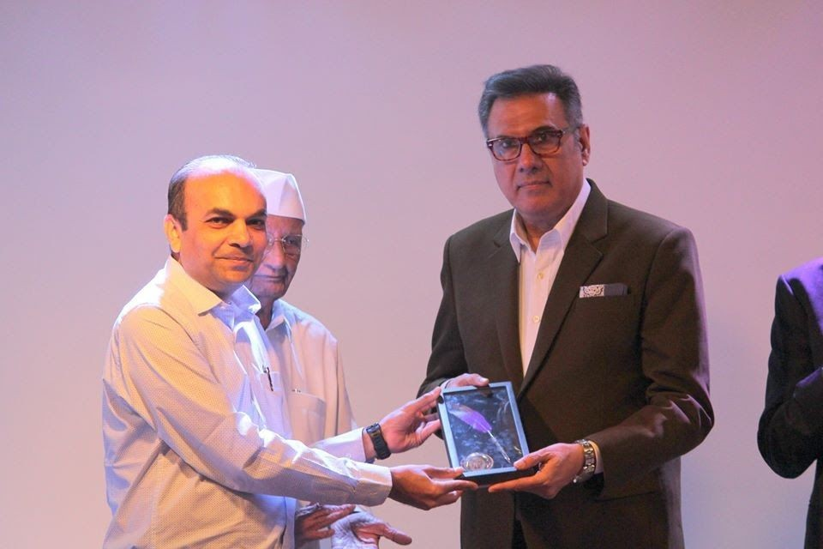

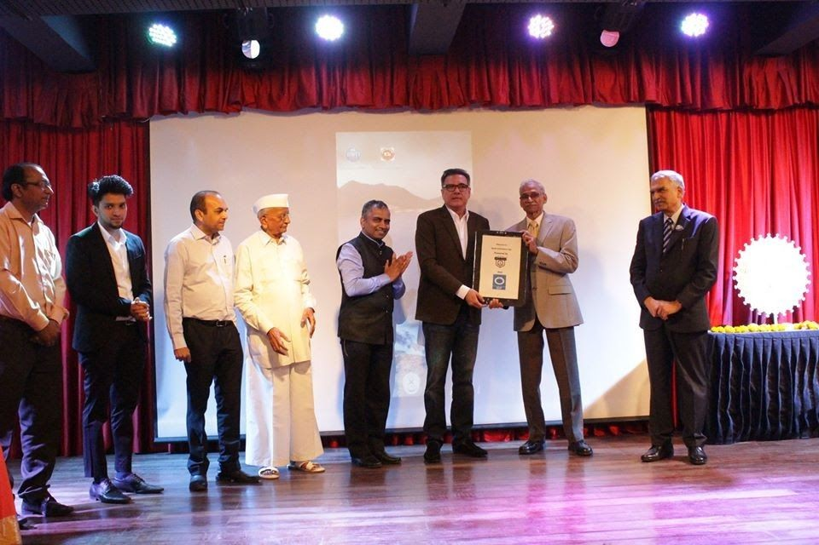

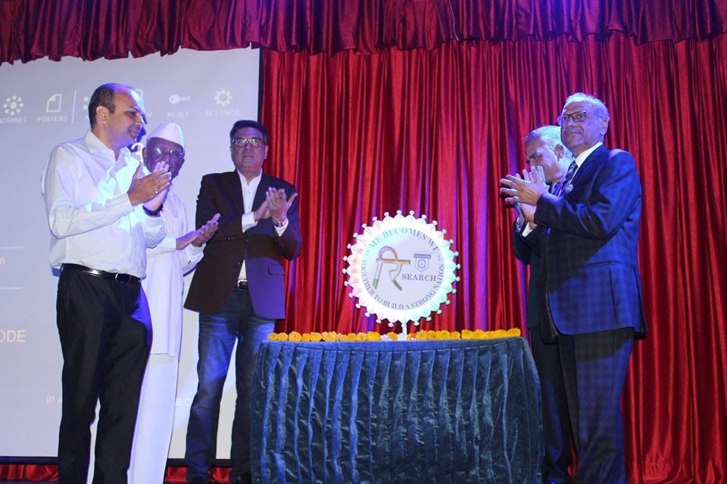

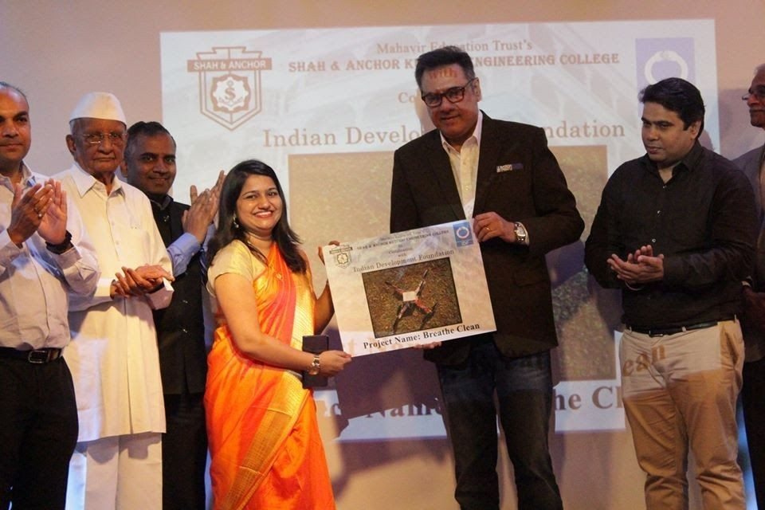

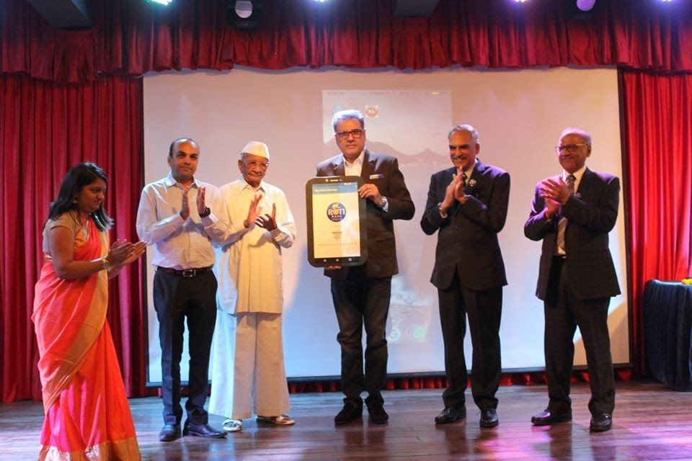

Attendees :

