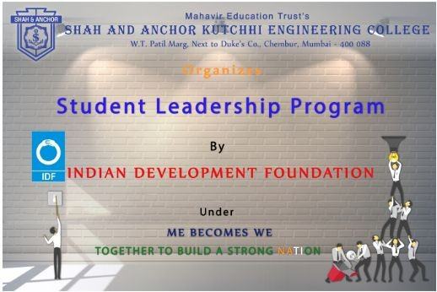

"Student Leadership Program by Indian Development Foundation" was conducted on 4th February 2019 to 9th February 2019 at SAKEC under the umbrella of "ME becomes WE - together to build a strong Nation".

Pre Event Publicity Message:
Shah and Anchor Kutchhi Engineering College organizes “Student Leadership Program by Indian Development Foundation ” for SAKEC students under the umbrella of ME becomes WE: Together to build a Strong Nation.
IDF Team Members will train the SAKEC students who will be called as Mentors. Mentors will train School students because student days are the most important part of upbringing in one’s life. The mentors will be later assigned the task in different schools to train school students. The school project will be closer to the Mentor’s location to save travel time.

Date & Time of Event:-19th September 2018, 10:00 A.M. Onwards. Venue:-2nd & 3rd Floor Auditorium
Registration Link:-http://www.shahandanchor.com/home/?page_id=4091

*Thanks and Regards*
*Research Cell*
*SAKEC*

Post Event Publicity Message:
Shah and Anchor Kutchhi Engineering College, takes immense pleasure to thank Indian Development Foundation (IDF) for giving the opportunity of “STUDENT LEADERSHIP PROGRAM (SLP)” at Anjuman-I-Islam Girls’ School , Bandra to the students of SAKEC (Mentors for SLP). Total of 27 SAKEC-mentors were at the school for mentoring 480 school students. Highlights of the program : 1. A six day program dated 4th to 9th February 2019 where students were taught topics like Time Management, Anger Management, Public Speaking, Good company & Bad company, Career guidance, Community Hygiene etc, by mentors of SAKEC. 2. The students were encouraged to take initiative and be a responsible citizen of India, the leaders of India by interactive sessions conducted by the mentors and also students were quite supportive as well. 3. Mentors got a new exposure to teach and learn from the young students at Anjuman-I-Islam Girls School. 4. On 8th March, 2019 the students at Anjuman-I-Islam School, were felicitated by CEO & National Co-ordinator (Mumbai) of IDF, Dr. Narayan B. Iyer and Dr. Beena Narayan with certificates to students. The mentors and dignitaries were felicitated with bouquet of flowers and sweet words. And memories to be cherished forever……. Dignitaries: Chief Guest Dr. Narayan B. Iyer, CEO & National Co-ordinator (Mumbai) Chief Guest Dr. Beena Narayan Principal of Anjuman-I-Islam Girls School Dr. Saba Patel.

Post Event Publicity Link:-
https://www.facebook.com/pg/shahanchor/photos/?tab=album&album_id=1100510310128285& xts

%5B0%5D=68.ARBA19_6VkOmjoUo0Xh300FofjH6JLPGgmVtTcW-6D8E9EUnh1hwwF8mE0eEoZIB
VcWoPcJNxv_pQ522bcCgOAIak3mrdiLRDAdsJIkeTkF0cqeplXge-mebI2n7zD2VmIW5hnfPtXndJsZb TI9HAQKp4eEk31EUy2Yoe7C4S3IIn5P_p7FEha31OffFTaysPaHfGz10-a5ShVdgdC_yblCJ91ijv7K6Kx Wy2i7wLoBiP4IYR3OQdjIkKPJjCLl0OXIB1gOFsYIdt-oET1uYhK0yx2mWXP0e30DonpakawRYlAfu 6Ov_zqUHQjGBePgFYEE5wn61clj0lQwECUEmjFPXc6-2P_3OQu7kJsCNSBF6fe-wkOL5ON5gRpma 7syoGGgAP8b7SgHOsfuRV9qhJzpo7Lv0Pljv29A54O14tddwD_gRVTc34dl4tVhB0YkKSzWGKS6A6s Ar80A2EtIxnA_3DuMJ_3nD_j9z0WBMXJfjdr_4xyzUuxHL1dG_PoAwokp1rzmSKpoOhjTa6i-fuDHBe Yp_JXjLmDNPxv18WA& tn =-UC-R

No Of Participants: 28(27 Students and 1 Faculty)

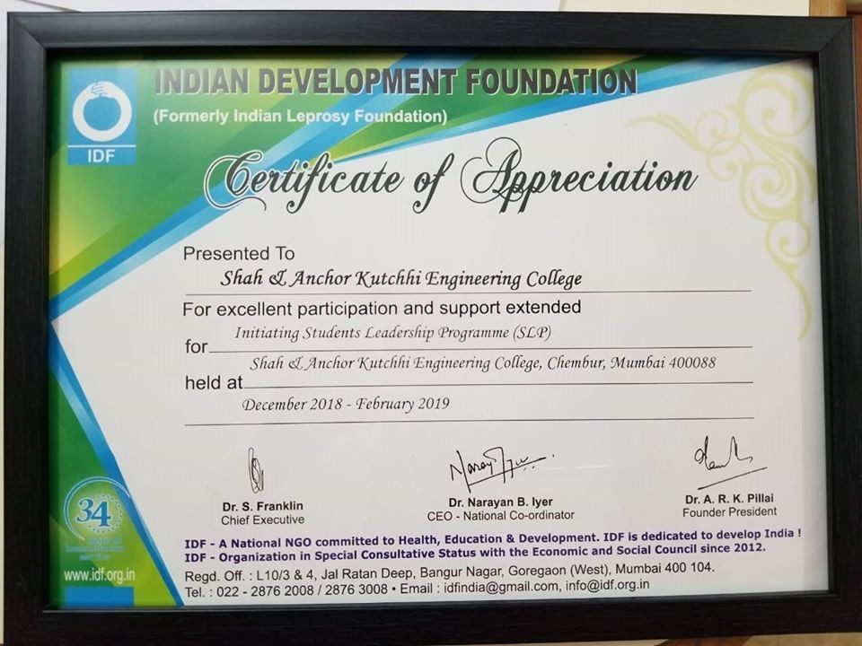
Photos:

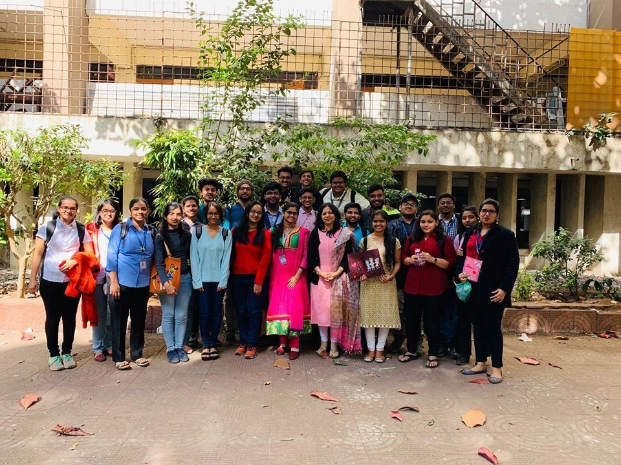

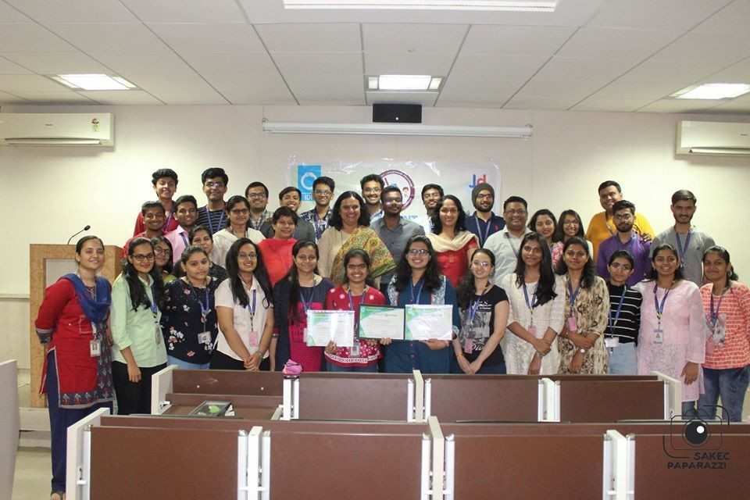

Attendees :

