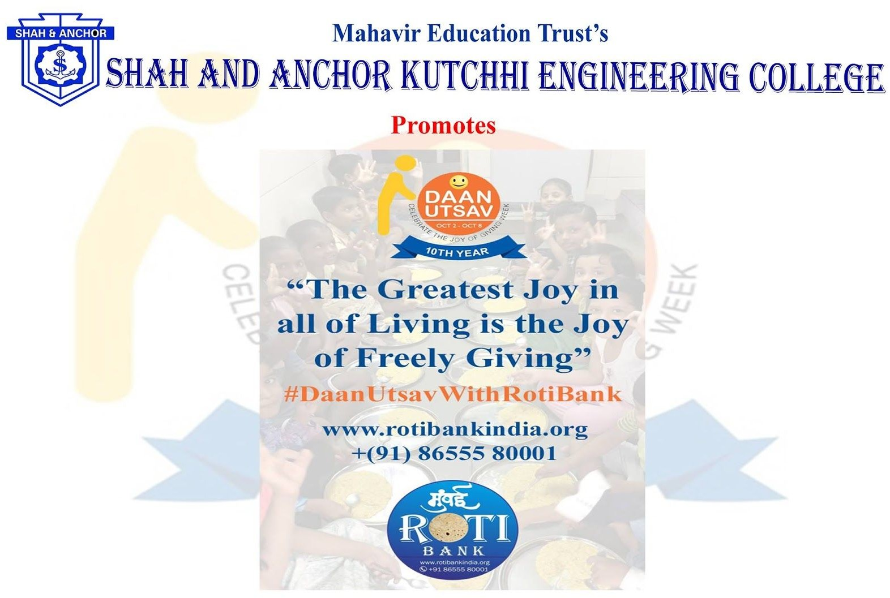

SAKEC in collaboration with Roti Bank Mumbai celebrated “Daan Utsav 2018” on 26th October 2018 at Sulabha Special School, Tilaknagar.

Pre-Event Publicity Whatsapp Message:
he greatest Joy in all of the Living is a joy of freely GIVING !
Feel yourselves Lucky under the roof of SAKEC to be a part of the greatest charity that is the charity of food.
SAKEC in collaboration with Roti Bank Mumbai promotes “Daan Utsav”. Your small donation will help to buy food for the needy.

From your smallcontribution SAKEC will provide food items to the needy. For more details click on the link provided: http://www.shahandanchor.com/home/?page_id=3564

Please coordinate with the following faculties:
Ms Asha Durafe (90040408302)
Ms. Shwetambari Pawar (8850200720) Ms. Radhika Fulzele (08788362617) Ms. Seema Kawale (09594258315)

Thanks and Regards SAKEC

SAKEC in collaboration with Roti Bank Mumbai celebrated “Daan Utsav 2018” on 26th October 2018 at Sulabha Special School, Tilaknagar.
The event was a great success with the whole hearted efforts of college staff and student volunteers who donated food items like Daal, rice and bournvita packets to the underprivileged school children.
The event was coordinated by Prof. Asha Durafe and Prof. Pinky Vishwakarma
SAKEC staff members Prof. Dhanashree T., Prof. Manoj Dhande, Dr. Nilakshi Jain, Prof. Bhakti Sonawane, Prof. Manisha Mane, Prof. Nibha Desai, Prof. Aparajita Bera, Prof. Seema Kawale and Prof. Radhika Fulzele along with many students enjoyed the moment of giving.

Post Event Publicity:

https://www.facebook.com/media/set/?set=a.1012815378897779&type=1&l=5526b61eed

No Of Participants: 30( 4 Faculty and 26 Students)

Photos:

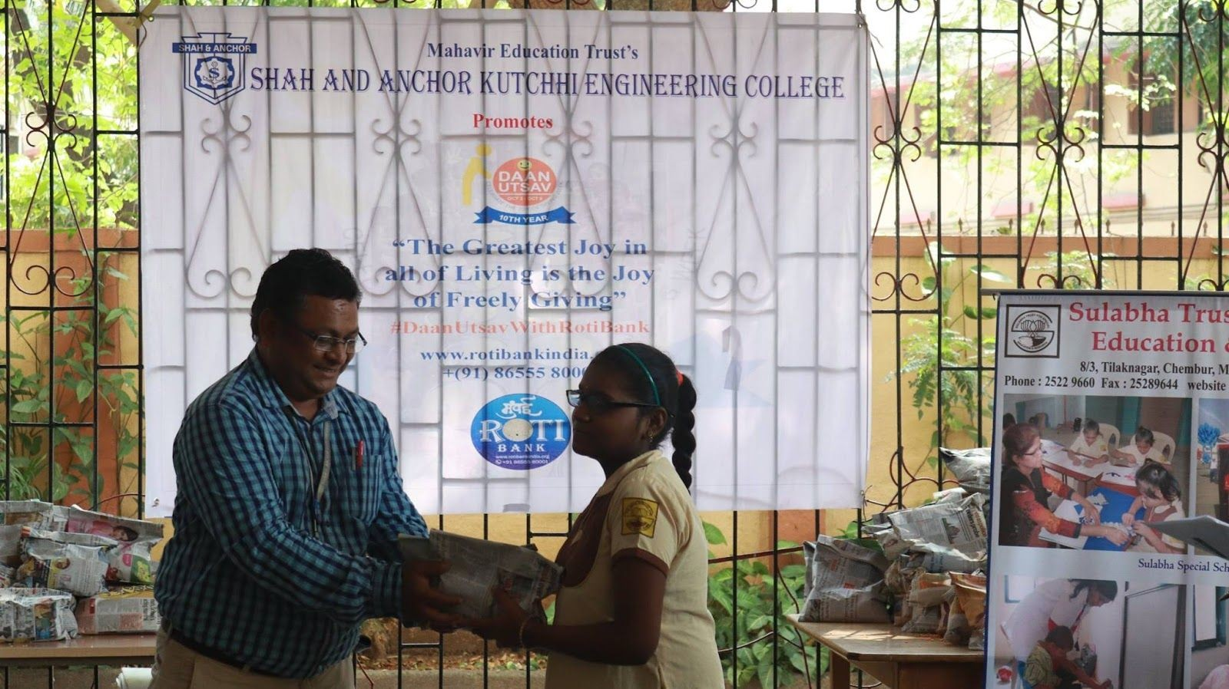
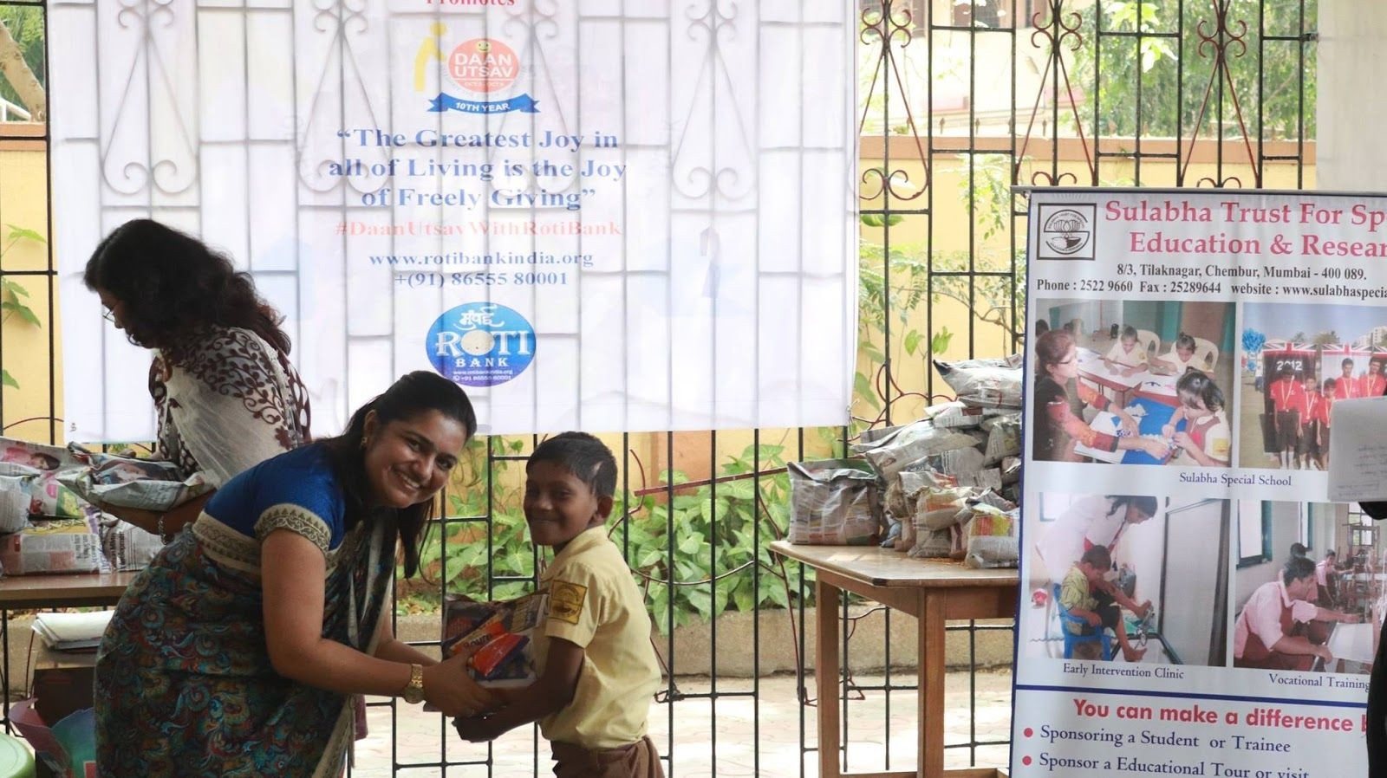

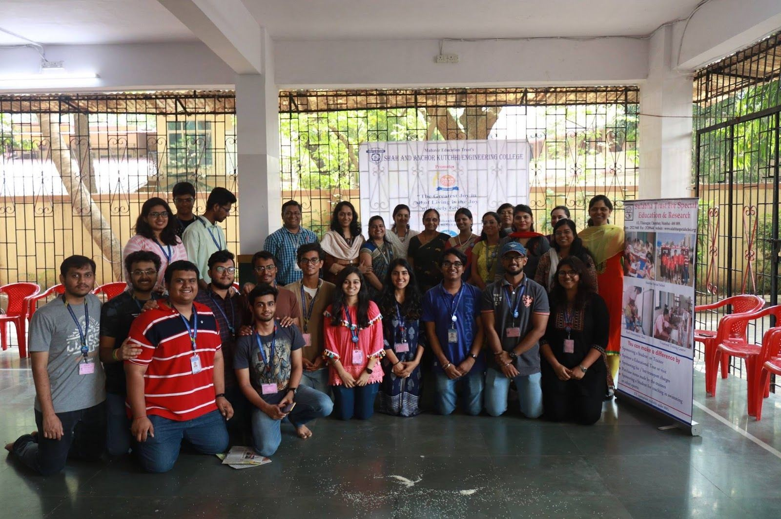

Attendees :

