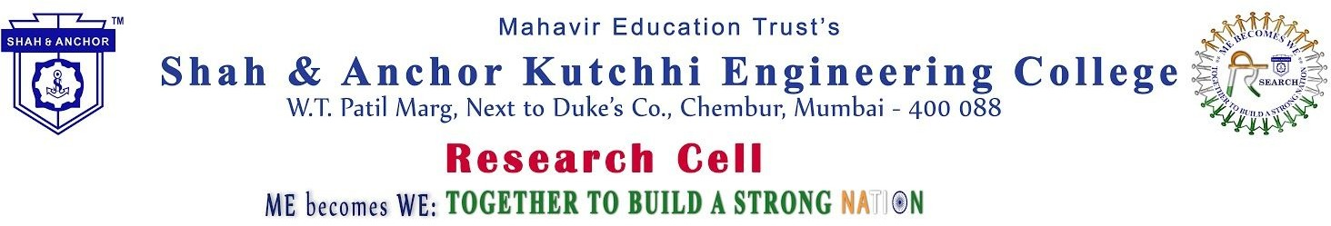

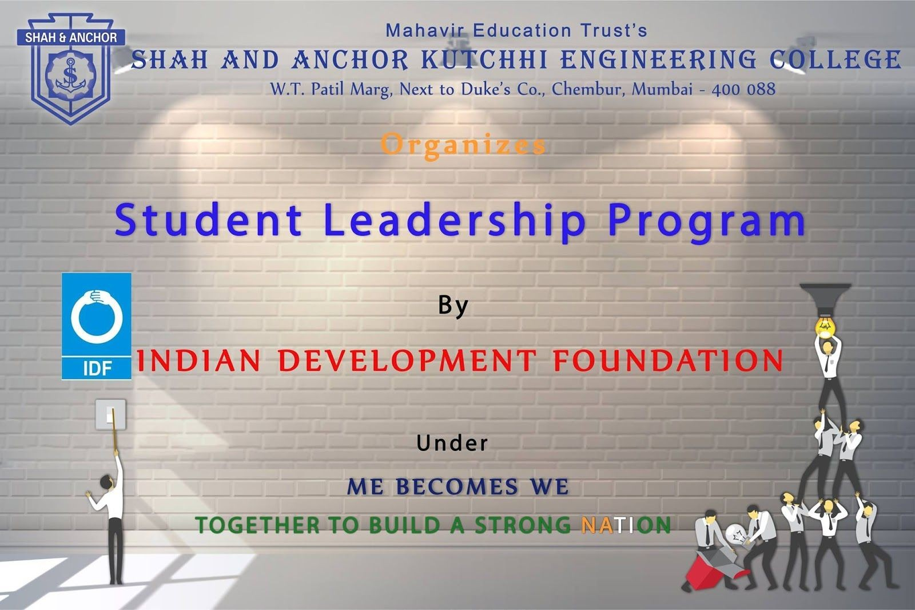

"Student Leadership Program by Indian Development Foundation " was conducted on 19th September 2018 at SAKEC under the umbrella of "ME becomes WE - together to build a strong Nation".

Pre Event Publicity Message:
Get a chance to inculcate and nurture THE LEADER inside you because its time to transform ME into WE.
Shah and Anchor Kutchhi Engineering College welcomes you in Student Leadership Program by Indian Development Foundation(IDF). Under the umbrella of ME becomes WE: Together to build a strong nation.

Very Limited Registration

REgistration link: http://www.shahandanchor.com/home/?page_id=4091 Date: Sept 19, 2018
Thanks and Regards Research cell SAKEC

"Student Leadership Program by Indian Development Foundation " was conducted on 19th September 2018 at SAKEC under the umbrella of "ME becomes WE - together to build a strong Nation". We had excellent speakers, Ms Mallika Ramchandran and Mr. Roshan D'souza from Indian Development Foundation who are experienced SLP co-ordinators. The co-ordinators conducted the session for our students on how they can become mentors and help IDF and thus the nation, in achieving their goal of teaching the underprivileged children. The session was truly inspiring as the students were looking forward to get real time exposure of mentoring.The speakers also assured the students that this would be a life-changing experience for them to give back to the society and lead a successful, satisfying and happy life in true sense. The session was appreciated by the students who thanked the speakers as well as college and faculty for conducting such a diverse session for them. Speakers were given positive assurance about SAKEC's collaboration with IDF which will bear sweet results to build a strong society and Nation

Post Event Publicity :
https://www.facebook.com/media/set/?set=a.991500344362616&type=1&l=bab68388bf

No Of Participants: 52 Students

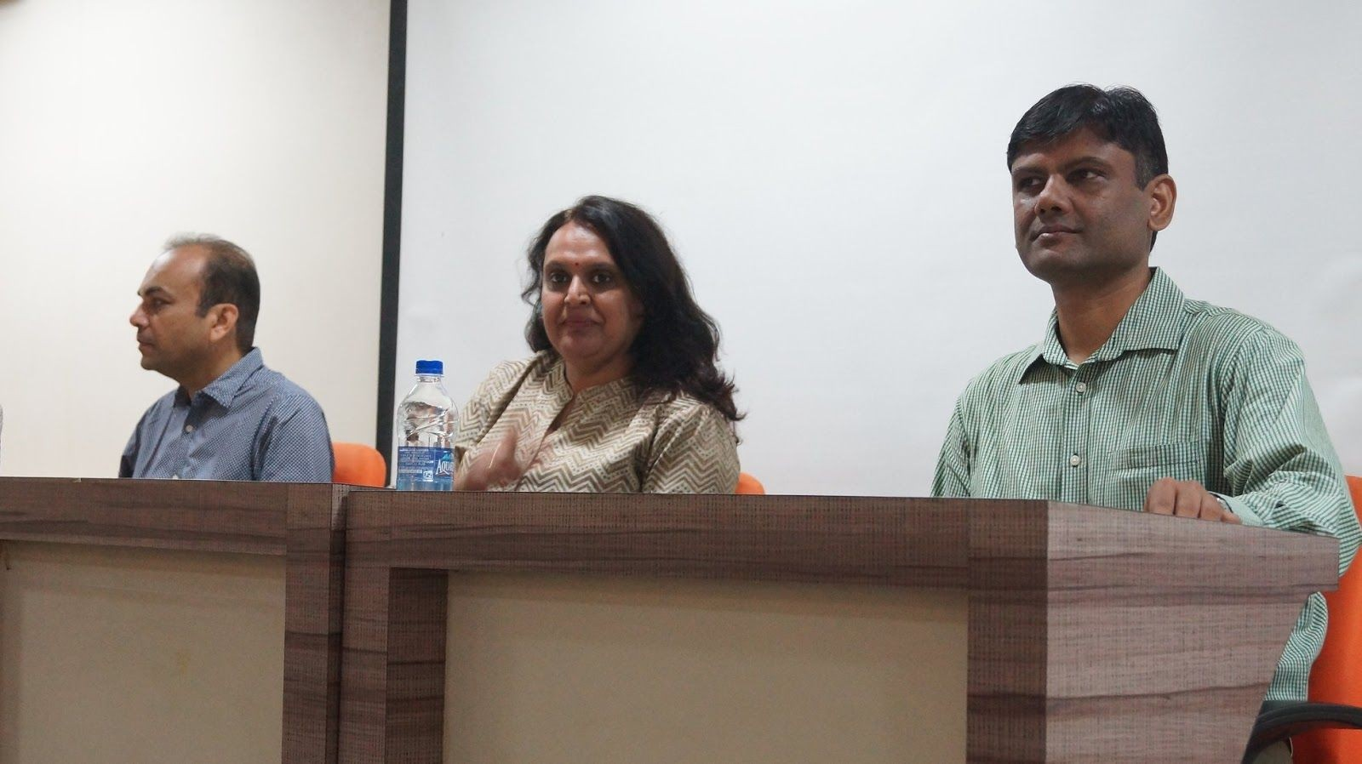
Photos:

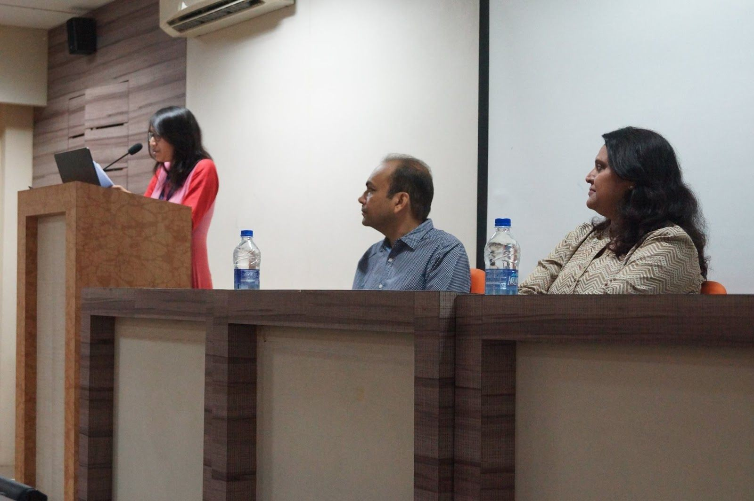

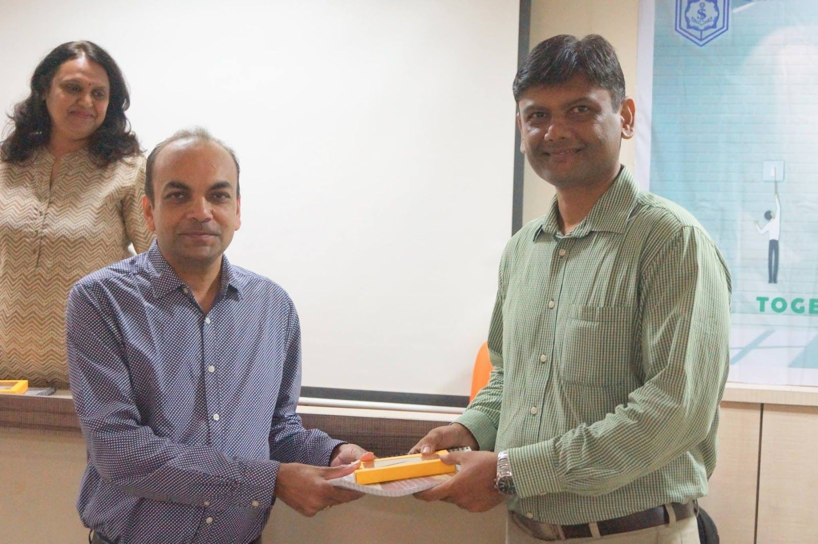

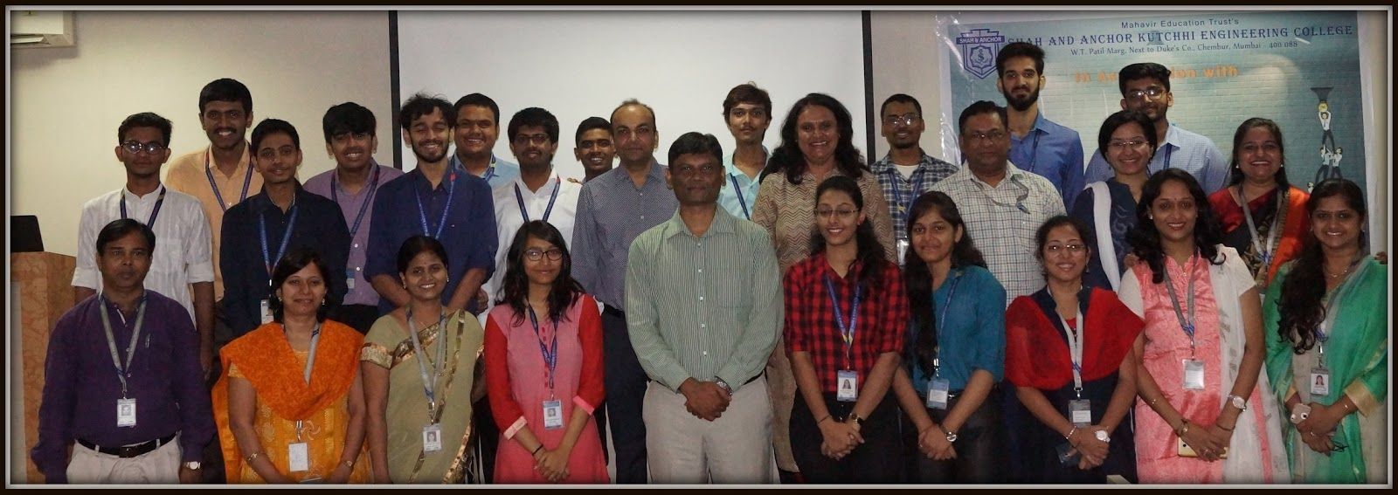

Attendees :

