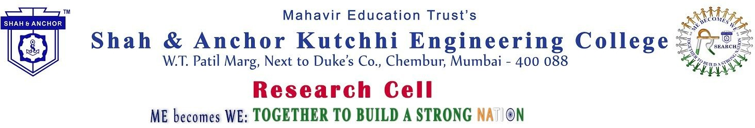

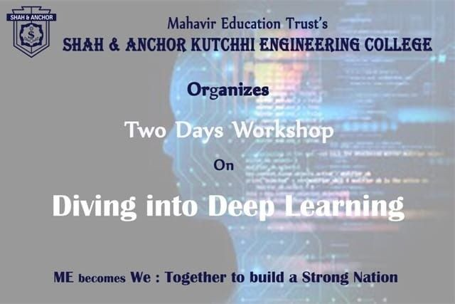

Under the banner of ME becomes WE, students of SAKEC organized Diving into Deep Learning with an interactive hands-on session conducted by Dr.Kranti Ghag, Ms. Jalpa Mehta, Mr. Milind Khairnar and Ms Vaishali Hirlekar on 1st and 2nd September,2018.

Pre Event Whatsapp message:
Do you have a passion for AI and Deep Learning?
Do you want to develop your own Neural Network models for your applications, learn how to fine tune these models to give the best results? Here is an opportunity!
The Dive into Deep Learning - a Two day workshop.
The participants will be trained on topics in full hands on sessions. Topics are as follows: Artificial Intelligence - Mrs Jalpa Mehta
Artificial Neural Networks - Mr. Milind Khairnar Convolutional Neural Networks - Mrs Vaishali Hirlekar Recurrent Neural Networks - Dr. Kranti Ghag
- Session is open for all SAKEC faculty and students.
- No registration Fees
Only limited seats available and registration on First Come First Serve basis. For Registration and details, kindly visit the following link: http://www.shahandanchor.com/home/?page_id=3540

Students and faculties of SAKEC got an opportunity of Diving into Deep Learning on 1st and 2nd September of 2018.
The hands-on session were conducted under the umbrella of ME becomes WE: Together to build a Strong Nation by Dr. Kranti Ghag , Ms. Jalpa Mehta , Mr. Milind Khairnar and Ms Vaishali Hirlerkar .
On the last day of event online quiz was conducted and Rohit Mutalik secured first place with 20/20 marks and Poojan Sanghvi stood second with 19/20 marks. Both were appreciated with mementos.
Focussed group of students and faculty members participated and also expressed that such events should be conducted oftenly.
Feedback inspired us to take this journey ahead and special Interest Group on AI and Deep Learning was initated.

Post Event publicity Facebook link:

https://www.facebook.com/media/set/?set=a.983121705200480&type=1&l=fa0f0c267d

No of Participants: 16 ( 2 Faculties and 14 Students)

Photos

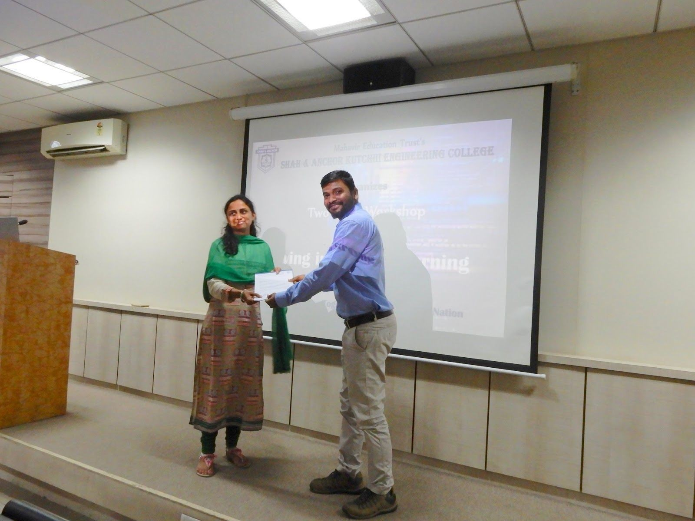
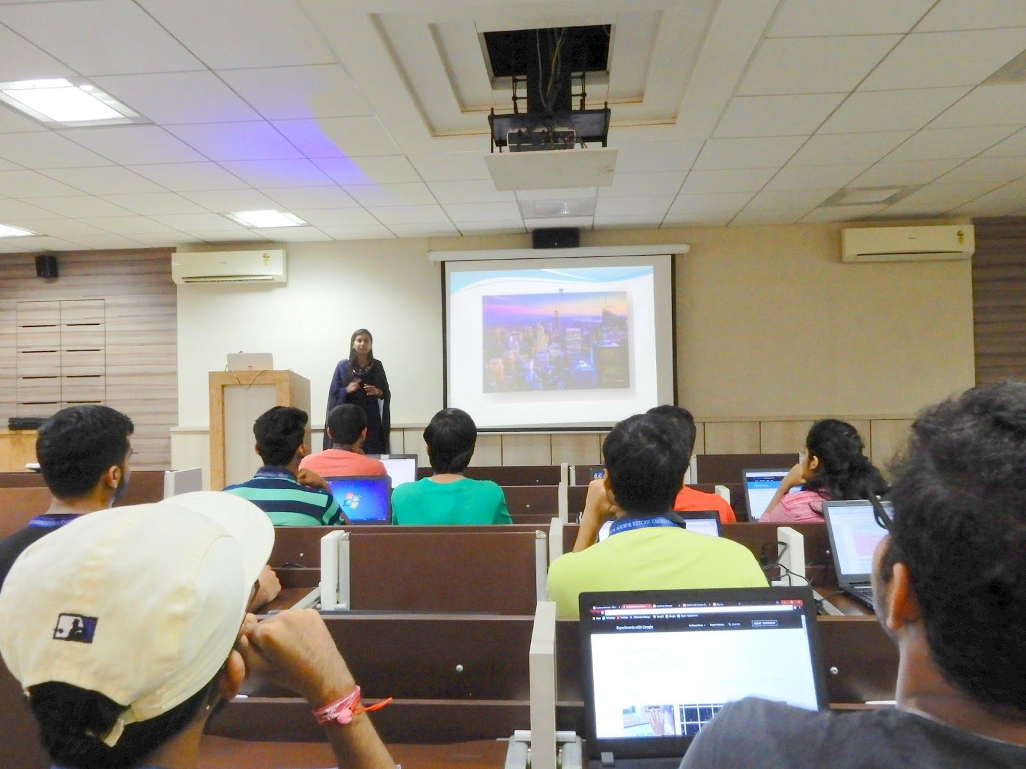

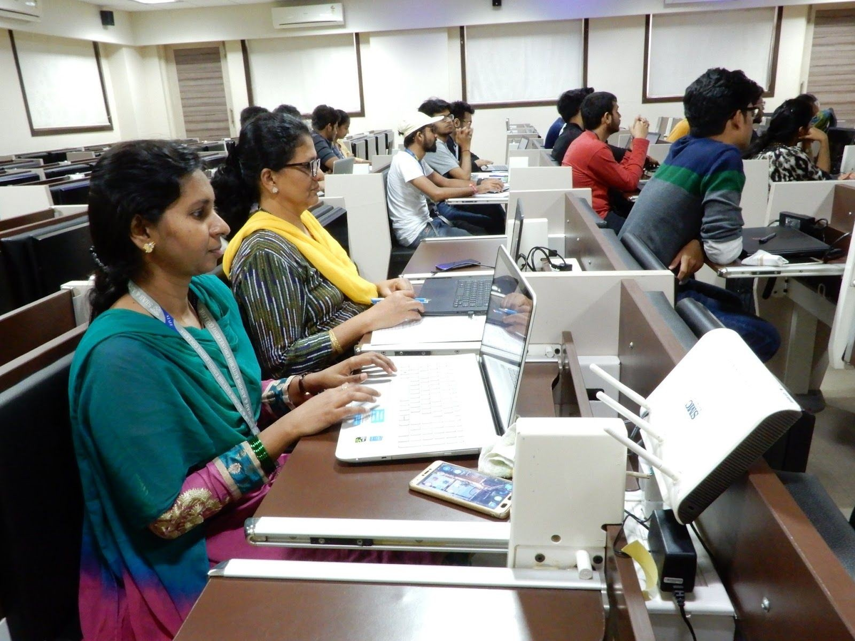

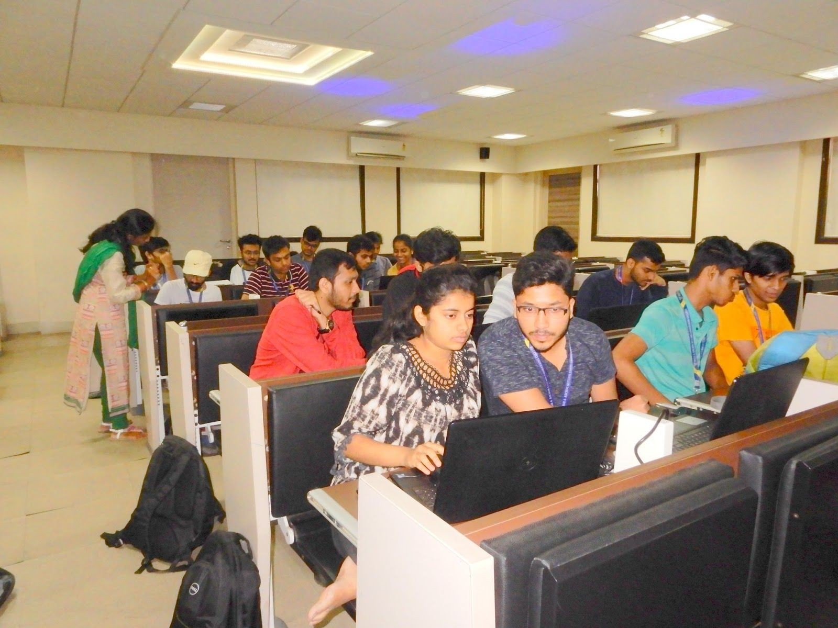

Attendees :

