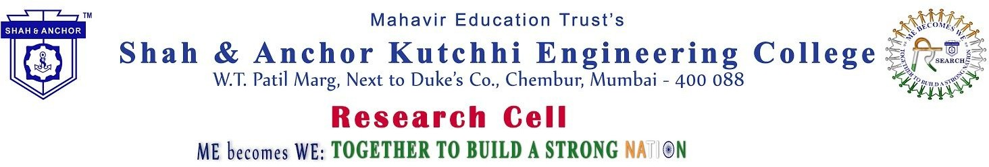

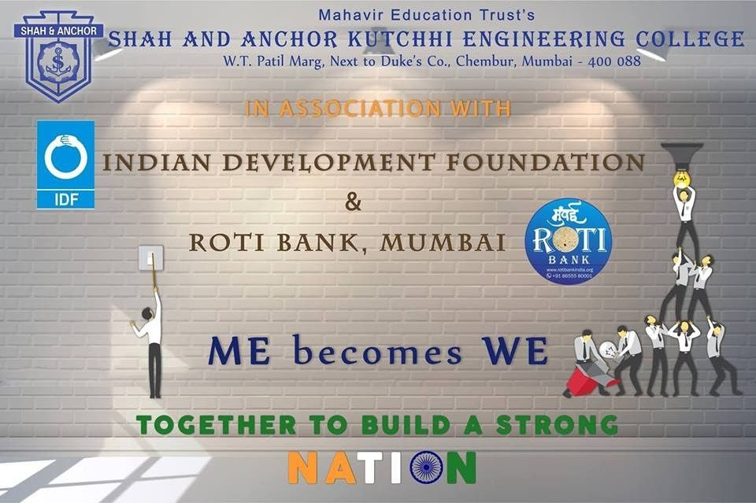

“ Me Becomes We event was organized in association with Indian Development Foundation and Roti Bank, Mumbai on 4th of August 2018 at the 7th floor Auditorium of SAKEC, Mumbai.

Pre-Event Publicity Whatsapp Message:

✨Greetings from SAKEC!
Shah and Anchor Kutchhi Engineering College, takes immense pleasure to organize the event “ME BECOMES WE: Together to Build a Strong Nation” to celebrate the collaboration of SAKEC with Indian Development Foundation (IDF) &amp;

Roti Bank Mumbai. Highlights of the event :
�� Till Date: Presentation of our on-going projects in collaboration with IDF an Roti bank.
�� Opportunities: Discussion on opportunities for students in existing new project Music keeps you going: Musical Tribute by our Student Ms. Devika Azhakesan
���� And Many more Surprises…………
����Dignitaries:

Chief Guest
Dr. Narayan B. Iyer,
CEO &amp; National Co-ordinator (IDF) Guest of Honour :
Shri D Sivanandan IPS ( Retd.)
Former Director General of Police Guest of Honour :
Mrs. Vijayaa Shanker
Music Director of Hindi Film &amp; Singer &amp; Composer Member of IDF Board of Trustees
(Singer by heart …Social Activist by Soul)

Guest Speaker:
Mr. Shashank Shetty,
Hon. Director IDF Education Projects &amp; Project Lead (Larsen &amp; Toubro Infotech) Guest Speaker:
Ms. Shriya Kumar
Strategy Advisor (Roti Bank Mumbai) &amp; Derivatives Sales and Structuring (JPMorgan Chase) Date: 4th August, 2018.
Time: 10:00 AM onwards
Venue: 7th Floor Auditorium, SAKEC No Registration Fees
Registration Link : http://www.shahandanchor.com/home/?page_id=3695 Registration is Open for All SAKEC Staff members and students.

������ Internship and Volunteering Oppurtunities for Students! Thanks and Regards
SAKEC

Shah and Anchor Kutchhi Engineering College, Research Cell organized the event “ME BECOMES WE: Together to Build a Strong Nation” to celebrate the collaboration of SAKEC with Indian Development Foundation (IDF) & Roti Bank Mumbai on 4th August 2018. The Event was graced by Dr. Narayan B. Iyer, CEO & National Co-ordinator (Mumbai) ( Indian Development Foundation ),Shri D Sivanandan IPS ( Retd.) Former Director General of Police ( Mentor and Founder of (Roti Bank Mumbai),Mr. Shashank Shetty Hon. Director ( Indian Development Foundation ) Education Projects & Project Lead (Larsen & Toubro Infotech),Ms. Shriya Kumar Strategy Advisor (Roti Bank Mumbai) & Derivatives Sales and Structuring (JPMorgan Chase),Mr. Amit Sarkar Project Manager –Social Responsibility( Indian Development Foundation ),Mr. Bhavesh Adhia Social Ambassador (Indian Development Foundation) Robotics Education
,Principal Dr Bhavesh Patel ( SAKEC),Vice Principal Dr. Vinit Kotak ( SAKEC)

The collaboration aims to blend Technology for the upliftment of the Society where the students and the faculty will be developing software and tools for IDF and Roti Bank so as to help these organizations reach out to more humanitarian causes and create awareness of the same among the people. SAKEC also feels pride in being associated with these organizations and pledges to support their endeavors. We at SAKEC also look forward to our commitment towards Social Responsibility through this collaboration.

Post Event Publicity:
https://www.facebook.com/media/set/?set=a.956650001180984.1073742037.474323859413603&typ e=1&l=74dfdc2022

No. of Participants: 205 (13 Faculties and 192 Students)

Photos:
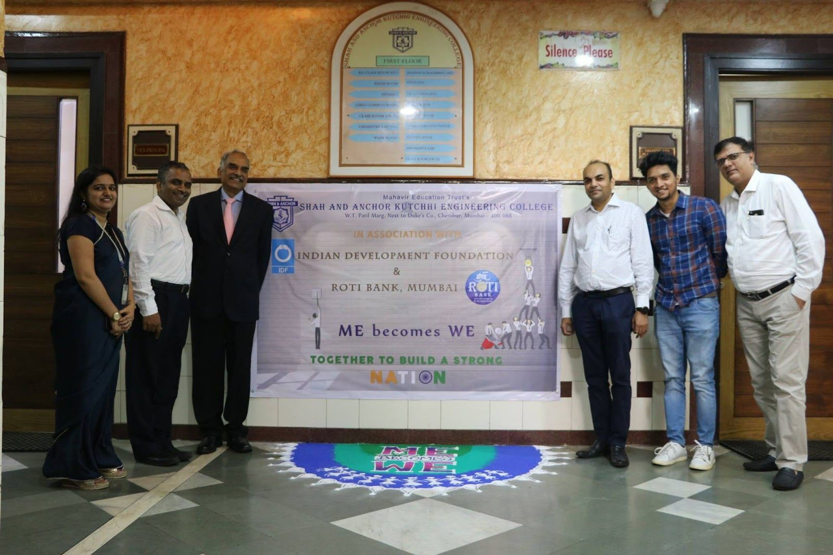

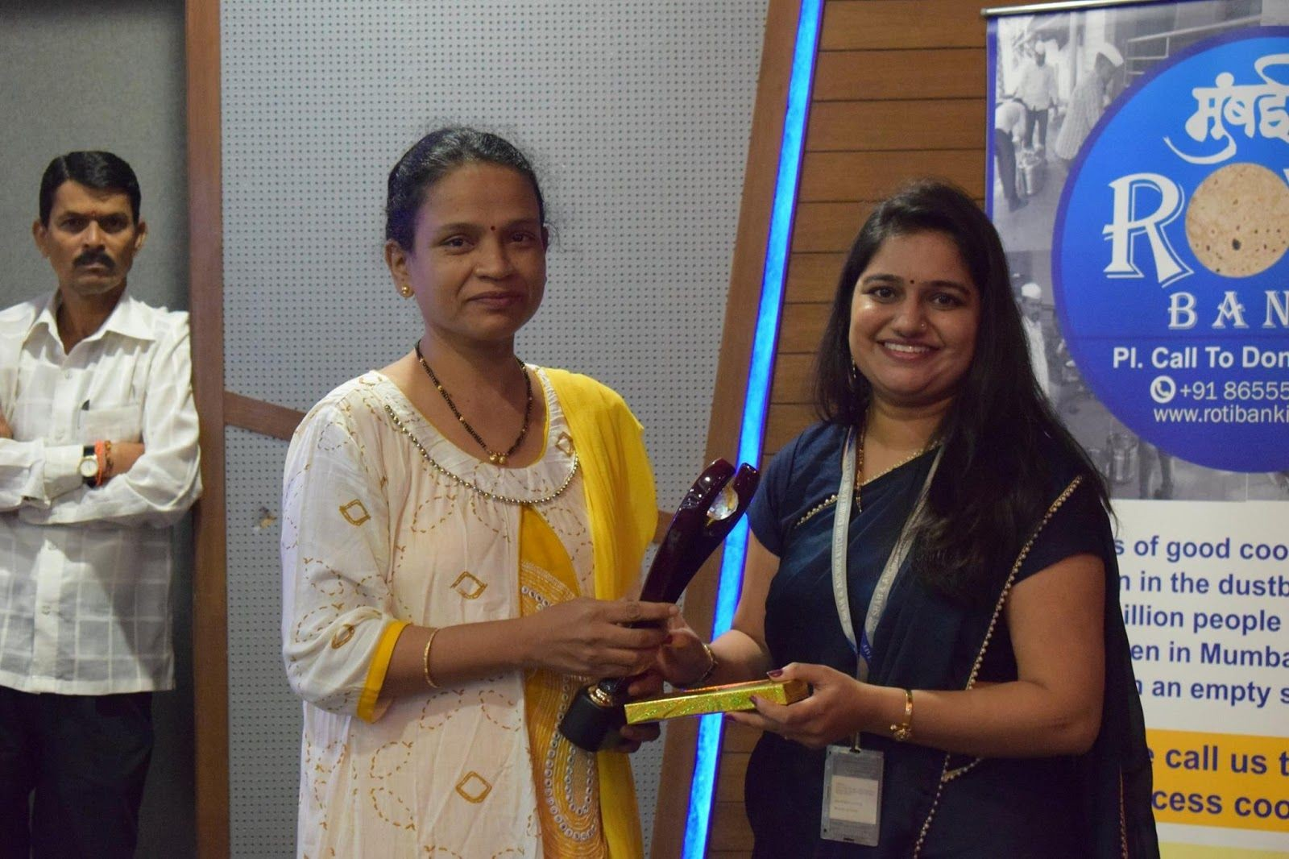

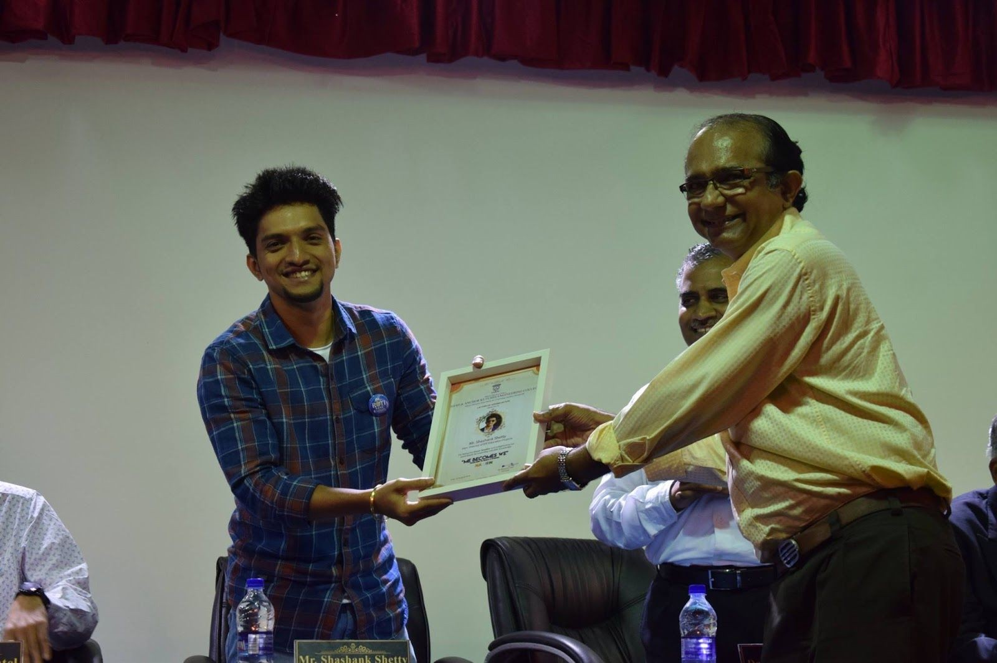
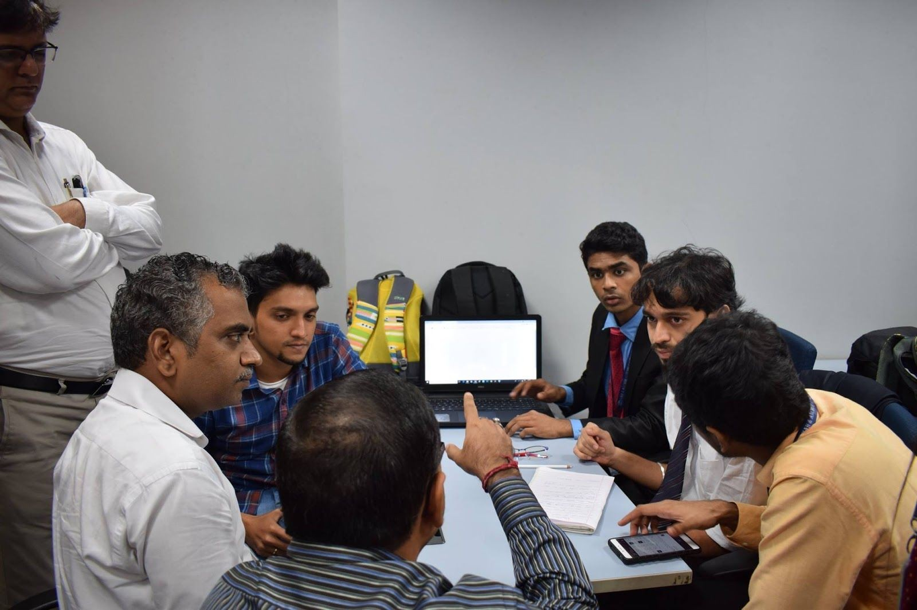

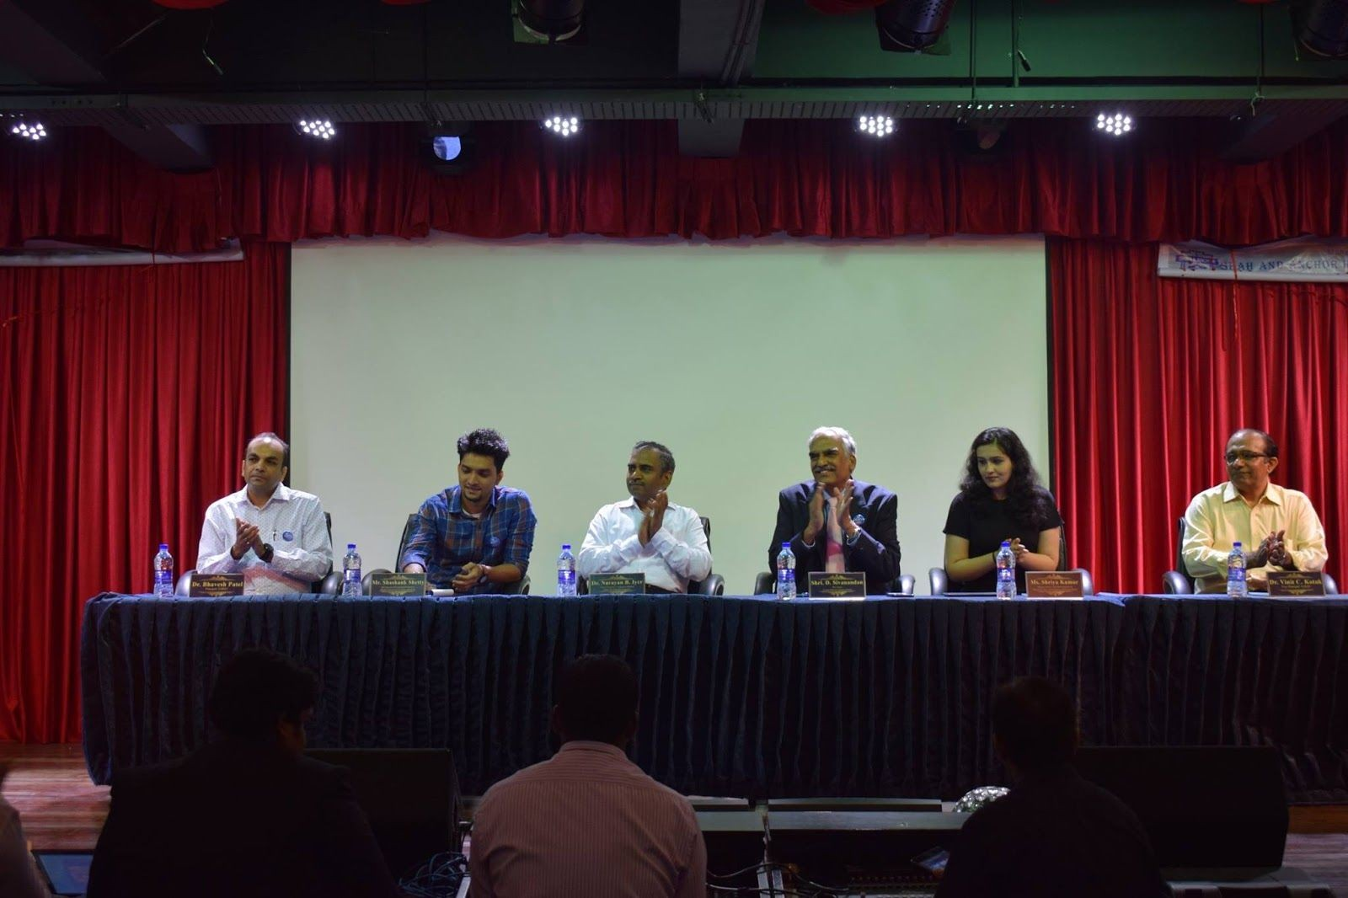

G

Attendees :

