leaders in action excel.xlsx

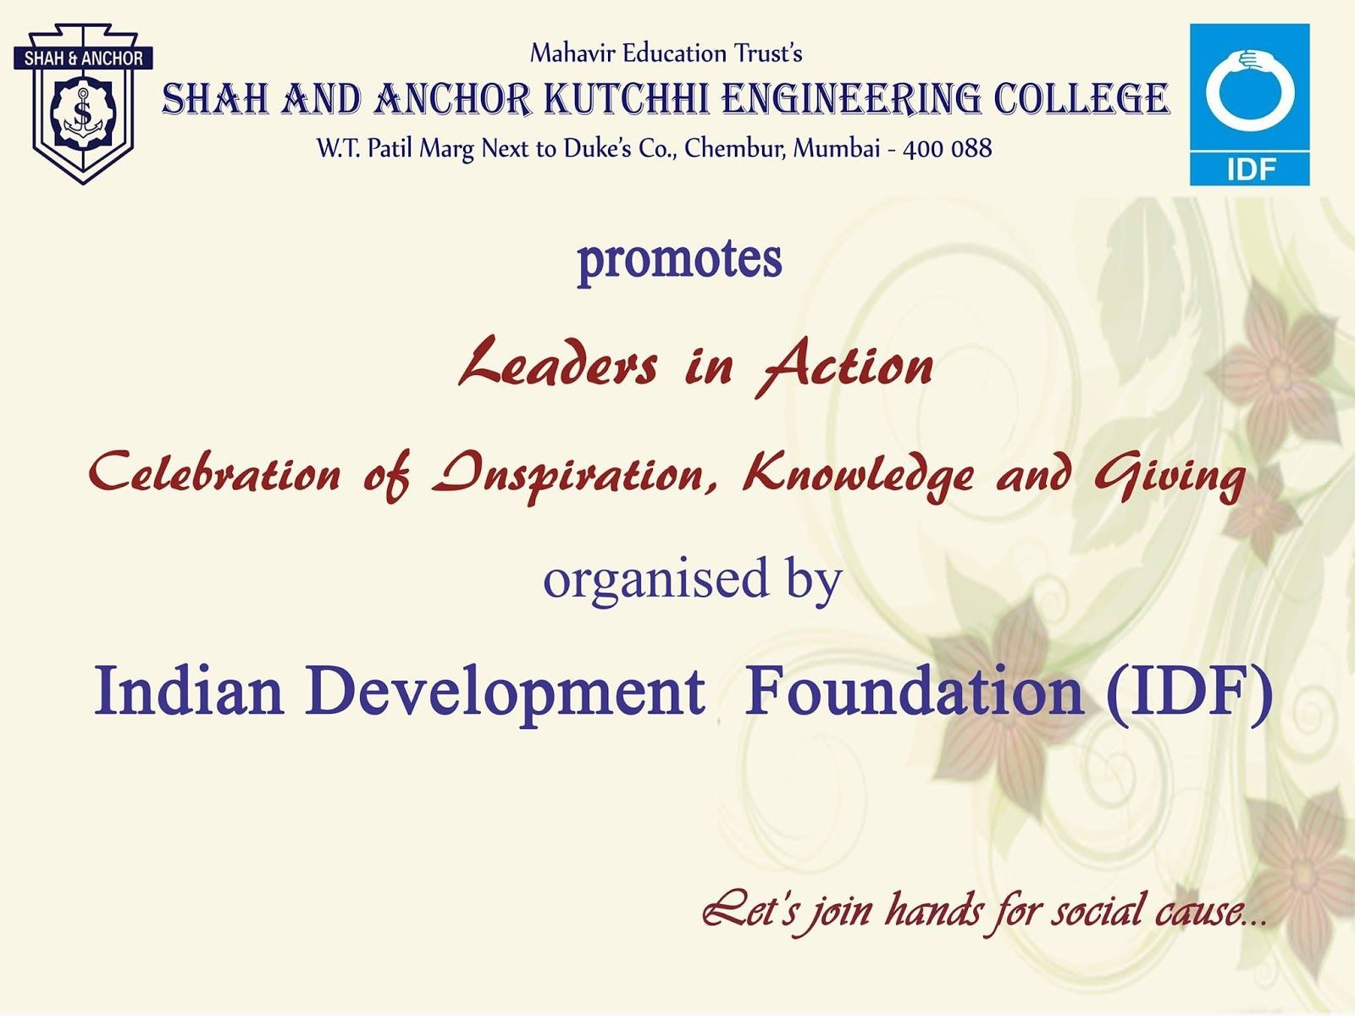

“Leaders in Action – Celebration of Inspiration, Knowledge and Giving”, event was organized to commemorate the 90th birthday celebrations of Dr. ARK Pillai, Founder of Indian Development Foundation (IDF) on Tuesday, 3rd of July 2018 at Shri Shanmukhananda Fine Arts & Sangeetha Sabha, Mumbai.

Pre-Event Publicity Whatsapp Message:

“Leaders in Action – Celebration of Inspiration, Knowledge and Giving”, event was organized to commemorate the 90th birthday celebrations of Dr. ARK Pillai, Founder of Indian Development Foundation (IDF) on Tuesday, 3rd of July 2018 at Shri Shanmukhananda Fine Arts & Sangeetha Sabha, Mumbai.
The event was Graced by many Leaders :

- Former Principal Scientific Adviser, Govt of India and Nuclear Scientist Dr. R Chidambaram
- IPS former Director General of Police Shri D Sivanandan
- Actor Mr.Johny Lever...... Many more .

Many faculties and students of SAKEC attended the event and got motivated by Leaders.

SAKEC extends warm regards and wish a very Happy Birthday to Dr. ARK Pillai and thank Dr. Narayan Iyer and IDF team for inviting SAKEC to be part of this auspicious and inspirational event.

Post Event Publicity:
https://www.facebook.com/media/set/?set=a.924265897752728.1073742017.474323
859413603&type=1&l=78d6739d52

No. of Participants: 102 ( 12 Faculties and 90 Students)

Photos:
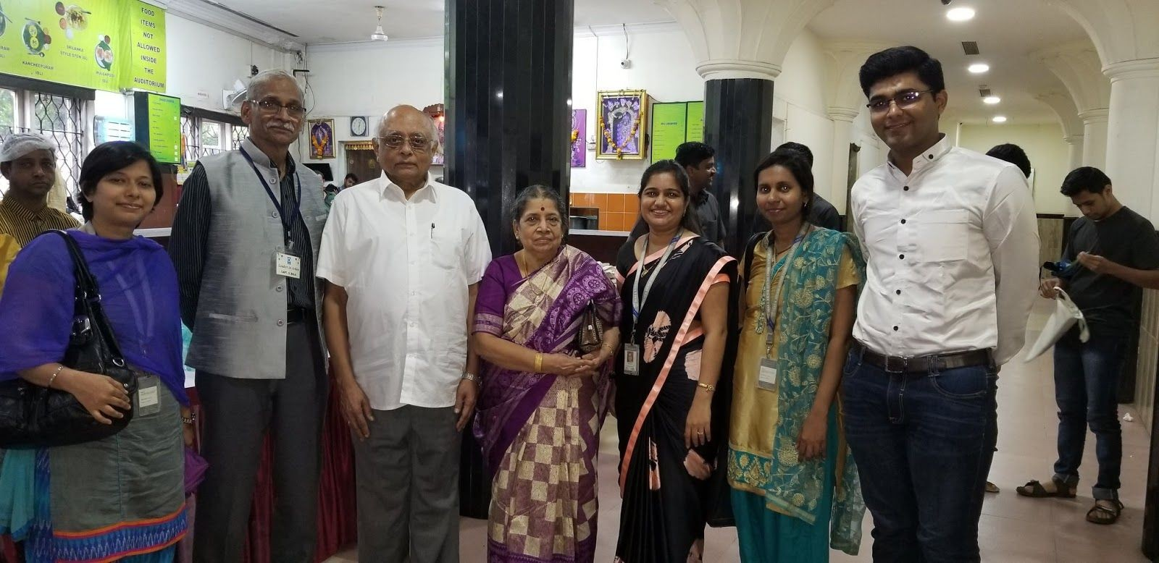

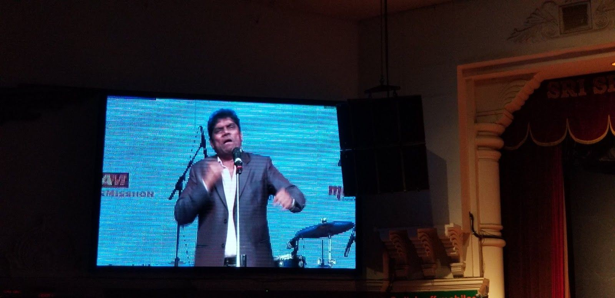

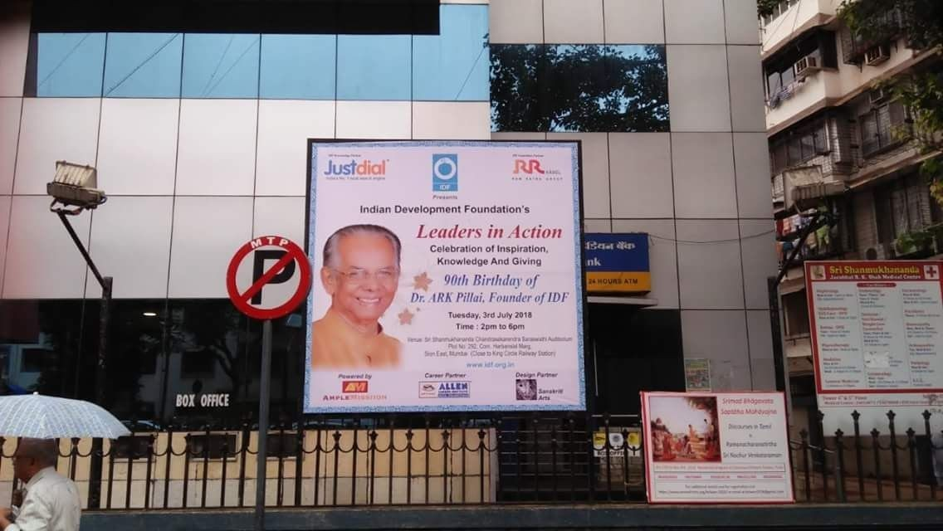
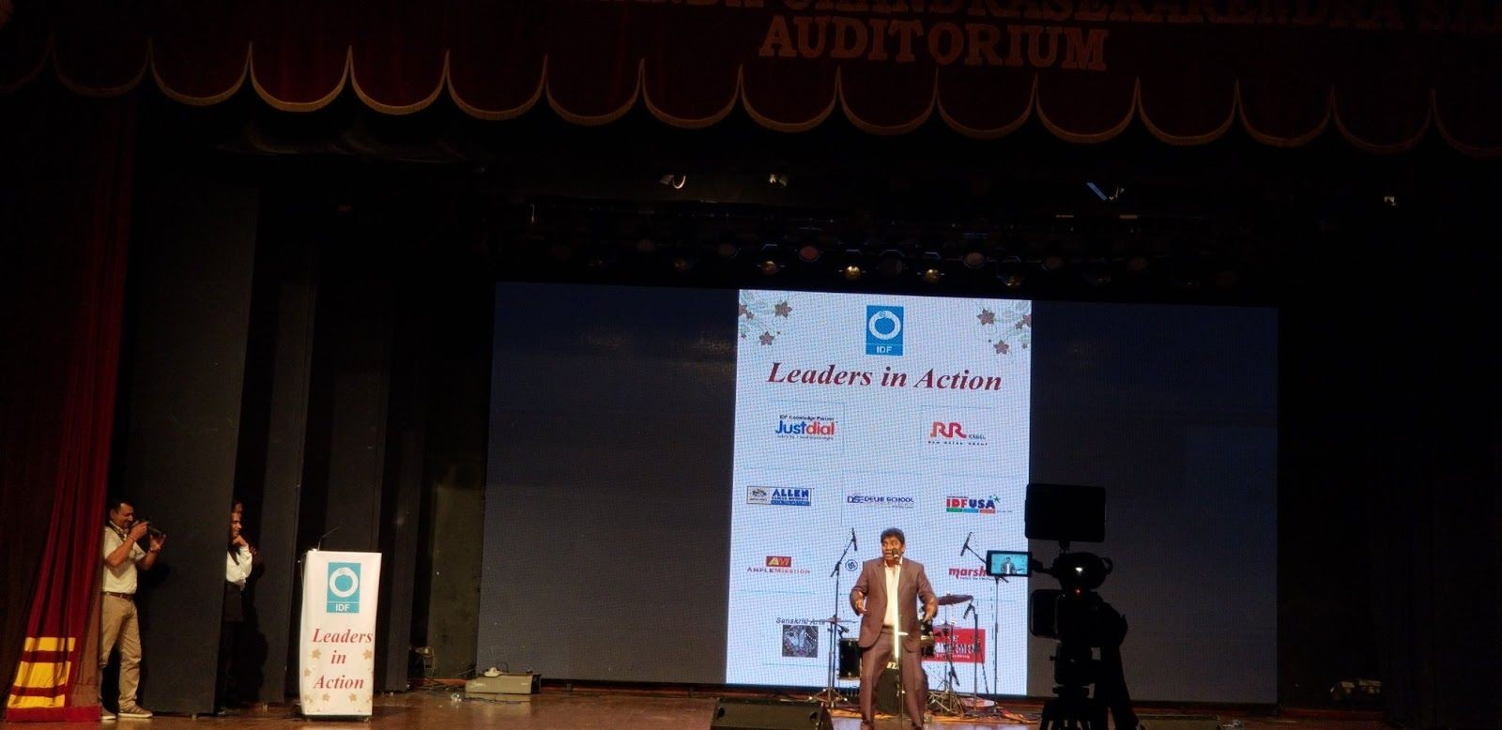

List of Attendees :

