Sample Questions
Computer Engineering

Subject Name: Quantitative Analysis Semester: VI

Multiple Choice Questions
Q:Multiple linear regression (MLR) is a __________ type of statistical analysis.

Options
- Univariate
- Bivariate
- Multivariate

- Trivariate

Q:A linear regression (LR) analysis produces the equation Y = 0.4X + 3. This indicates that:
Options
When Y = 0.4, X = 3
When Y = 0, X = 3
When X = 3, Y = 0.4
When X = 0, Y = 3

Q:A LR analysis produces the equation Y = -3.2X + 7. This indicates that:
Options
- A 1 unit increase in X results in a 3.2 unit decrease in Y.
- A 1 unit decrease in X results in a 3.2 unit decrease in Y.
- A 1 unit increase in X results in a 3.2 unit increase in Y.
- An X value of 0 would would increase Y by 7

When writing regression formulae, which of the following refers to the predicted value on the dependent variable (DV)?
a)Y
b)Y (hat)
c)X
d)X (hat)

In MLR, the square of the multiple correlation coefficient or R2 is called the
a)Coefficient of determination
b)Variance
c) Covariance
d)Cross-product

Which of the following is true about the adjusted R2?
It is usually larger than the R²
It is only used when there is just one predictor
It is usually smaller than the R²
It is used to determine whether residuals are normally distributed

Least square method calculates the best-fitting line for the observed data by minimizing the sum of the squares of the _______ deviations.
- Vertical
- Horizontal
- Both of these
- None of these

A residual is defined as
- The difference between the actual Y values and the mean of Y.
- The difference between the actual Y values and the predicted Y values.
- The predicted value of Y for the average X value.
- The square root of the slope.

The correct relationship between SST, SSR, and SSE is given by;
- SSR = SST + SSE
- SST = SSR + SSE
- SSE = SSR – SST
- d) all of the above

Below you are given a summary of the output from a simple linear regression analysis from a sample of size 15, SSR=100, SST = 152. The coefficient of determination is;
- 0.5200
- 0.6579
- 0.8111
- 1.52

Significance for the coefficients (b) is determined by
a)an F-test.
b)an R² test.
c)a correlation coefficient.
d)a t-test.

Q:A researcher polls people as they walk by on the street.

Options
- Systematic Random Sample
- Convenience Sampling
- Judgmental Sampling
- Quota Sampling

Q:Inspectors for a hospital chain with multiple locations randomly select some of their locations for a cleanliness check of their operating rooms.
Options
- Cluster sampling
- Stratified Sampling
- Quota Sampling
- Snowball Sampling

Q: The runs scored by a batsman in 5 ODIs are 31,97,112, 63, and 12. The standard deviation is

Options
1: 24.79
2: 23.79
3: 25.79
4: 26.79

Q: Find the mode of the call received on 7 consecutive day 11,13,13,17,19,23,25

Options
1: 11
2: 13
3: 17
4: 23

Q: Find the median of the call received on 7 consecutive days 11,13, 17, 13, 23,25,19

Options
1: 13
2: 23
3: 25
4: 17

Q: If the probability of hitting an object is 0.8, find the variance

Options
1: 0.18
2: 0.16
3: 0.14
4: 0.12

Q: E(X) = λ is used for which distribution?

Options
1: Binomial distribution
2: Poisson's distribution
3: Bernoulli's distribution
4: Laplace distribution

Q: The classification of data on geographical basis is also called as
Options
1: reflected classification
2: populated classification
3: sampling classification
4: spatial classification

Q: The summary and presentation of data in tabular form with several non-overlapping classes is referred as

Options
1: nominal distribution
2: ordinal distribution
3: chronological distribution
4: frequency distribution

Q: The largest value is 60 and smallest value is 40 and the number of classes desired is 5 then the class interval is
Options
1: 20
2: 4
3: 25
4: 15

Q: The diagram used to represent group and ungrouped data is classified as
Options
1: breadth diagram
2: width diagram
3: bar diagram
4: length diagram

Q: Histogram, pie charts and frequency polygon are all types of
Options
1: one dimensional diagram
2: two dimensional diagram
3: cumulative diagram
4: dispersion diagram

Q: Which of the following is not a type of univariate frequency distribution

Options
1: Individual observation
2: Discrete frequency distribution
3: Continuous frequency distribution
4: Random frequency distribution

Q: The method of classification of data in terms of class intervals in which both the lower limit and the upper limit of any class (class interval) are included in that class (class interval) is known as __________________ method of classification

Options
1: exclusive
2: inclusive
3: equal
4: unequal

Q: What is the arithmetic mean of 2, 8, 10, 6, 14?

Options
1: 5
2: 6
3: 7
4: 8

Q: From the following frequency distribution, find the median class:

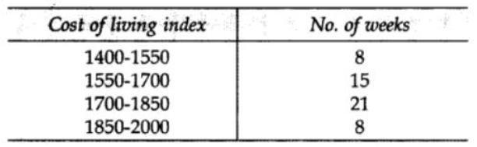
Options
1: 1400–1550
2: 1550–1700
3: 1700–1850
4: 1850–2000

Q: We need _____ dimension(s) to table or plot a univariate (1-variable) frequency distribution

Options
1: one
2: two
3: three
4: four

Q: Quota sampling is similar to ____________ sampling.

Options
1: purposive
2: convenience
3: stratified
4: cluster

Q: The number of possible samples of size 2 out of 5 population size in simple random sampling with replacement (SRSWR) is equal to

Options
1: 10
2: 15
3: 20
4: 25

Q: Which of the following method of sampling is not a part of ‘restricted random sampling’?

Options
1: Lottery method
2: Stratified method
3: Systematic method
4: Cluster method

Q: Consider simple random sampling without replacement (SRSWOR) from a population of size N. The number of samples of size n is

Options
1: ^{N}P_{n}
2: ^{N}C_{n}
3: N^{n}
4: N

Q: Population census conducted by the government of India after every 10 years is an example of __________ data.

Options
1: Primary data
2: Secondary data
3: Structured data
4: Unstructured data

Q: If b_{yx} = 0.5 and b_{xy} = 0.46, then the value of coefficient of correlation (r) is

Options
1: 0.39
2: 0.48
3: 0.23
4: 0.25

Q: From the given table, the MAE value is

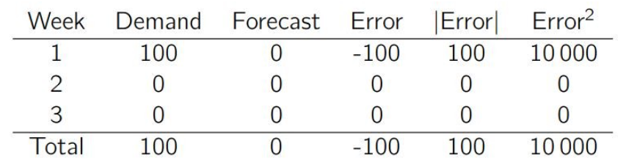
Options
1: 100
2: 333.33
3: 133.33
4: 33.33

Descriptive Questions
In a simple study about coffee habits in two towns A and B the following information is given
Town A: Females were 40%, total coffee drinkers were 45% and female non coffee drinkers were 20%.
Town B: males were 55%, male non coffee drinkers were 30% and female coffee drinkers were 15%
Present the data into a table format

What is diagrammatic representation of data explain advantages of it.
The data with regard to the output of gram and cost of seed and labour per hectare at ten farmers’ fields, are as given below

Sr No | Cost of produce (Y)  (RS/ha) | Cost of Seed (X1)  (RS/ha) | Cost of Labour (Y)  (RS/ha)
1 | 1127 | 235 | 128
2 | 840 | 236 | 82
3 | 735 | 238 | 205
4 | 570 | 241 | 71
5 | 462 | 238 | 110
6 | 614 | 233 | 130
7 | 916 | 235 | 200
8 | 460 | 190 | 170
9 | 1540 | 235 | 180
10 | 1065 | 243 | 165
- Fit the regression equation Y^=b₀+b₁X₁+b₂X₂
- Estimate the cost of produce per hectare given that X₁=230 and X₂=125
- Test the significance of partial regression coefficients
- Find the partial correlation coefficient r_{YX2X1}

What do you mean by a questionnaire? What is the difference between a questionnaire and a schedule? State the essential points to be remembered in drafting a questionnaire.
What are the different methods of collection of data? Why are personal interviews usually preferred to questionnaire? Under what conditions may a questionnaire prove as satisfactory as a personal interview?
Perform simple linear regression
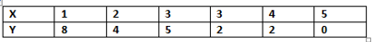
Determine slope and intercept
Exercise on find correlation of the following data
x | 9 | 8 | 7 | 6 | 5 | 4 | 3 | 2 | 1
y | 15 | 16 | 14 | 13 | 11 | 12 | 10 | 8 | 9

Relationship of R² and Adjusted R² with additional of one independent variable
Using t-test check significance of independent variable.
What is the effect of R2 and Adjusted R2 for addition of new variable in multiple linear regression.
Obtain Partial correlation coefficients for following data
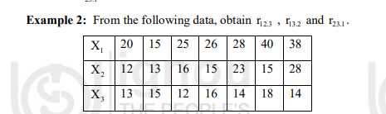
- Explain in details primary and secondary data.

How will you decide about the relative importance of various independent variables?
What is non-probability sampling and explain types of non-probability samplings.

From 10 observations on Price (x) and Supply (y) of a commodity, the following
summary of figures were obtained.

∑ x = 130 , ∑y = 220, ∑x² = 2288, ∑xy = 3467

Compute the line of regression of y on x and interpret the result. Estimate the
supply when price is 16 units.

Let X_{1,}X_{2,…….}X_{n} be a random . sample show that the sample mean
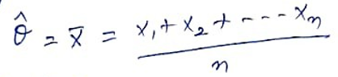 is an unbiased estimator of 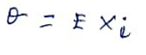
Obtain Partial correlation coefficients for following data
Frequency Distribution, Types of Univariate Frequency Distribution, Cumulative Frequency Distribution, Bivariate/Two-way classification of data, Cumulative frequency curve or ogive (i.e., more than ogive and less than ogive)
Methods to Check the Performance of Regression Models: MAE, MSE, R², MAPE (Moving Averages)
Sums on Point Estimate of the Population mean, Population Std Deviation, and Std. Error of the Estimate mean
Hypothesis Testing:
- Z test for Single Mean
- Z test for Difference of Mean
Explain 1.Test of significance 2.Level of significance 3.Simple hypothesis
4.Composite Hypothesis
The manufacturer of a certain make of electric bulbs claims that his bulbs have a mean life of 25 months with standard deviation of 5 months. A random sample of 6 such bulbs gave the following values
Life of bulb in months 24,26,30,20,20,18
Is the manufacturer’s claim valid at 1% level of significance?(Given that the table values of the appropriate test statistics at said level are 4.032,3.707 and 3.499 for 5, 6 and 7 degree of freedom respectively)
Explain in details MP and UMP-Test
Define MAPE, MAE, RMSE with formula and example

