Sample Questions
Computer Engineering

Subject Name: Artificial Intelligence (CSC604) Semester: VI

Multiple Choice Questions
 | Choose the correct option for following questions. All the Questions carry equal marks
1. | What is the goal of Artificial Intelligence?
Option A: | To solve artificial problems
Option B: | To extract scientific causes
Option C: | To explain various sorts of intelligence
Option D: | To solve real-world problems
2. | Which of the following is a component of Artificial Intelligence?
Option A: | Learning
Option B: | Designing
Option C: | Puzzling
Option D: | Training
3. | What is the function of an Artificial Intelligence “Agent”?
Option A: | Mapping of precept sequence to an action
Option B: | Work without the direct interference of the people
Option C: | Mapping of environment sequence to an action
Option D: | Mapping of goal sequence to an action
4. | What is the action of task environment in artificial intelligence?
Option A: | Problem
Option B: | Solution
Option C: | Agent
Option D: | Observation
5. | Which of the following is not the commonly used programming language for Artificial Intelligence?
Option A: | Perl
Option B: | Java
Option C: | PROLOG
Option D: | LISP
6. | Which of the following machine requires input from the humans but can interpret the outputs themselves?
Option A: | Actuators
Option B: | Sensor
Option C: | Agents
Option D: | AI system
7. | Which search comes under Local search ?
Option A: | A* search
Option B: | BFS
Option C: | Hill Climbing Search
Option D: | DFS
8. | Memory space requirement in hill climbing algorithm is _____
Option A: | Less
Option B: | More
Option C: | very high
Option D: | Zero
9. | Which search strategy is also called as blind search?
Option A: | Simple reflex search
Option B: | Uninformed search
Option C: | Informed search
Option D: | Adversarial search
10. | The time and space complexity of BFS is (For time and space complexity problems consider b as branching factor and d as depth of the search tree.)
Option A: | O(bd+1) and O(bd+1)
Option B: | O(b2) and O(d2)
Option C: | O(d2) and O(b2)
Option D: | O(d2) and O(d2)
11. | What are the two main features of Genetic Algorithm?
Option A: | Crossover techniques & Random mutation
Option B: | Fitness function & Crossover techniques
Option C: | Individuals among the population & Random mutation
Option D: | Random mutation & Fitness function
12. | What is state space?
Option A: | The whole problem
Option B: | Your Definition to a problem
Option C: | Problem you design
Option D: | Representing your problem with variable and parameter
13. | ______ are the curves in the search space that leads to sequence of local maxima
Option A: | Plateau
Option B: | Ridges
Option C: | Peak
Option D: | Mount
14. | Which is a best way to go for Game playing problem
Option A: | Linear approach
Option B: | Heuristic approach
Option C: | Random approach
Option D: | Optimal Approach
15. | Where does the values of alpha-beta search get updated?
Option A: | Along the path of search
Option B: | Initial state itself
Option C: | At the end
Option D: | None of the mentioned
16. | Which function is used to calculate the feasibility of whole game tree?
Option A: | Evaluation function
Option B: | Transposition
Option C: | Alpha-beta pruning
Option D: | All of the mentioned
17. | In propositional logic, propositional symbols are denoted with _________.
Option A: | capital letters
Option B: | numbers
Option C: | double letters
Option D: | double digits
18. | FOL is a
Option A: | lower level logic
Option B: | foundation level logic
Option C: | post order logic
Option D: | higher level logic
19. | Which are more suitable normal form to be used with definite clause?
Option A: | Positive literal
Option B: | Negative literal
Option C: | Generalized modus ponens
Option D: | Neutral literal
20. | Which is mainly used for automated reasoning?
Option A: | Backward chaining
Option B: | Forward chaining
Option C: | Logic programming
Option D: | Parallel programming
21. | Antecedent to consequent is the flow of __________
Option A: | Backward Chaining
Option B: | Forward Chaining
Option C: | First Chaining
Option D: | Last Chaining
22. | Which of the mentioned point correctly defines a quantifier in AI?
Option A: | Quantifiers are numbers ranging from 0-9.
Option B: | Quantifiers are the quantity defining terms which are used with the predicates.
Option C: | Quantifiers quantize the term between 0 and 1.
Option D: | Quantifiers quantize the term between 10 and 100.
23. | Knowledge and reasoning also play a crucial role in dealing with __________________ environment.
Option A: | Completely Observable
Option B: | Partially Observable
Option C: | Neither Completely nor Partially Observable
Option D: | Only Completely and Partially Observable
24. | Which of the following is not the style of inference?
Option A: | Forward Chaining
Option B: | Backward Chaining
Option C: | Resolution Refutation
Option D: | Modus Ponen
25. | What is the form of Fuzzy logic?
Option A: | Two-valued logic
Option B: | Crisp set logic
Option C: | Many-valued logic
Option D: | Binary set logic
26. | Which of the following is an advantage of using an expert system development tool?
Option A: | imposed structure
Option B: | knowledge engineering assistance
Option C: | rapid prototyping
Option D: | all of the mentioned
27. | What is Decision Tree?
Option A: | Flow-Chart
Option B: | Structure in which internal node represents test on an attribute, each branch represents outcome of test and each leaf node represents class label
Option C: | Flow-Chart & Structure in which internal node represents test on an attribute, each branch represents outcome of test and each leaf node represents class label
Option D: | None of the mentioned
28. | Which values are independant in minimax search algorithm?
Option A: | Pruned leaves x and y
Option B: | Every states are dependant
Option C: | Root is independant
Option D: | None of the mentioned
29. | Which of the following includes major tasks of NLP?
Option A: | Automatic Summarization
Option B: | Discourse Analysis
Option C: | Machine Translation
Option D: | All of the mentioned
30. | What is the main challenge/s of NLP?
Option A: | Handling Ambiguity of Sentences
Option B: | Handling Tokenization
Option C: | Handling POS-Tagging
Option D: | All of the mentioned

Descriptive Questions
10 marks each
Explain steps in problem formulation with example.
Draw and Describe the Architecture of Utility based agent. How is it different from Model based agent?
Compare different uninformed search strategies.
Explain DFS algorithm with example.
Define the terms chromosome, fitness function, crossover and mutation as used in Genetic algorithms. Explain how Genetic algorithms work.
Explain BFS algorithm with example.
Explain the steps involved in converting the propositional logic statement into CNF with suitable example.
Consider the search problem below with start state S and goal state E. The transaction cost and heuristic values are given. What is the final cost using A* algorithm to reach from the start State to goal state? (Heuristic values S=10, A=5, B=6, Y=8, Z=5, C=4, D=15, E=0
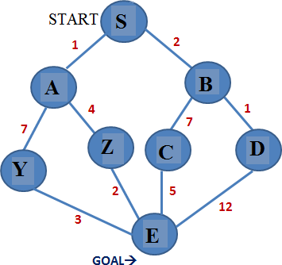
Figure depicts a search space in which the nodes are labelled with names like A,B, C and D. Node S is the start node and G is the goal node
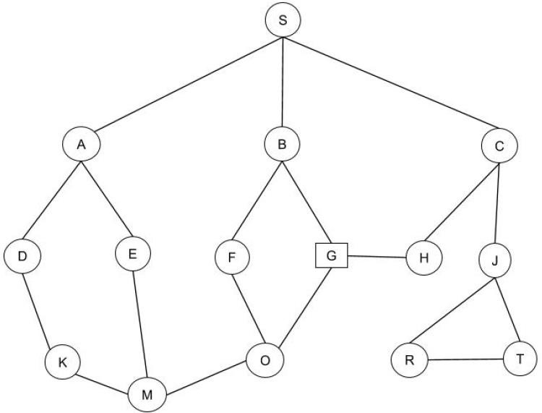
- List the order in which the Depth First Search algorithm inspect the nodes in Figure whenever there is a contention between more than one node the algorithm chooses one on left
- What is the path found by the algorithm in the previous question?
- List the order in which the Bredth First Search algorithm inspect the nodes in figure
- What is the path found by the algorithm in previous question?
List the order in which DFID algorithm inspect the nodes in figure
What are steps involved in natural language processing (NLP) of an English sentence? Explain with an example sentence.
Examine Architecture of Expert Systems with its applications
Describe backward chaining with example.
Design planning agent to solve block world problem. Assume suitable initial state and final state for the problem.
Discuss partial order planning giving suitable example.
Explain decision tree learning with an example. What are decision rules? How to use it for classifying new sample.

5 marks each
Define Intelligent Agent. What are the characteristics of Intelligent Agent?
What is an agent? Explain basic building blocks of learning agent?
Describe different types of environments application to AI System.
Formulate 8-puzzle problem
Explain detail architecture of goal based agent.
Explain heuristic function with example.
Explain various method of knowledge representation techniques.
Differentiate between forward and backward chaining.
Write short note on Hill Climbing algorithms.
Draw game tree of tic-tac-toe problem
What is Min-Max search?
Write short note on admissibility of A*.
Give PEAS properties of WUMPUS world.
Write first order logic statements for the following
- If a perfect square is divisible by a prime p then it is also divisible by square of p.
- Every perfect square is divisible by some prime
- Alice does not like Chemistry and History
- If it is Saturday and warm, then Sam is in the park
Anything anyone eats and is not killed is a food
Convert the following propositional logic statement into CNF “If it is humid then it will rain, since it is humid it will rain”
Define Belief Network. Explain conditional Independence relation in Belief Network with example.
Short note on predicate logic.
What is planning in AI?
Define partial order planner.
Describe unsupervised learning with example.
Write short note on natural language processing

