Sample Questions
Computer Engineering / Artificial Intelligence and Data Science / Artificial Intelligence and Machine Learning / Computer Science and Engineering (Artificial Intelligence and Machine Learning) / Computer Science and Engineering (Data Science) / Computer Science and Engineering (Internet of Things and Cyber Security Including Block Chain Technology) / Cyber Security / Data Engineering / Internet of Things (IoT)

Subject Name: Engineering Mathematics IV Semester: IV

Multiple Choice Questions
 | Choose the correct option for following questions. All the Questions are compulsory and carry equal marks
1. | The region of rejection of the null hypothesis H0 is known as
Option A: | Critical region
Option B: | Favourable region
Option C: | Domain
Option D: | Confidence region
2. | Sample of two types of electric bulbs were tested for length of life and the following data were obtained  The absolute value of test statistic in testing the significance of difference between means is
   | Size | Mean | SD
  Sample 1 | 8 | 1234 h | 36 h
  Sample 2 | 7 | 1036 h | 40 h
Option A: | t=10.77
Option B: | t=9.39
Option C: | t=8.5
Option D: | t=6.95
3. | If X is a poisson variate such that PX=1=PX=2, then P(X=3) is
Option A: | 4e23
Option B: | 4e2
Option C: | 43e2
Option D: | 4e2
4. | If A=1 0 0 0 0 2 0 0 3 , Then following is not the eigenvalue ofadj A.
Option A: | 6
Option B: | 2
Option C: | 4
Option D: | 3
5. | For the matrix2 -1 1 1 1 2 -1 -1 2 the eigenvector corresponding to the distinct eigenvalue λ=2 is
Option A: | 1 1 1
Option B: | -1 1 1
Option C: | 2 1 1
Option D: | 1 2 1
6. | The necessary and sufficient condition for a square matrix to be diagonalizable is that for each of it’s eigenvalue
Option A: | algebraic multiplicity > geometric multiplicity
Option B: | algebraic multiplicity = geometric multiplicity
Option C: | algebraic multiplicity < geometric multiplicity
Option D: | algebraic multiplicity geometric multiplicity
7. | If the characteristic equation of a matrix A of order 3×3 is 3-72+11λ-5=0, then by the Cayley-Hamilton theorem A-1 is equal to
Option A: | 15(A3-7A2+11A)
Option B: | 15(A2+7A+11I)
Option C: | 15(A3+7A2+11A)
Option D: | 15(A2-7A+11I)
8. | Value of an integral 01+ix2-iydz along the path y=x2 is
Option A: | 56-i6
Option B: | -56-i6
Option C: | 56+i6
Option D: | -56+i6
9. | Integral 5z2+7z+1z+1 dz along a circle z=12is equal to
Option A: | 1
Option B: | -1
Option C: | 3/2
Option D: | 0
10. | Analytic function gets expanded as a Laurent series if the region of convergence is
Option A: | rectangular
Option B: | triangular
Option C: | circular
Option D: | annular
11. | Residue of fz=z2z+12(z-2) at a pole z=2 is
Option A: | 4/9
Option B: | 2/9
Option C: | 1/2
Option D: | 0
12. | z-transform of an unit impulse function k=1 , at k=0 0 , otherwise is
Option A: | 1
Option B: | 0
Option C: | -1
Option D: | k
13. | zsin (3k+5) , k≥0 is
Option A: | z2sin 2-zsin 5 z2-2zcos 3+1
Option B: | z2sin 5+zsin 2 z2-2zcos 3+1
Option C: | z2sin 5-zsin 2 z2-2zcos 3+1
Option D: | z2sin 2+zsin 5 z2-2zcos 3+1
14. | The inverse z-transform of fz=zz-1z-2 ,z>2 is
Option A: | 2k-2
Option B: | 2k-1
Option C: | 2k+1
Option D: | 2k+2
15. | If the basic solution of LPP is x=1, y=0 then the solution is
Option A: | Feasible and non-Degenerate
Option B: | Non-Feasible and Degenerate
Option C: | Feasible and Degenerate
Option D: | Non-Feasible and non-Degenerate
16. | If the primal LPP has an unbounded solution then the dual has
Option A: | Unbounded solution
Option B: | Bounded solution
Option C: | Feasible solution
Option D: | Infeasible solution
17. | Dual of the following LPP is  Maximize z=2x1+9x2+11x3  Subject to x1-x2+x3≥3 -3x1+2x3≤1 2x1+x2-5x3=1  x1,x2,x3≥0
Option A: | Minimize w=-3y1+y2+y'  Subject to -y1-3y2+2y'≥2 y1+y'≥9 -y1+2y2-5y'≥11  y1,y2≥0, y’ unrestricted
Option B: | Minimize w=-3y1+y2+y3  Subject to -y1-3y2+2y3≥2 y1+y3≥9 -y1+2y2-5y3≥11  y1,y2,y3≥0
Option C: | Minimize w=2y1+9y2+11y'  Subject to -y1-3y2+2y'≥3 y1+y'≥1 -y1+2y2-5y'≥1  y1,y2≥0, y’ unrestricted
Option D: | Minimize w=2y1+9y2+11y3  Subject to -y1-3y2+2y3≥3 y1+y3≥1 -y1+2y2-5y3≥1  y1,y2≥0, y’ unrestricted
18. | Consider the NLPP:  Maximize z=f(x1,x2), subject to the constraint h=gx1,x2-b≤0.  Let L=f-λg, then the Kuhn-Tucker conditions are
Option A: | ∂Lx1≥0, ∂Lx2≥0, λh≥0, h≥0, λ≥0
Option B: | ∂Lx1=0, ∂Lx2=0, λh=0, h≤0, λ≥0
Option C: | ∂Lx1=0, ∂Lx2=0, λh≥0, h≤0, λ≤0
Option D: | ∂Lx1≥0, ∂Lx2≥0, λh≥0, h≥0, λ=0
19. | In a non-linear programming problem,
Option A: | All the constraints should be linear
Option B: | All the constraints should be non-linear
Option C: | Either the objective function or atleast one of the constraints should be non-linear
Option D: | The objective function and all constraints should be linear.
20. | Pick the non-linear constraint
Option A: | xy+y≥7
Option B: | 2x-y≤5
Option C: | x+y≤6
Option D: | x+2y=9
21. | The Eigen values of adjA where 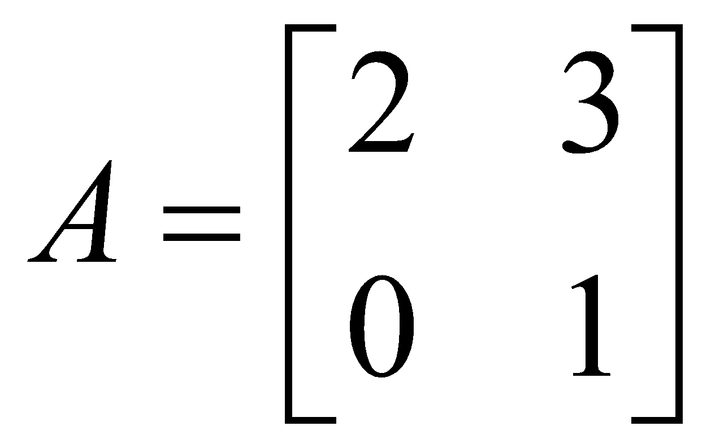
Option A: | 1, 1
Option B: | 1, 2
Option C: | 3, 4
Option D: | 2, 5
22. | If the algebraic multiplicity ‘t’ of  is equal to the geometric multiplicity ‘s’, then the matrix is
Option A: | Orthogonal
Option B: | Symmetric
Option C: | Diagonalizable
Option D: | None of these
23. | The product of eigen values for 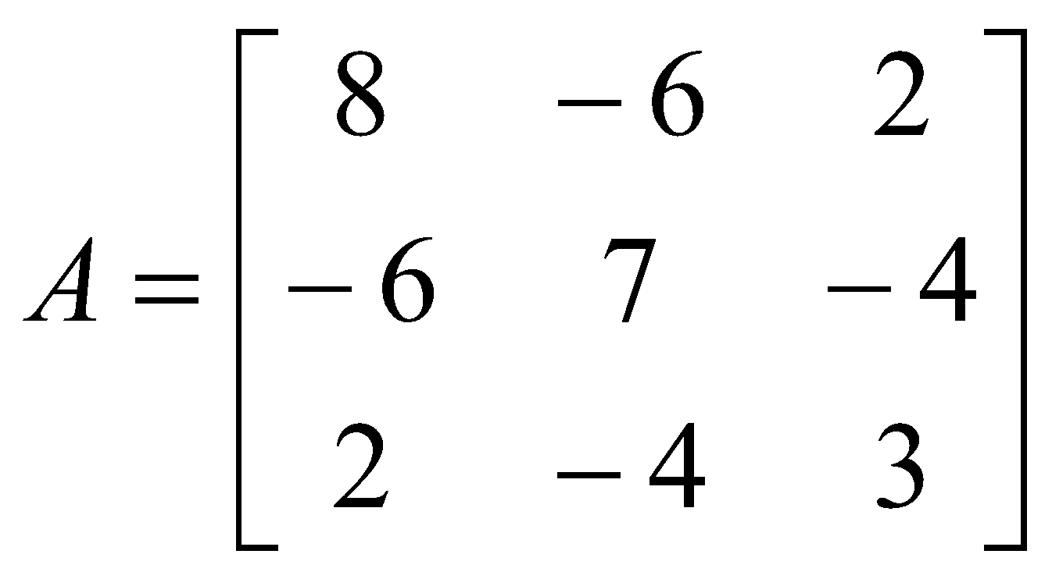 is
Option A: | 4
Option B: | 0
Option C: | 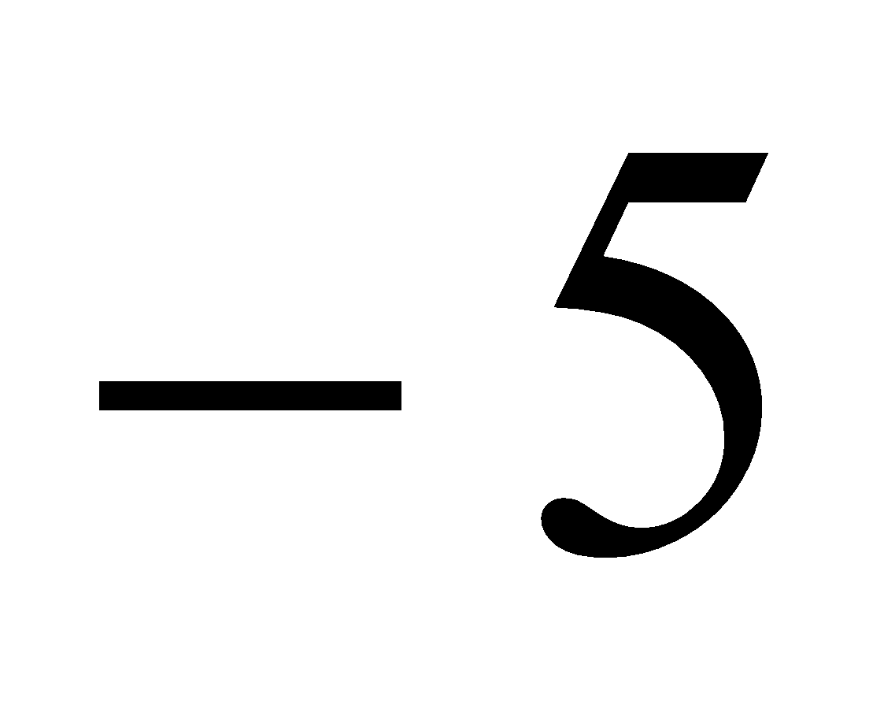
Option D: | 3
24. | Two of the eigen values of a 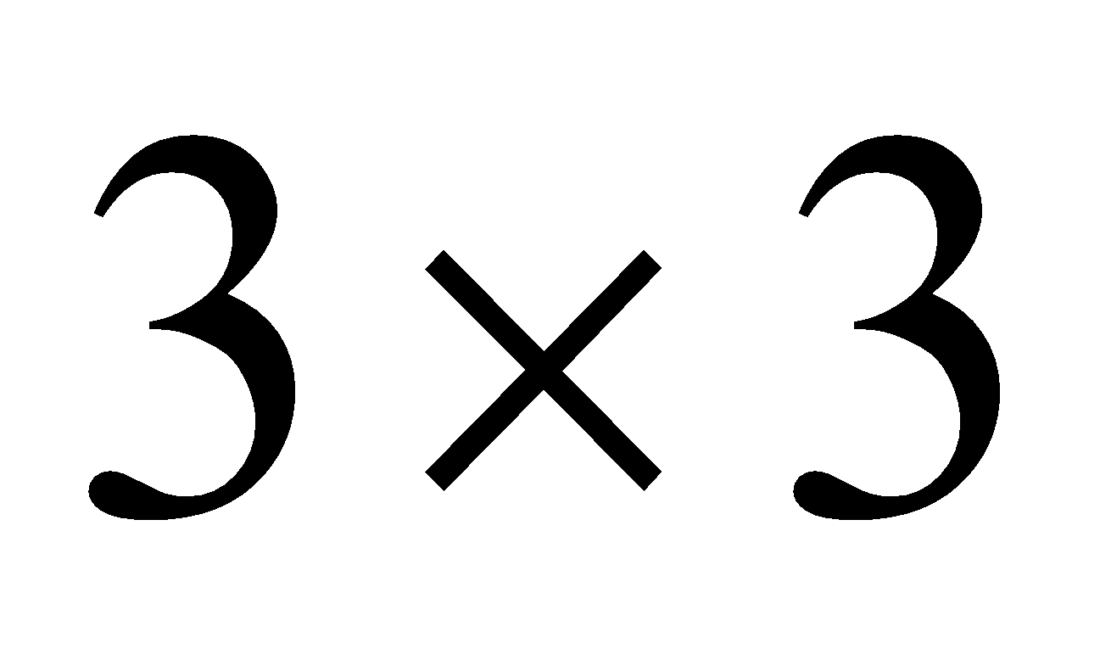 matrix are 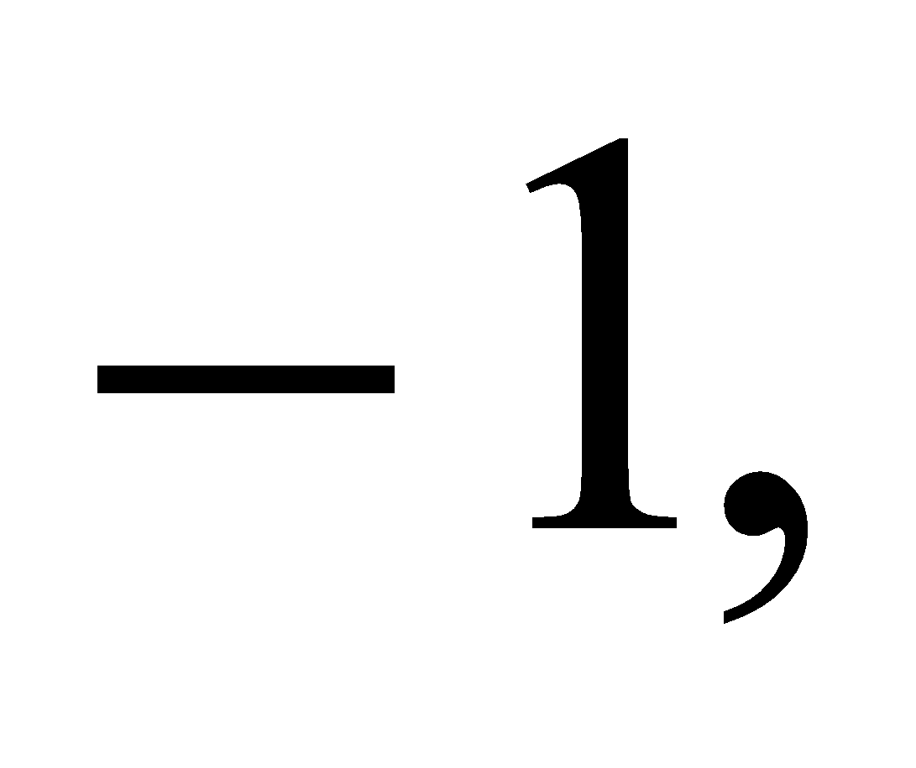 2. If the determinant of the matrix is 4, then its third eigen value is
Option A: | 2
Option B: | 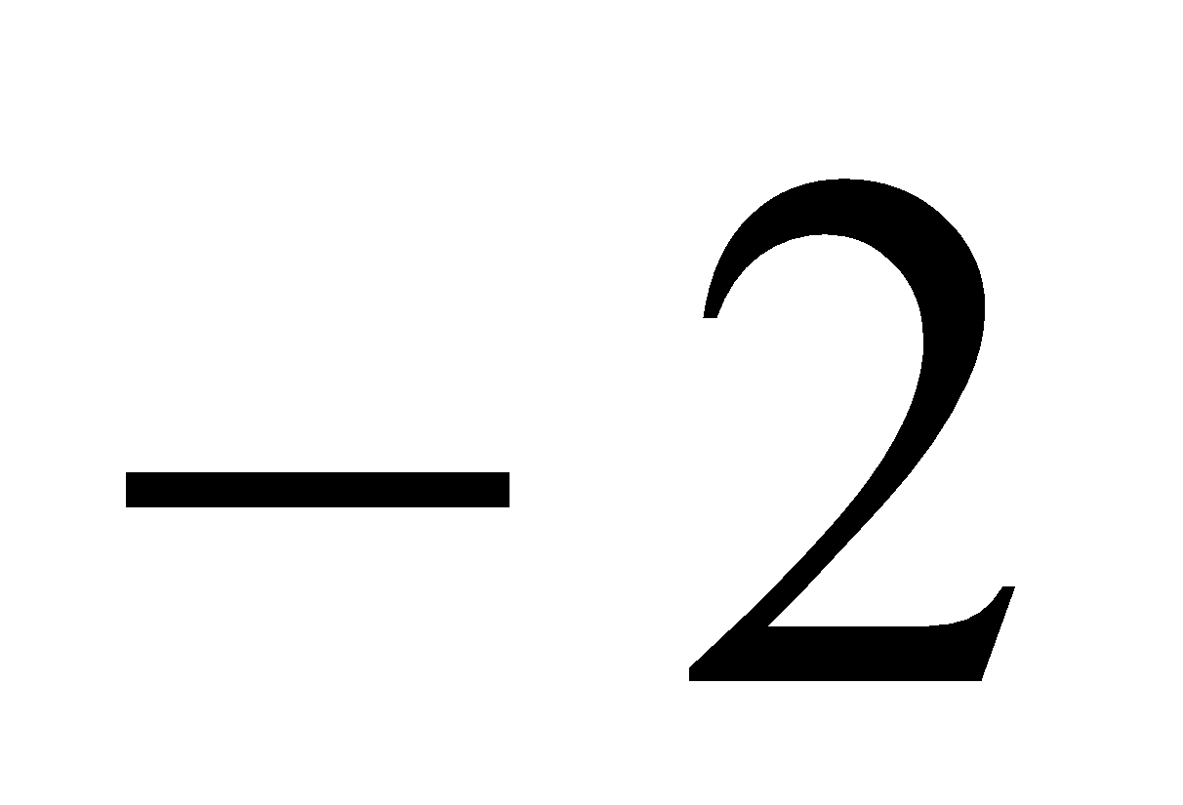
Option C: | 7
Option D: | 5
25. | The value of the sample statistic which separates the regions of acceptance and rejection, is called the
Option A: | Accepted value
Option B: | Critical value
Option C: | Rejected Value
Option D: | Separated value
26. | The table value of  at 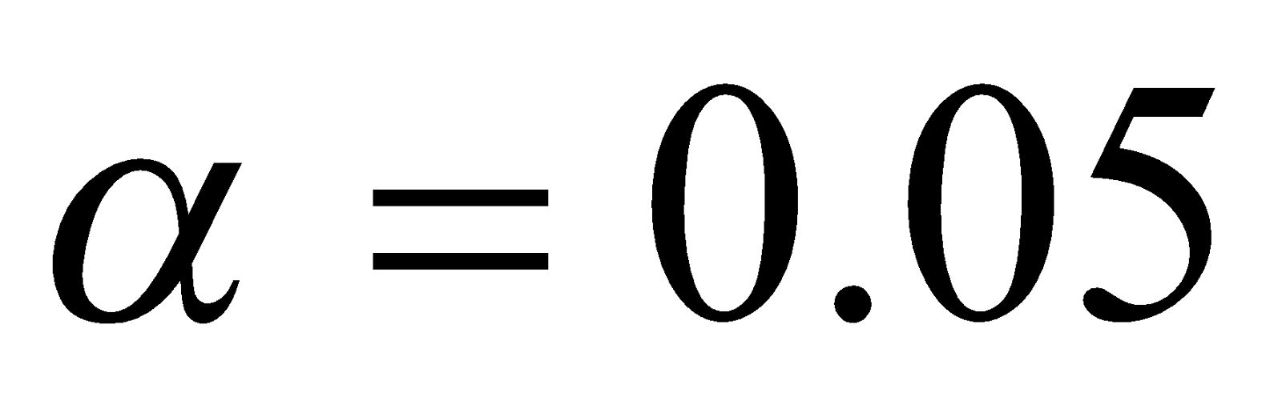 is
Option A: | 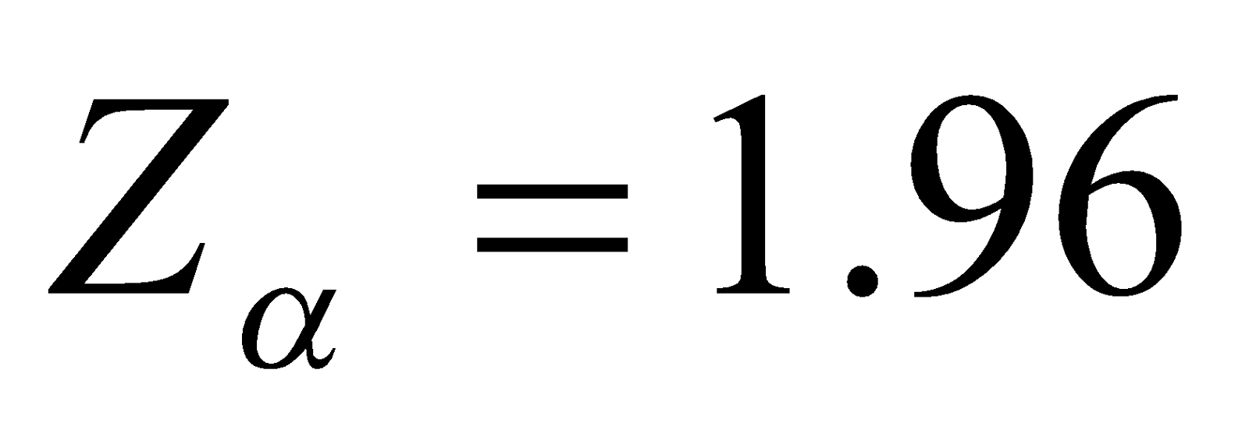
Option B: | 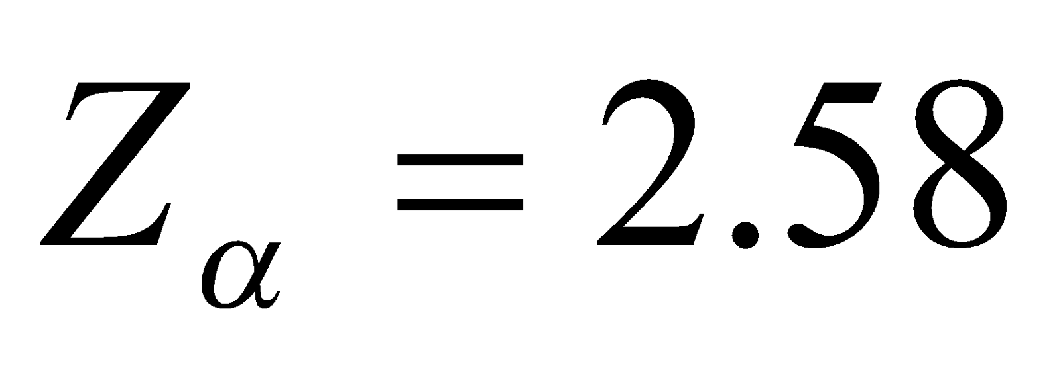
Option C: | 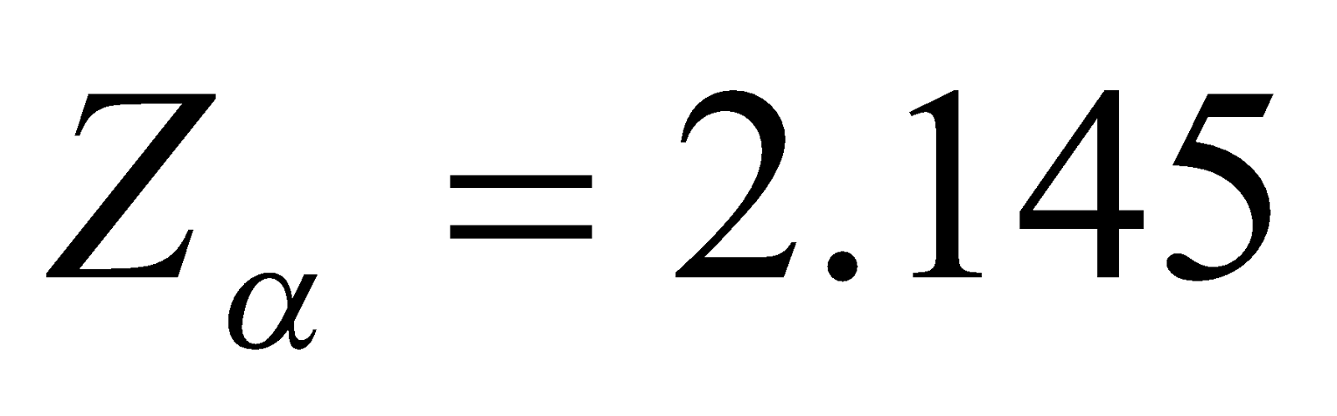
Option D: | 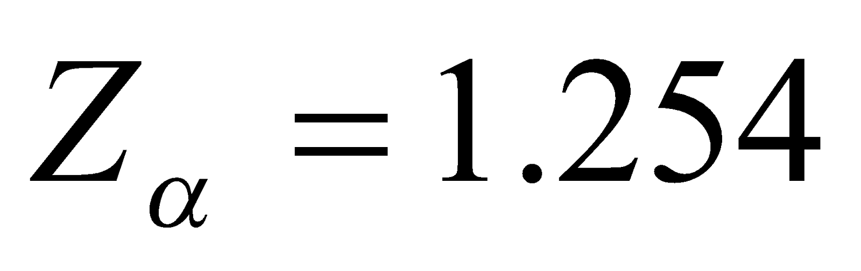
27. | If a random variable X follows Poisson distribution such that 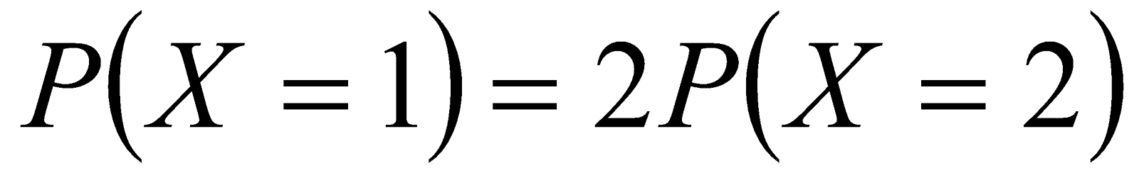, the mean and the variance of the distribution is
Option A: | 7
Option B: | 4
Option C: | 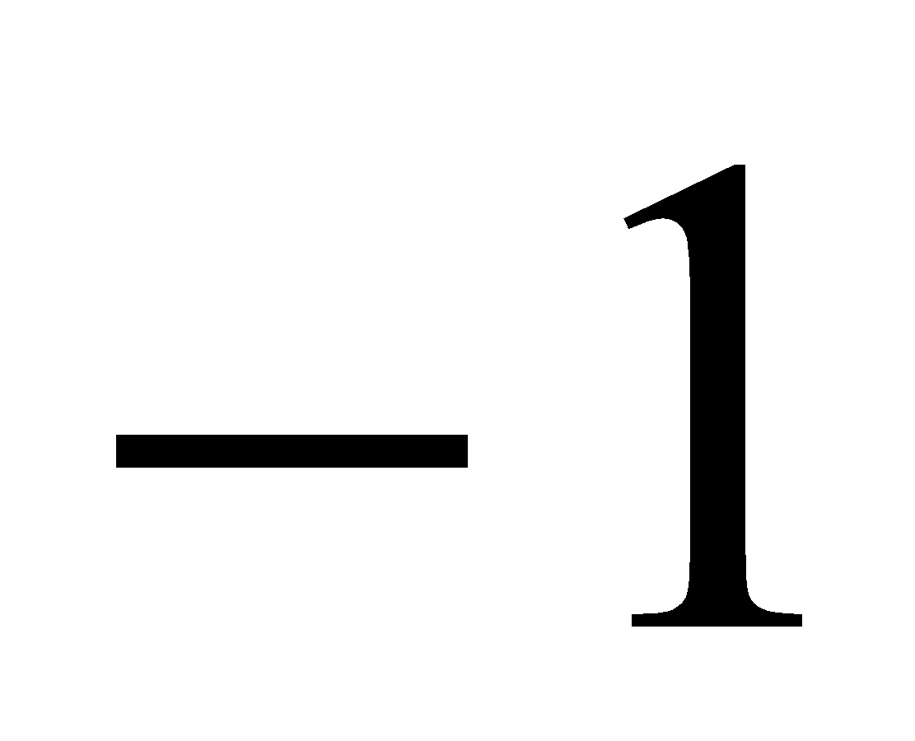
Option D: | 1
28. | The function 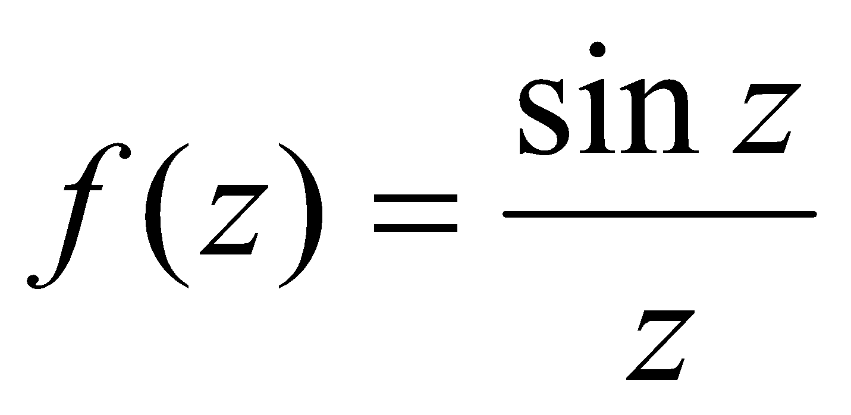 has the singularity at 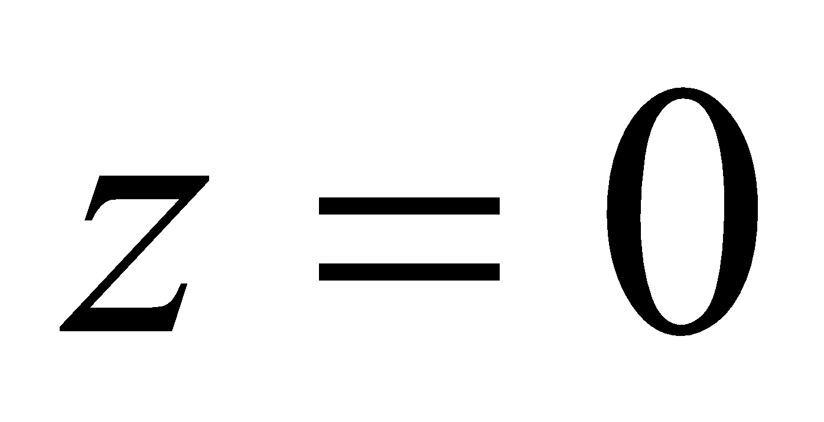 is of the type
Option A: | Non isolated singularity
Option B: | Isolated singularity
Option C: | Removable singularity
Option D: | Isolated essential singularity
29. | Evaluate 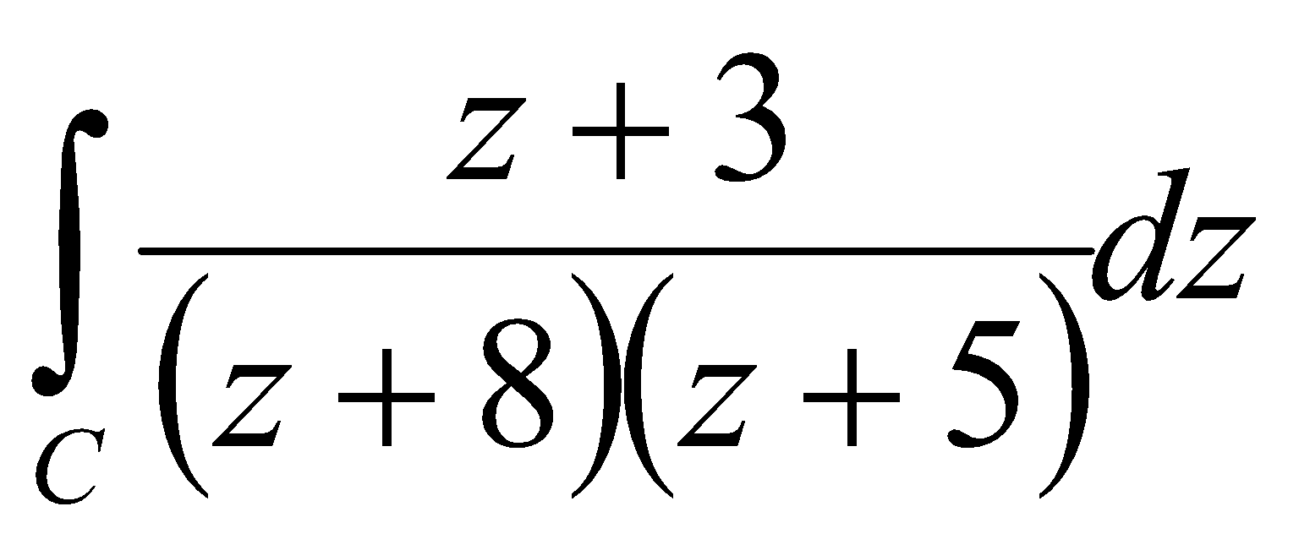 where c is the circle z=2
Option A: | 1
Option B: | I
Option C: | 2πi
Option D: | 0
30. | Pole of 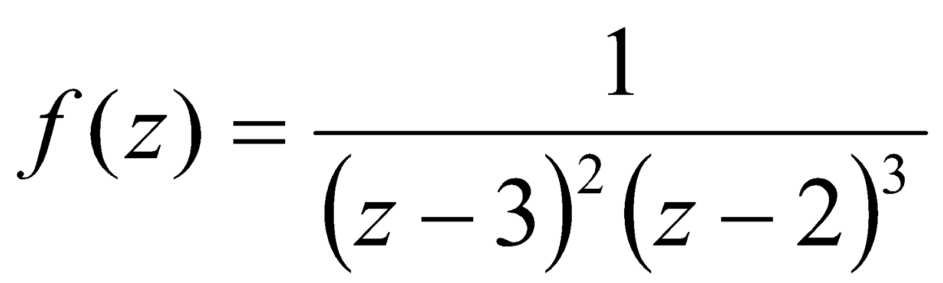
Option A: | z = 3 pole of order 2 and z = 2 pole of order 3
Option B: | z = 3 and z = 2 are simple pole
Option C: | 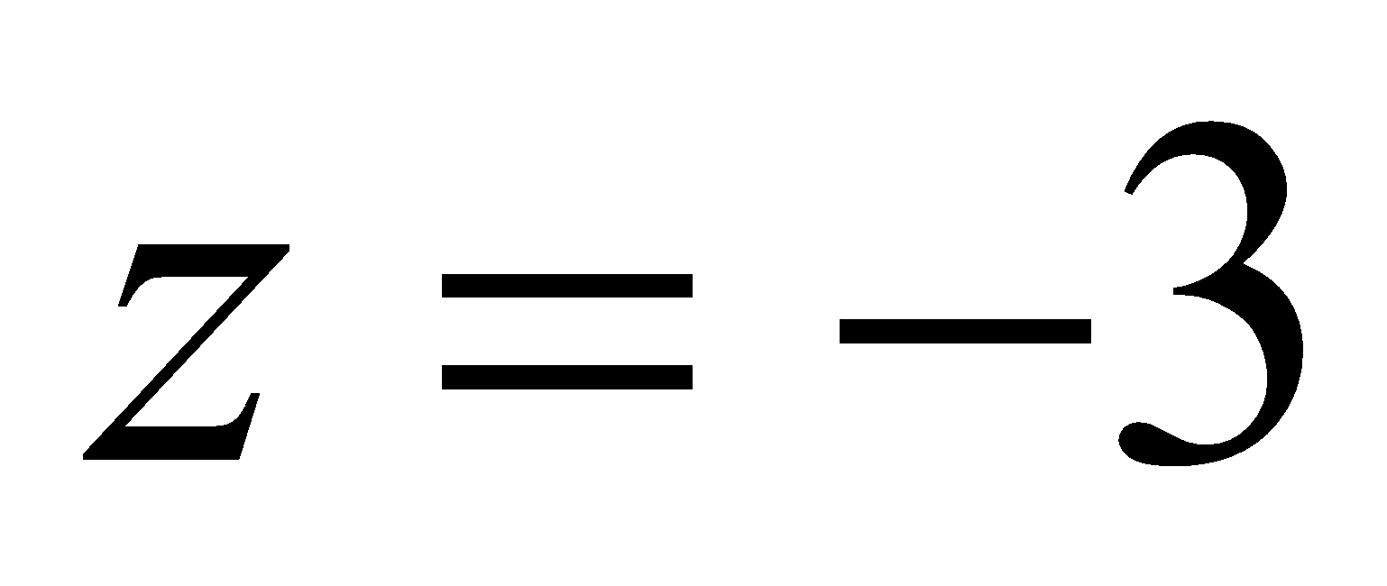 pole of order 2 and 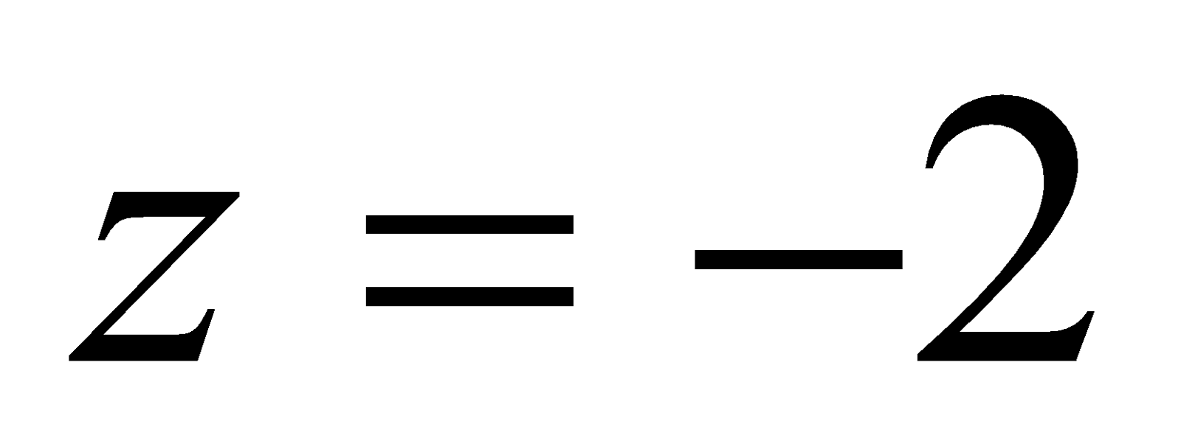pole of order 3
Option D: | and are simple pole
31. | The analytic function 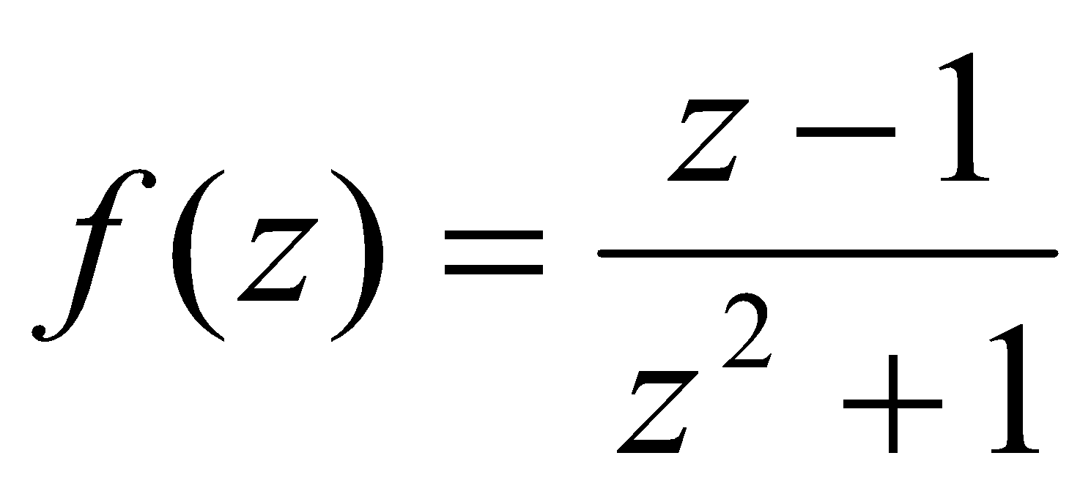 has singularity at
Option A: | 1 and
Option B: | 1 and 
Option C: | 1 and 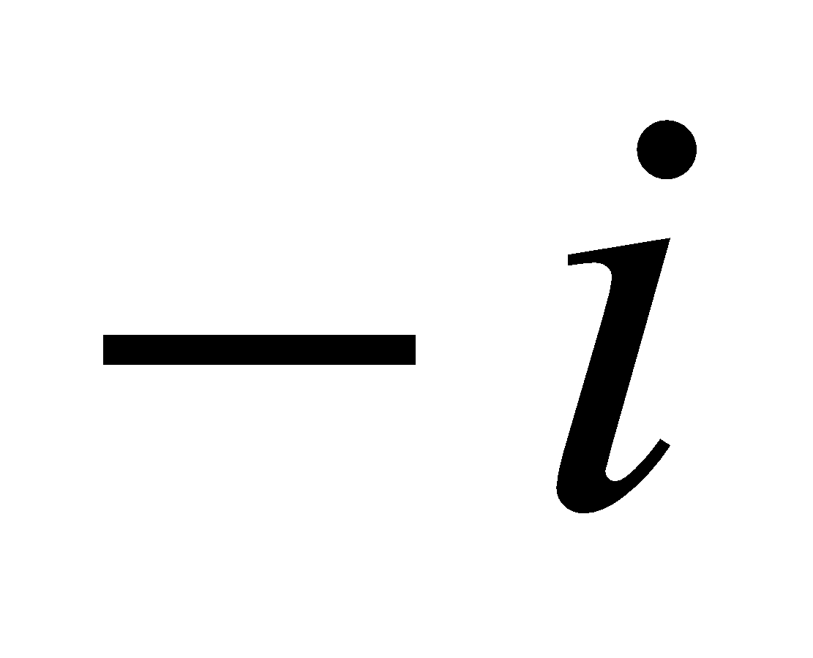
Option D: | and
32. | The Z- transform of Discrete Unit Step function 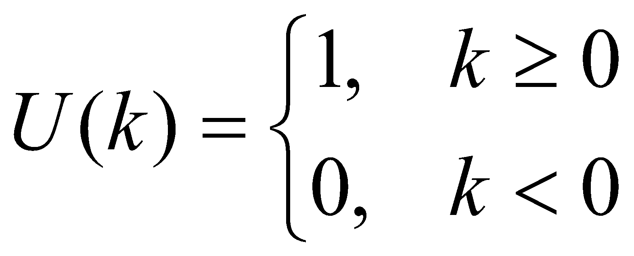 is given by
Option A: | 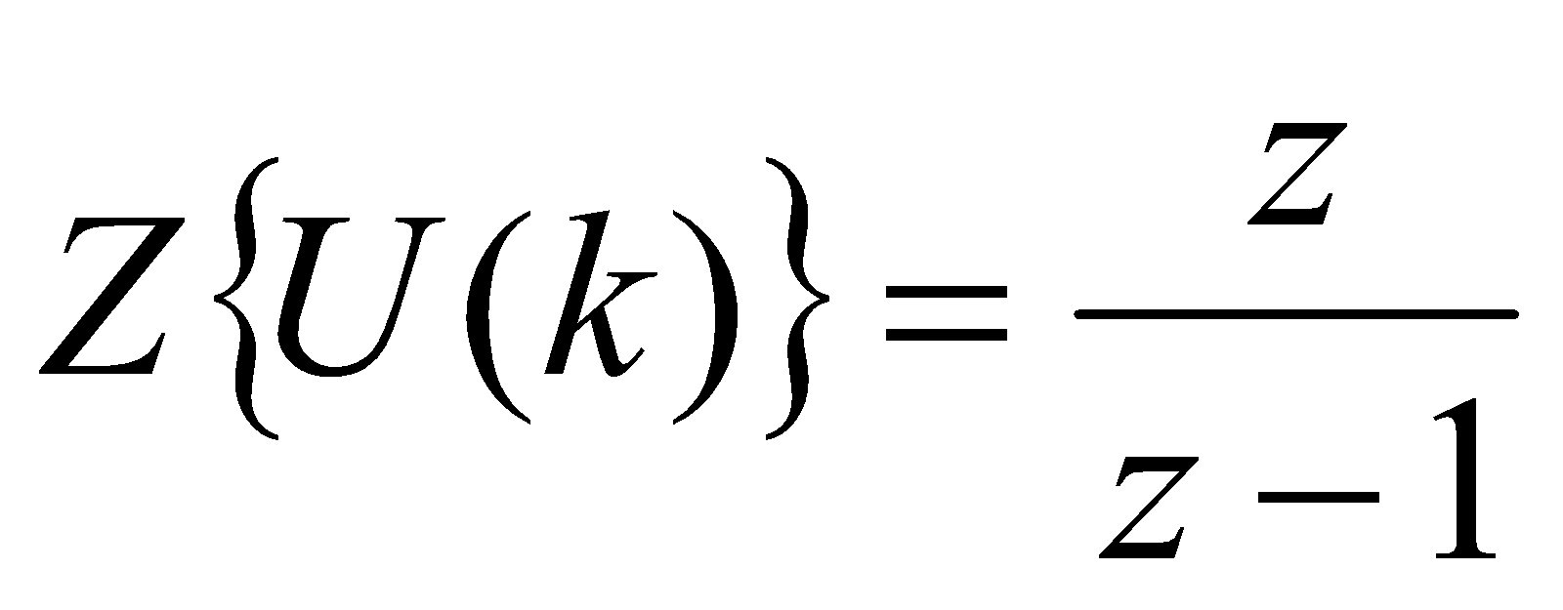, 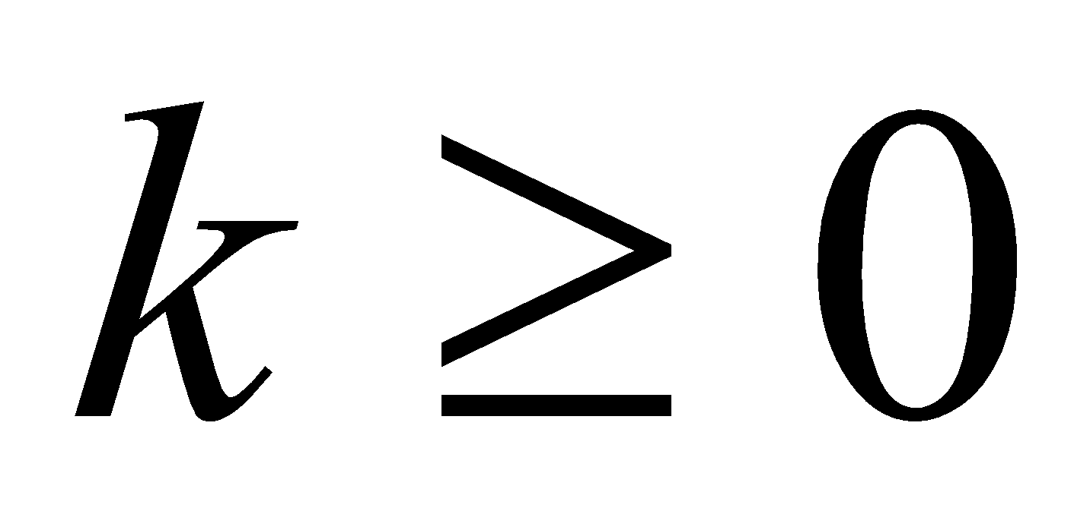
Option B: | 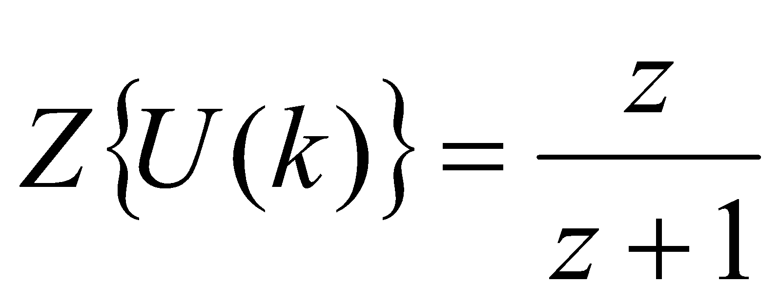,
Option C: | 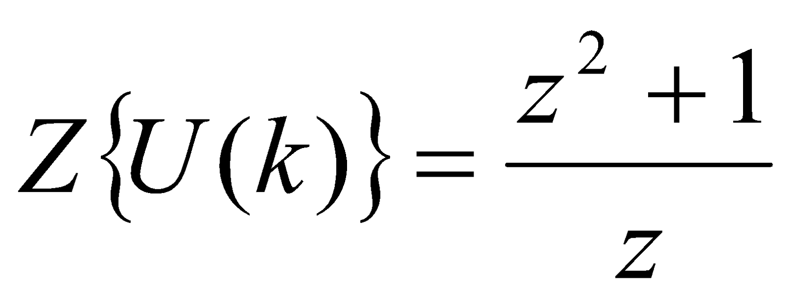,
Option D: | 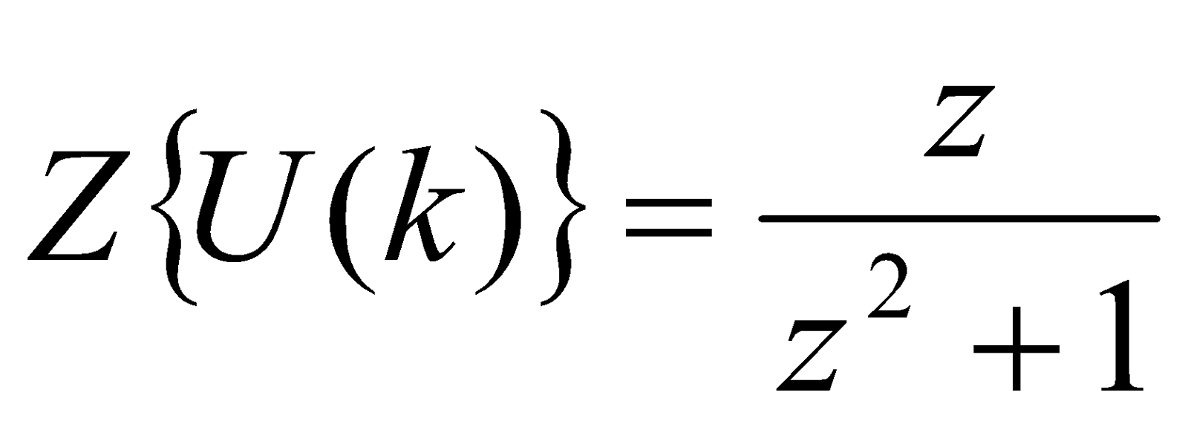,
33. | Find the Z- transform of fk= ak , k≥0
Option A: | zz+a
Option B: | 11-az
Option C: | 11+az
Option D: | zz-a
34. | If 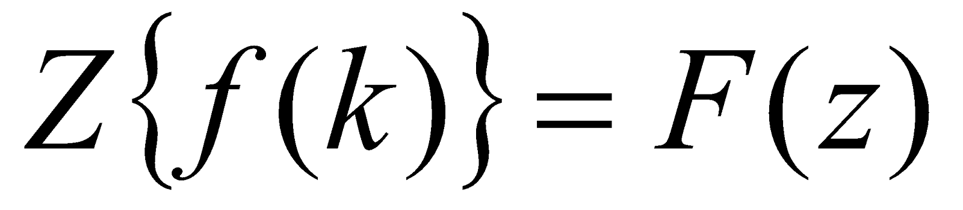 then 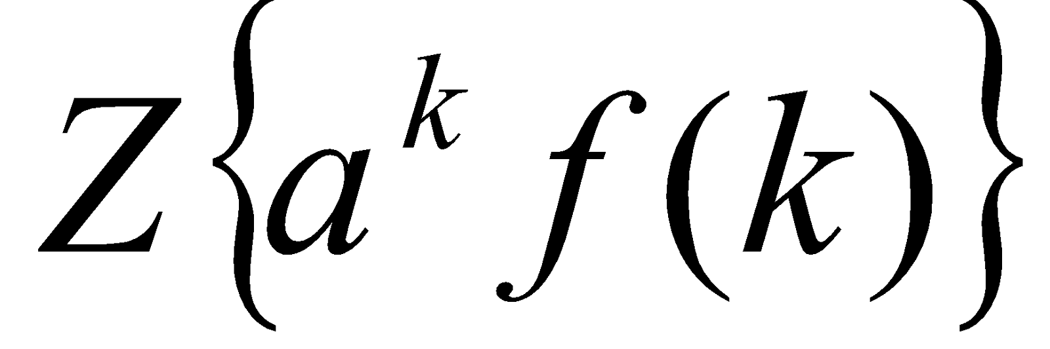 is
Option A: | 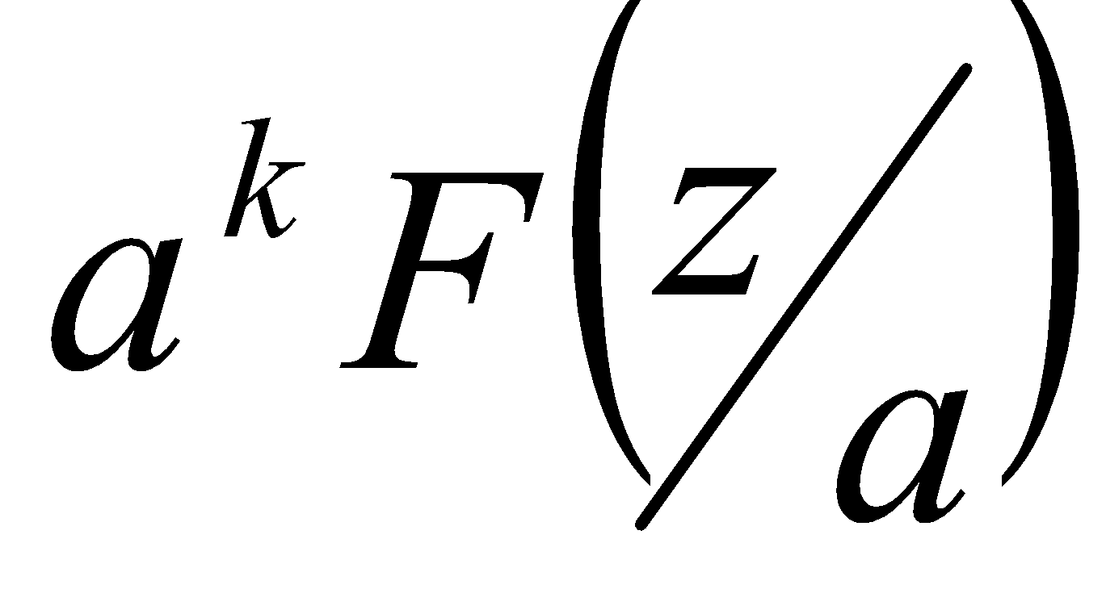
Option B: | 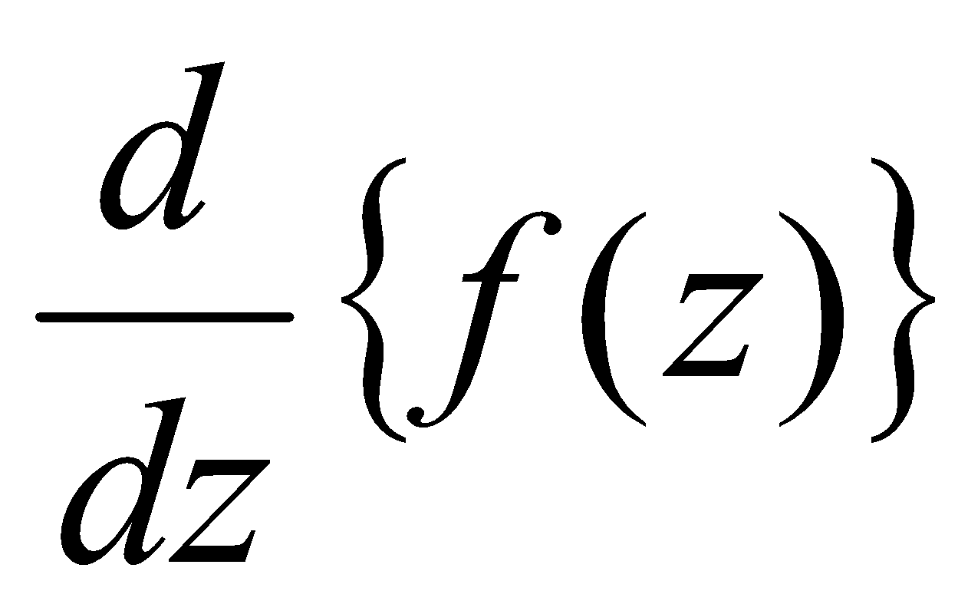
Option C: | 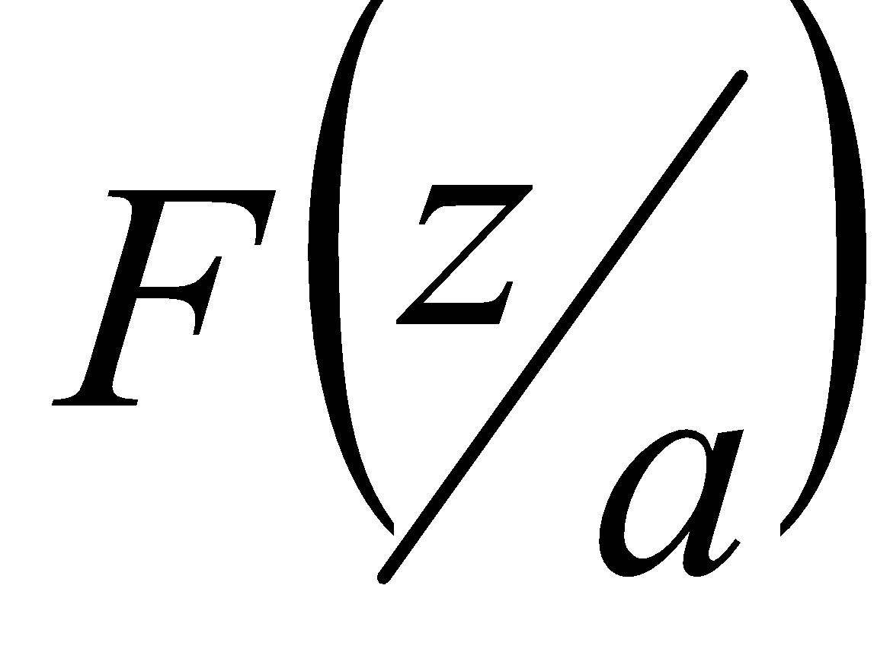
Option D: | 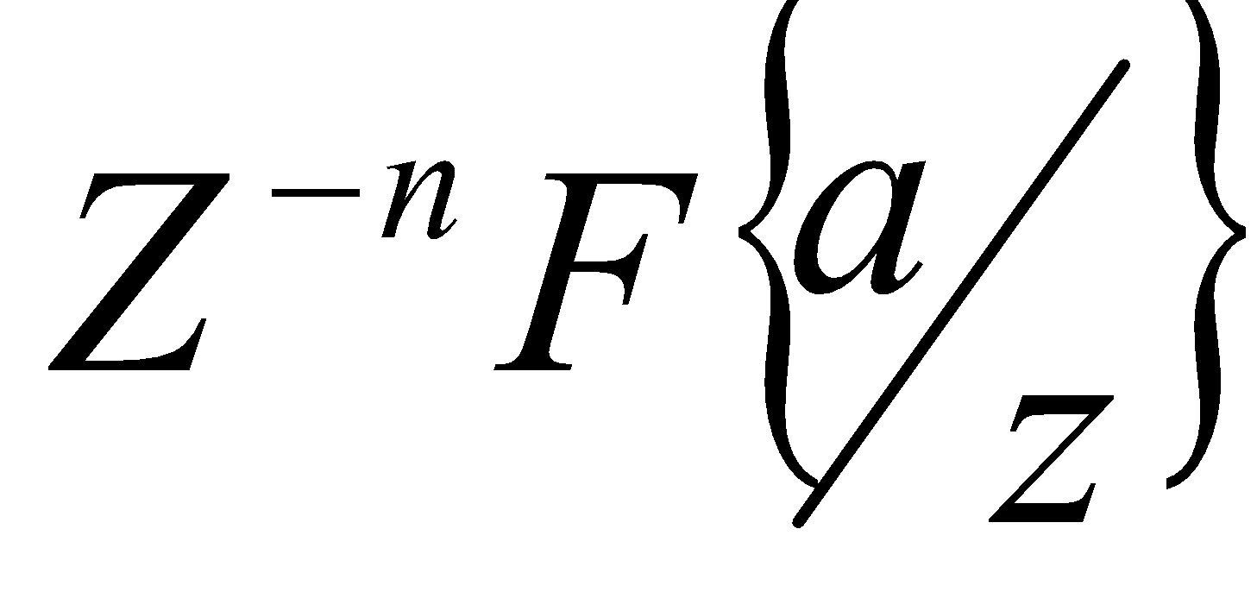
35. | For a maximizing LPP, during the simplex method, the criteria for a variable to enter into the basis is
Option A: | Minimum ratio test
Option B: | Maximum ratio test
Option C: | Minimum deviation entry
Option D: | Maximum deviation entry
36. | The advantage of dual simplex algorithm is that
Option A: | It starts with a basic feasible solution
Option B: | It involves artificial variable
Option C: | It does not involve artificial variable
Option D: | It involves dual variables
37. | In a Simplex table, the pivot row is computed by
Option A: | dividing every number in the profit row by the pivot number.
Option B: | dividing every number in the pivot row by the corresponding number in the profit row.
Option C: | dividing every number in the pivot row by the pivot number.
Option D: | dividing every number in the net profit row by the corresponding number in the gross profit row.
38. | The value of Lagrange’s multiplier for the following NLPP is  Optimize 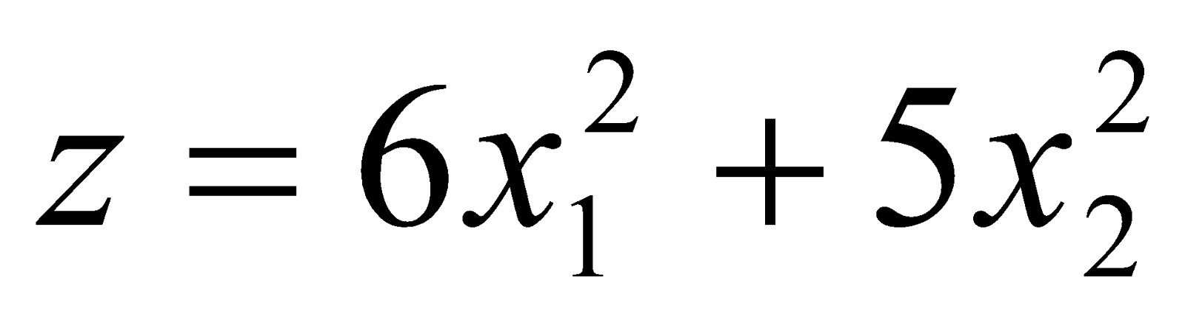  Subject to 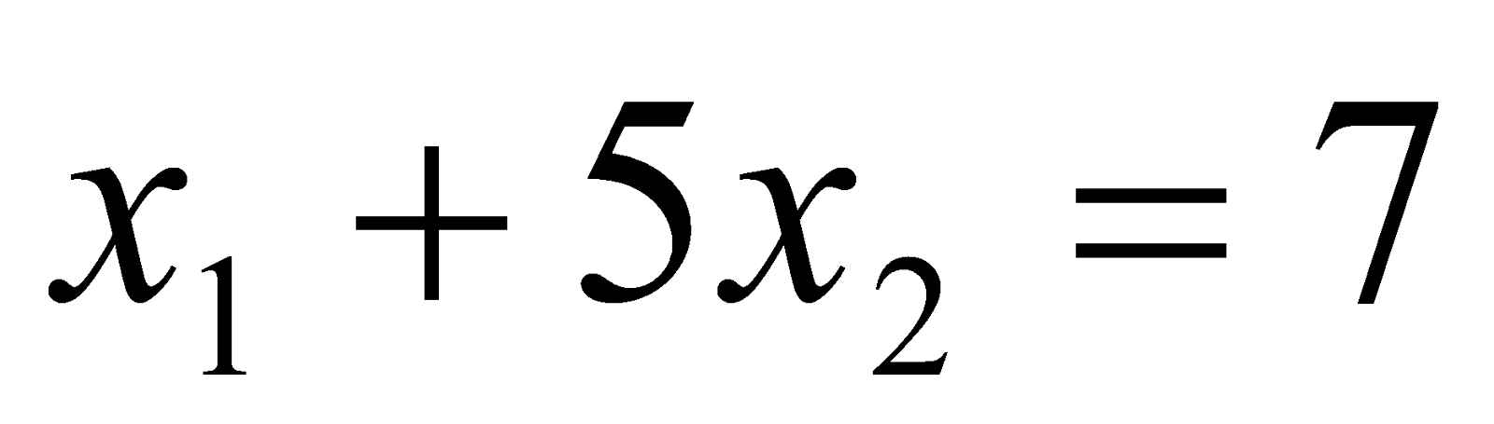  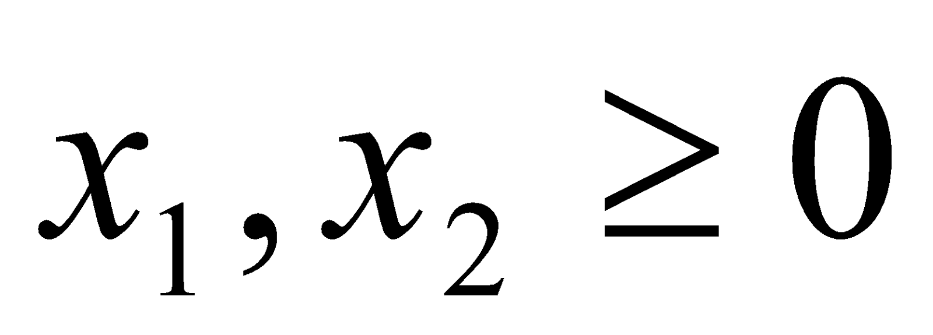
Option A: | 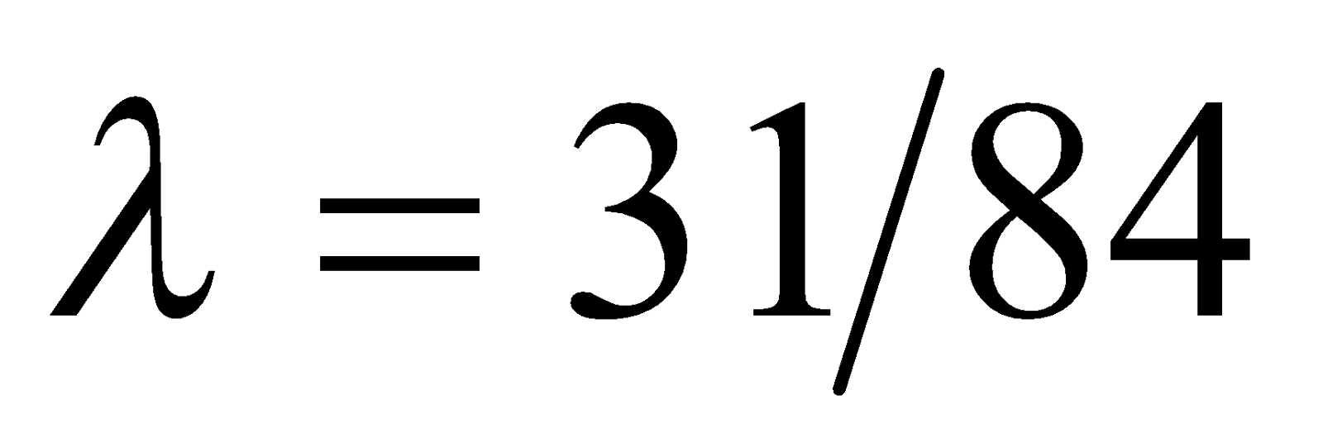
Option B: | 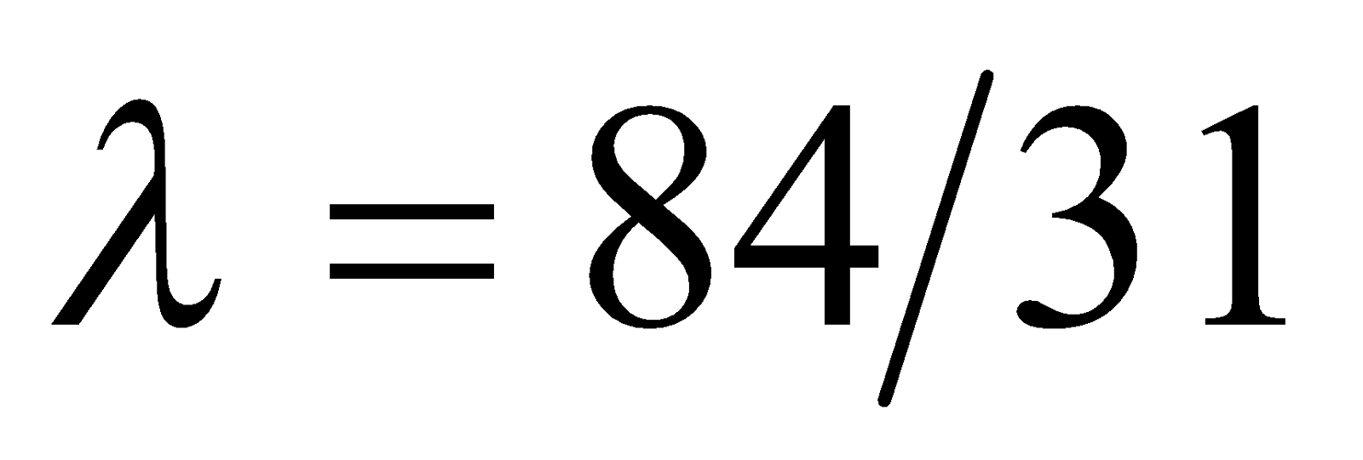
Option C: | 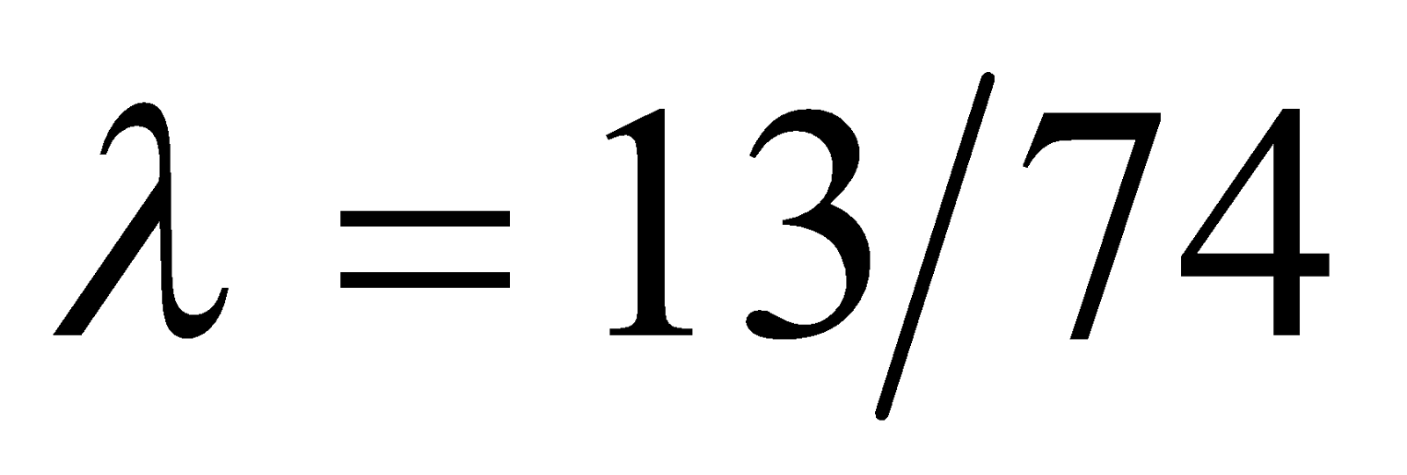
Option D: | 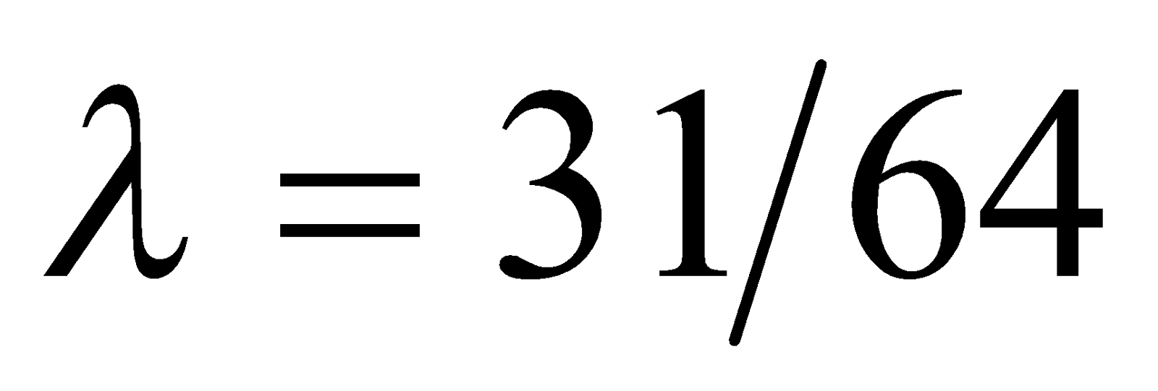
39. | If the objective function of NLLP is maximization type, then in Kuhn-Tucker conditions is
Option A: | λ=0
Option B: | λ<0
Option C: | λ≥0
Option D: | λ is not defined
40. | In a non-linear programming problem (NLPP),
Option A: | All the constraints should be linear
Option B: | All the constraints should be non-linear
Option C: | Either the objective function or at least one of the constraints should be non-linear
Option D: | The objective function and all constraints should be linear.
41. | If A=2 3 1 0 -1 0 0 0 3 then eigen values of A2+2I are
Option A: | 6,3,11
Option B: | 2,-1,3
Option C: | 4,3,-1
Option D: | 0,3,2
42. | If A=-2 2 -3 2 1 -6 -1 -2 0 then by Cayley-Hamilton theorem
Option A: | 2A3+A2-10A-45I=0
Option B: | A3-A2+16A-5I=0
Option C: | A3+A2-21A-45I=0
Option D: | A3+2A2-2A-9I=0
43. | If A=2 1 1 2 is diagonalisable then the diagonal matrix is
Option A: | D=1 0 0 3
Option B: | D=-1 0 0 3
Option C: | D=2 0 0 3
Option D: | D=-1 0 0 5
44. | If A is a singular matrix of order 3×3 then one of the eigen value of A is
Option A: | 1
Option B: | 0
Option C: | 3
Option D: | -1
45. | If C the upper half of the unit circle then the value of ZdZ over C is
Option A: | πi
Option B: | 0
Option C: | -πi
Option D: | 2πi
46. | The value of CZ+3(Z-4)(Z+2)2 , C:Z=1 is
Option A: | 0
Option B: | 4πi
Option C: | -πi
Option D: | 2πi
47. | fz=sin z z has the singularity at z=0 is of the type
Option A: | Non isolated singularity
Option B: | Isolated singularity
Option C: | Isolated essential singularity
Option D: | Removable singularity
48. | If fz=z2(z+2)(z-1)2 then residue at the pole z=-2 is
Option A: | 49
Option B: | 13
Option C: | 29
Option D: | 0
49. | The Z-transform of fk= 3k , k<0 is
Option A: | z3-z , z<3
Option B: | 33-z , z<3
Option C: | zz-3 , z<3
Option D: | z3-z , z>3
50. | If Z transform of fk=F(Z) then Zakf(k) is
Option A: | akF(za)
Option B: | ddzF(z)
Option C: | F(za)
Option D: | znF(z)
51. | Inverse Z-transform of zz-4, z>4 is
Option A: | -4k , k≥0
Option B: | 4k , k≥0
Option C: | -4k , k≤0
Option D: | 4k , k<0
52. | If a random variable X follows Poisson distribution such that P ( X=1) = 3P(X=2) then mean and variance of the distribution are
Option A: | Mean = 1, variance = 1
Option B: | Mean = 0, variance = 1
Option C: | Mean = 2/3, variance = 2/3
Option D: | Mean = 3/2, variance = 1/2
53. | If X is a normal variate with mean 9 and S.D. 6, then P(|X-15|)1 is............ (given area between z=0 to z=1 is 0.3413)
Option A: | 0.3413
Option B: | 1.0239
Option C: | 0.6826
Option D: | 0.2316
54. | To test independence of attributes, the degree of freedom is
Option A: | (r-1)(c+1)
Option B: | (r-1)(c-1)
Option C: | (r+1)(c-1)
Option D: | (r+1)(c+1)
55. | Basic feasible solution of the LPP is said to be degenerate if
Option A: | One or more values of basic variable are zero.
Option B: | All basic variables are positive.
Option C: | All basic variables are negative.
Option D: | Some basic variables are positive and some basic variables are negative.
56. | If the given LPP is in canonical form , then the primal-dual pair is said to be
Option A: | Symmetric
Option B: | Asymmetric
Option C: | Standard
Option D: | Pseudo
57. | The Standard form of following LPP is  Minimise Z= -2x1+x2  Subject to 3x1-2x2≥-4  x1+4x2≤7  x1,x2≥0
Option A: | Maximise Z'= -2x1+x2  Subject to 3x1-2x2=4  x1+4x2=7  x1,x2≥0
Option B: | Maximise Z'= 2x1-x2  Subject to 3x1-2x2+s1=4  x1+4x2+s2=7  x1,x2,s1,s2≥0
Option C: | MaximiseZ'= 2x1-x2  Subject to 3x1-2x2+s1=4  x1+4x2+s2=7  x1,x2,s1,s2≥0
Option D: | MaximiseZ'= 2x1-x2  Subject to -3x1+2x2+s1=4  x1+4x2+s2=7  x1,x2,s1,s2≥0
58. | If 3, 3 0 0 3 , 3 0 0 0 3 0 0 0 3 are the principal minor determinants of Hessian matrix at X0, then X0 is a
Option A: | Minima
Option B: | Maxima
Option C: | Saddle point
Option D: | No conclusion
59. | If the objective function of NLLP is maximization type, then in Kuhn-Tucker conditions is
Option A: | λ=0
Option B: | λ<0
Option C: | λ≥0
Option D: | is not defined
60. | The value of Lagrange’s multiplier for the following NLPP is  Optimise Z=7x12+5x22  Subject to 2x1+5x2=7  x1,x2≥0
Option A: | λ=49/39
Option B: | λ=14/36
Option C: | λ=98/39
Option D: | λ=39/64

Descriptive Questions
1 | In an exam taken by 800 candidates, the average and standard deviation of marks obtained (normally distributed) are 40% and 10% respectively. What should be the minimum score if 350 candidates are to be declared as passed
2 | If A= , By using Cayley-Hamilton theorem find the matrix represented by
3 | Evaluate the following integral using Cauchy-Residue theorem.  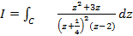 where c is the circle
4 | Obtain inverse z-transform
5 | Solve by the Simplex method  Maximize  Subject to
6 | Using Lagrange’s multipliers solve the following NLPP  Optimise  Subject to
7 | By using Cayley-Hamilton theorem find 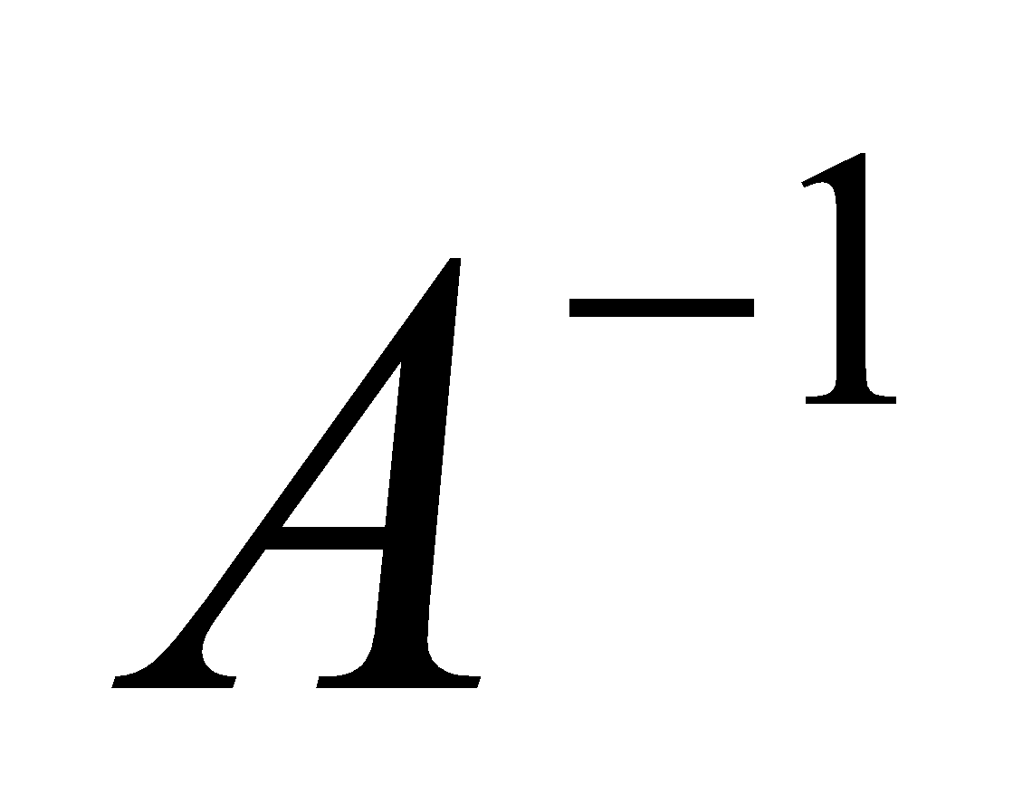 and 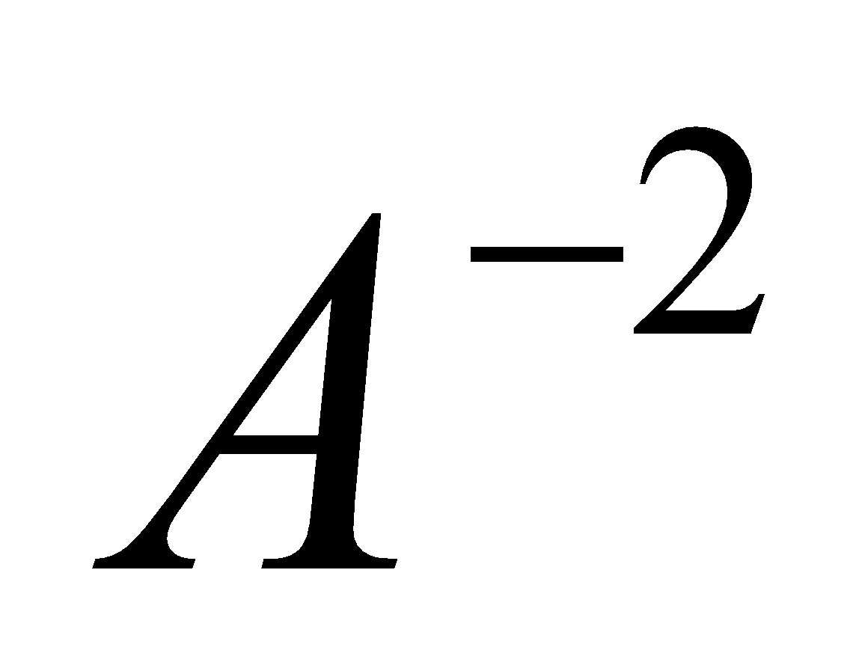 where 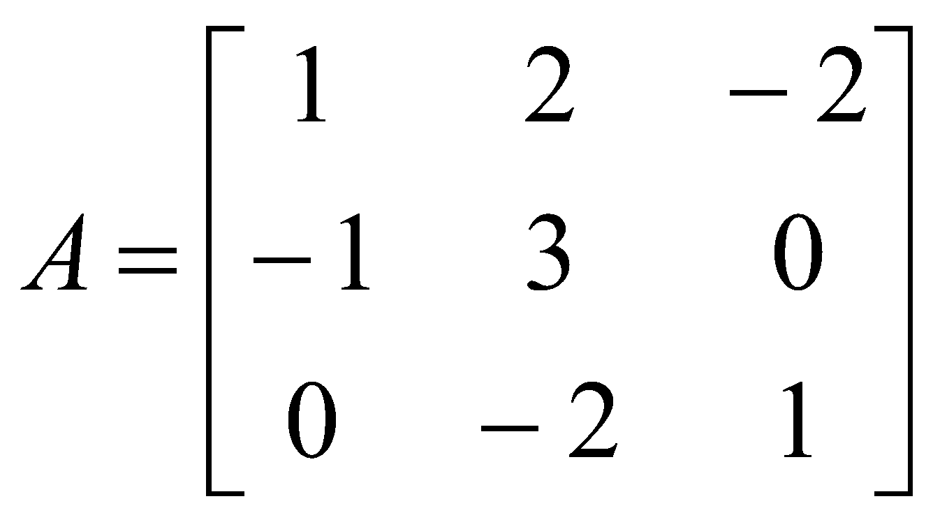
8 | Evaluate 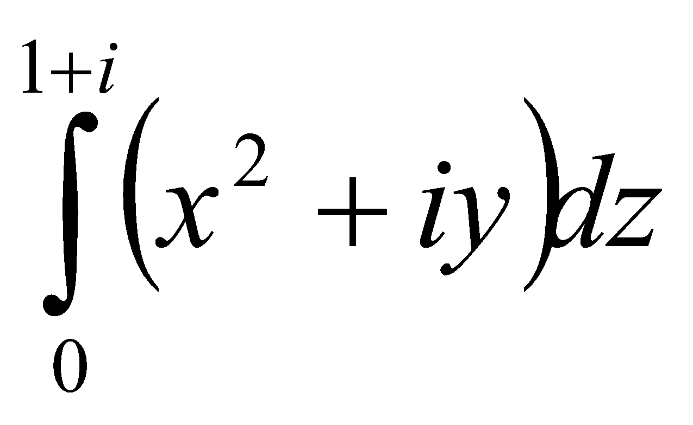 along the path (i)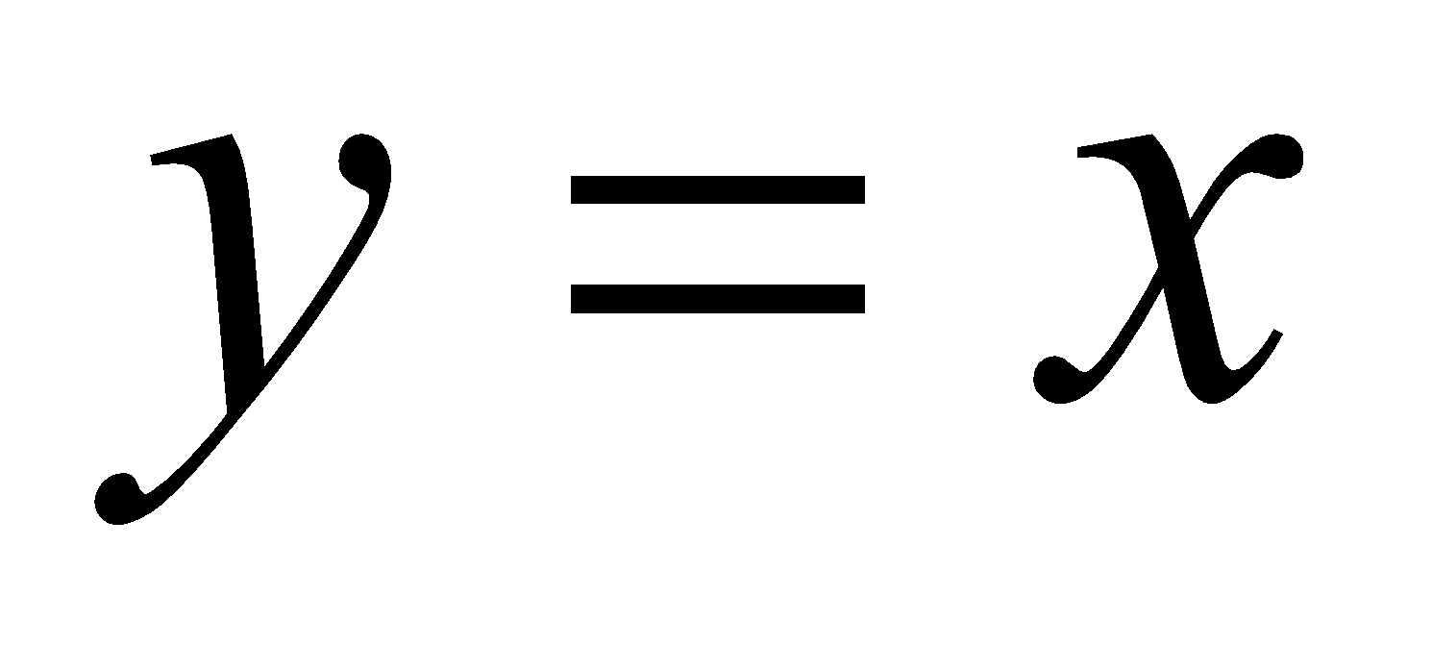, (ii)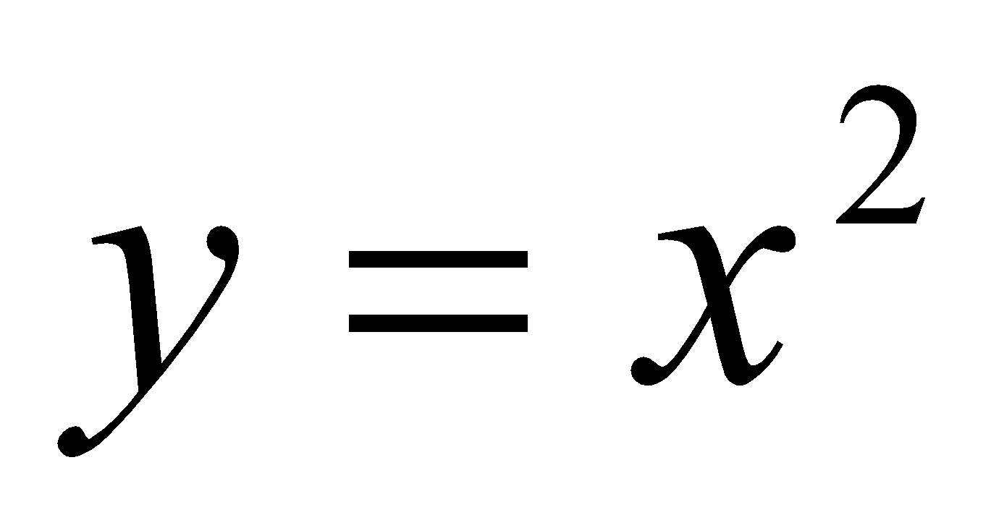. Is the line integral independent of the path?
9 | Find the Z-transform of 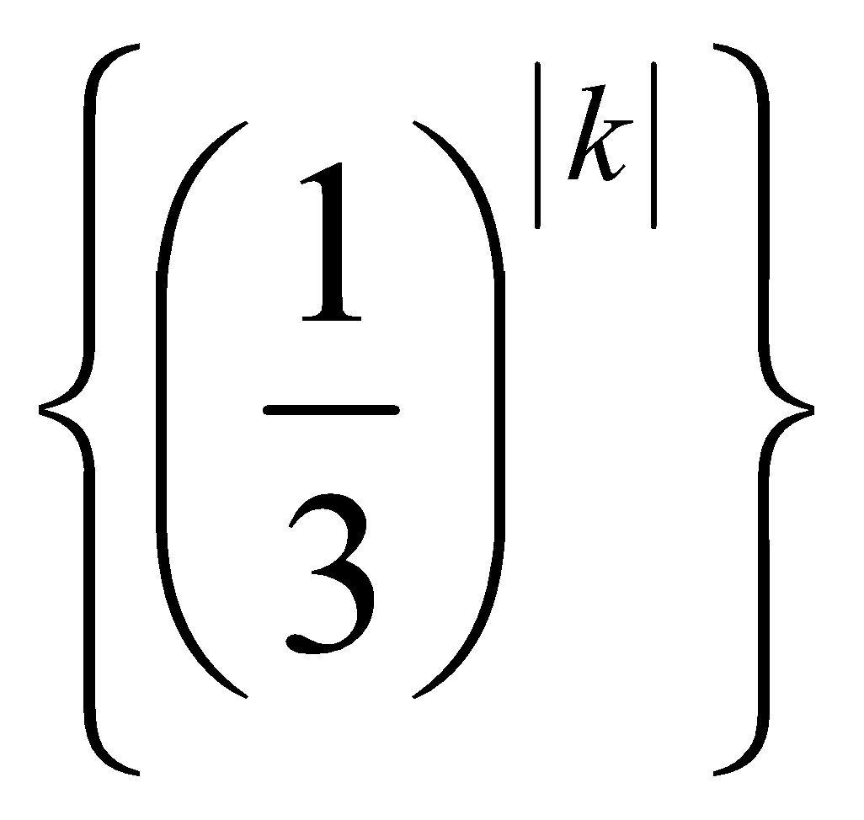
10 | A car hire firm has two cars which it hires out day by day. The number of demands for a car on each day is distributed as Poisson variate with mean 1.5. Calculate the proportion of day on which i) neither car is used ii) some demand is refused.
11 | Find the dual of the following LPP  Maximize 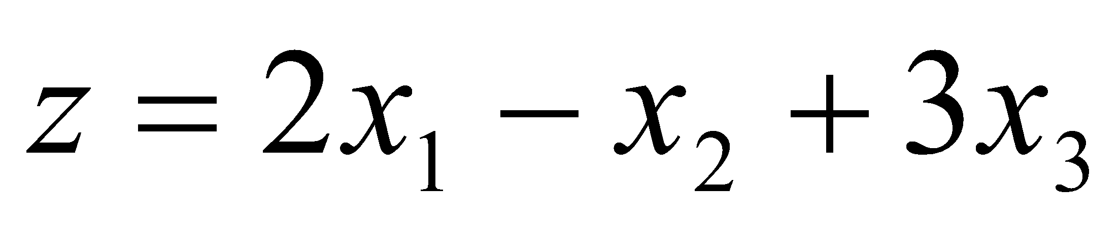  Subject to 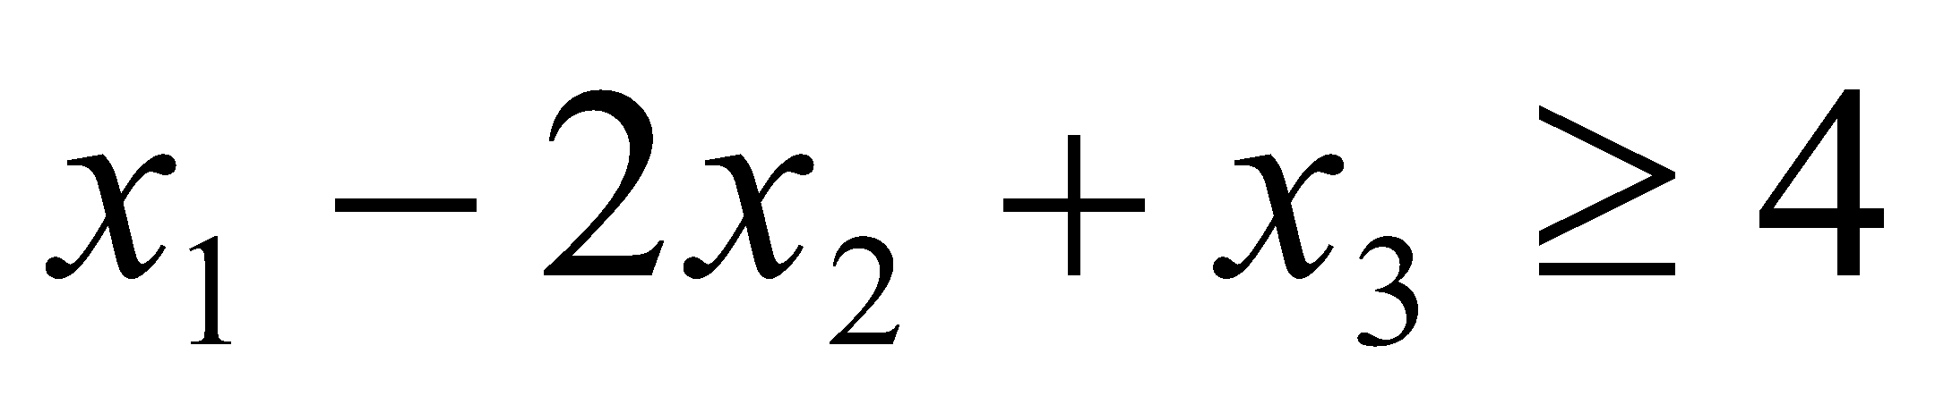; 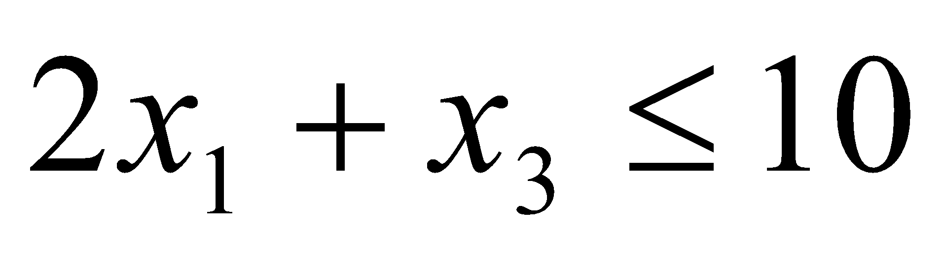; 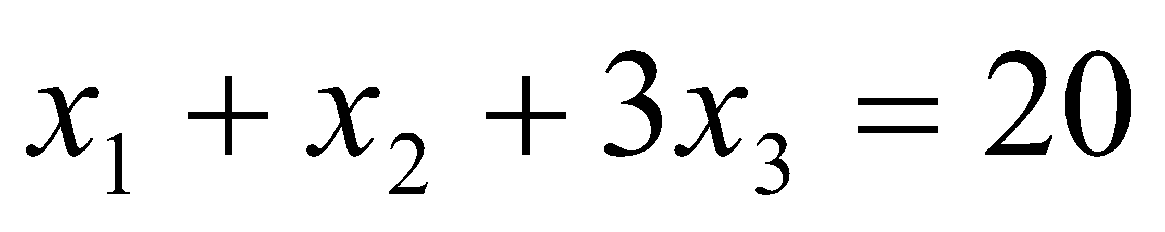  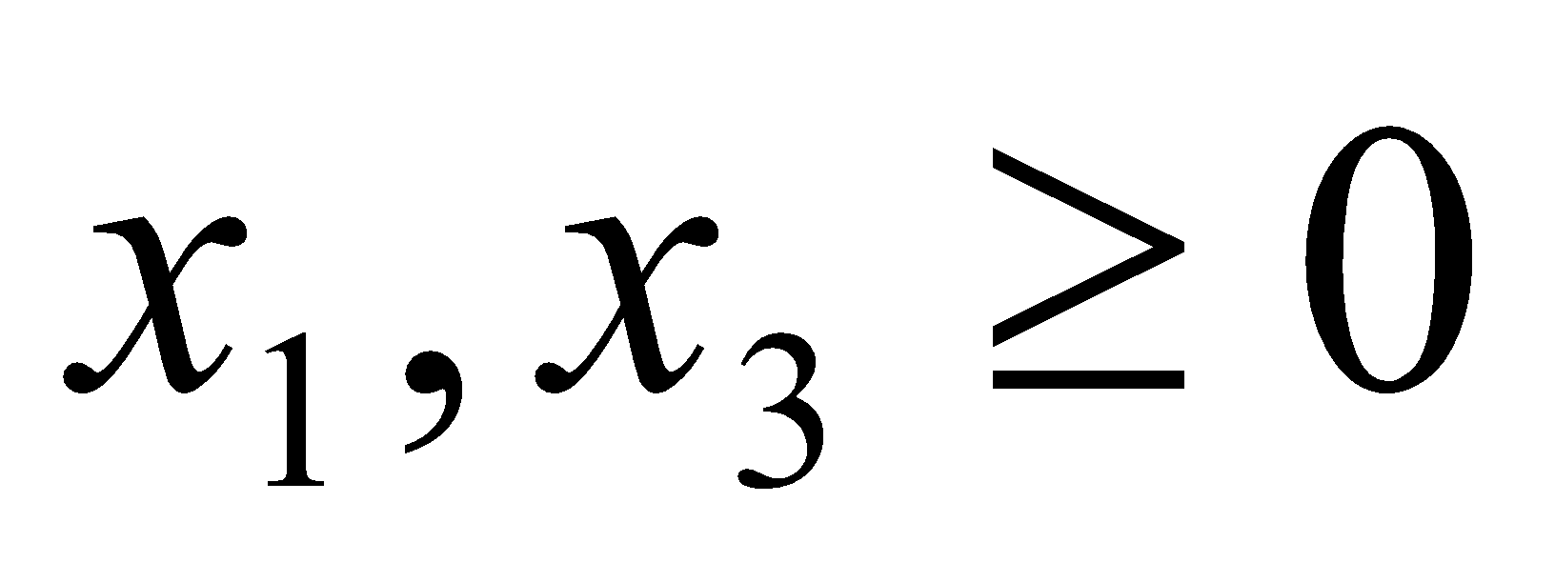 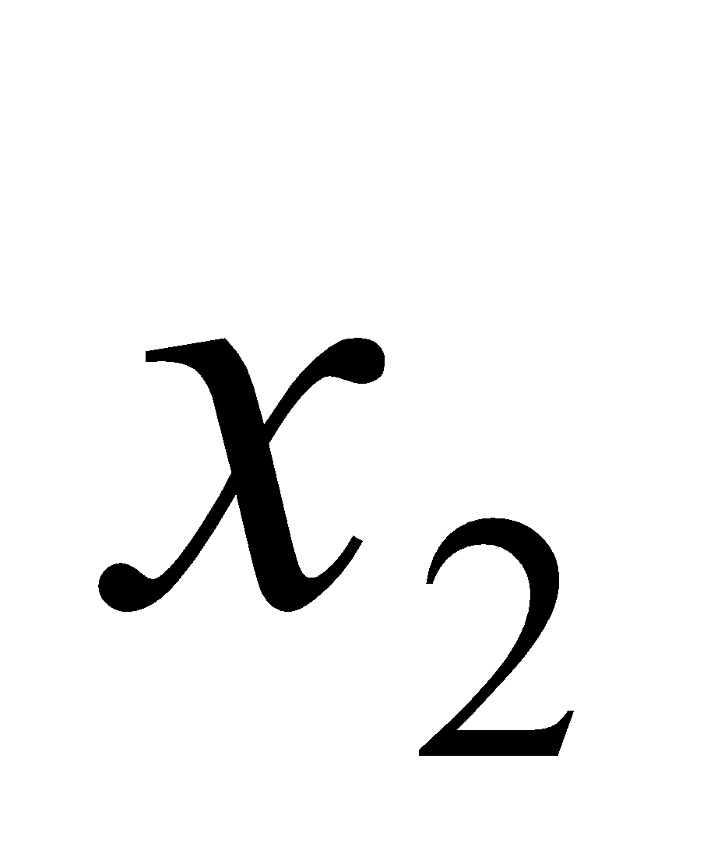 unrestricted.
12 | Using the method of Lagrange’s multiplier solve the following NLPP  Optimize 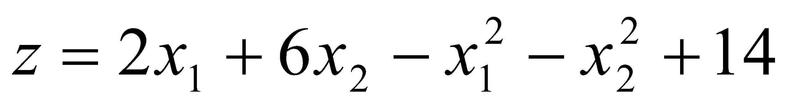  Subject to 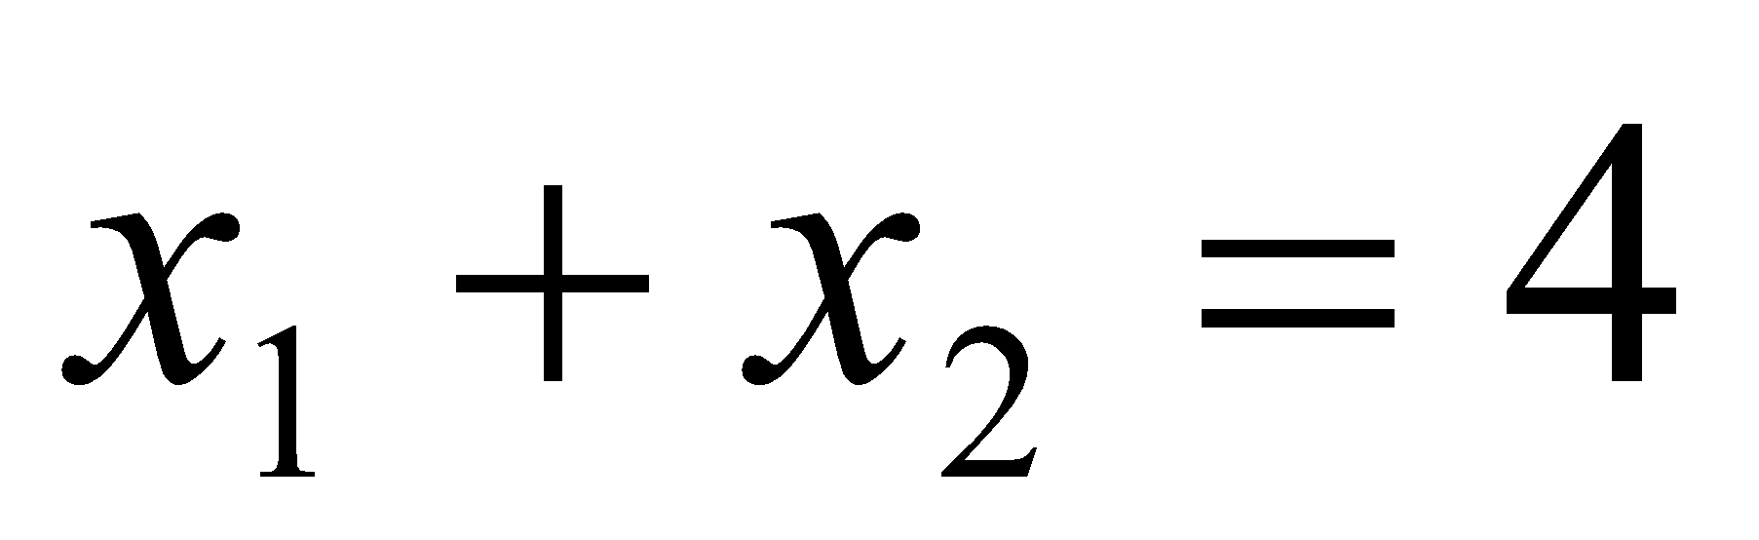; 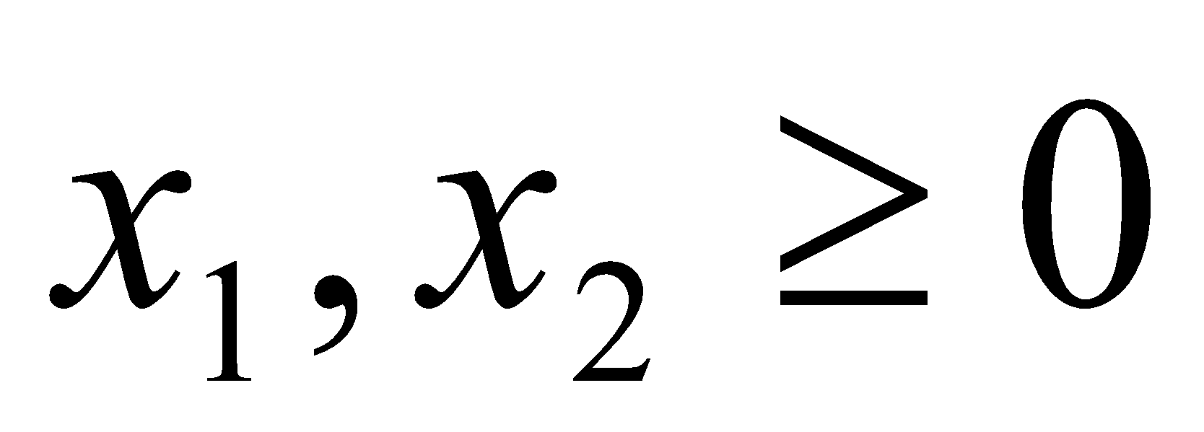
13 | Find the Eigen values and Eigen vectors of
14 | Evaluate 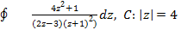using Cauchy’s residue theorem.
15 | Find the Z transform of 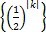
16 | A certain drug administered to 12 patients resulted in the following change in their blood pressure.  5, 2, 8, -1, 3, 0, 6, -2, 1, 5, 0, 4  Can we conclude that the drug increases the blood pressure ?
17 | Solve the following LPP by simplex method
18 | Solve the following NLPP using Kuhn-Tucker conditions
19 | When the first proof of 392 pages of a book of 1200 pages were read, the distribution of printing mistakes were found to be as follows.  Fit a poisson distribution to the above data and test the goodness of fit.
  No of mistakes in page (X) | 0 | 1 | 2 | 3 | 4
  No. of pages (f) | 275 | 72 | 30 | 7 | 5
20 | Show that the matrix is not diagonalizable.
21 | If obtain Taylor’s and Laurent’s series expansions of f(z) in the domain & respectively.
22 | If find
23 | Solve using dual simplex method  Minimize  Subject to
24 | Solve following NLPP using Kuhn-Tucker method  Maximize  Subject to
25 | Find the eigen values and eigen vectors of 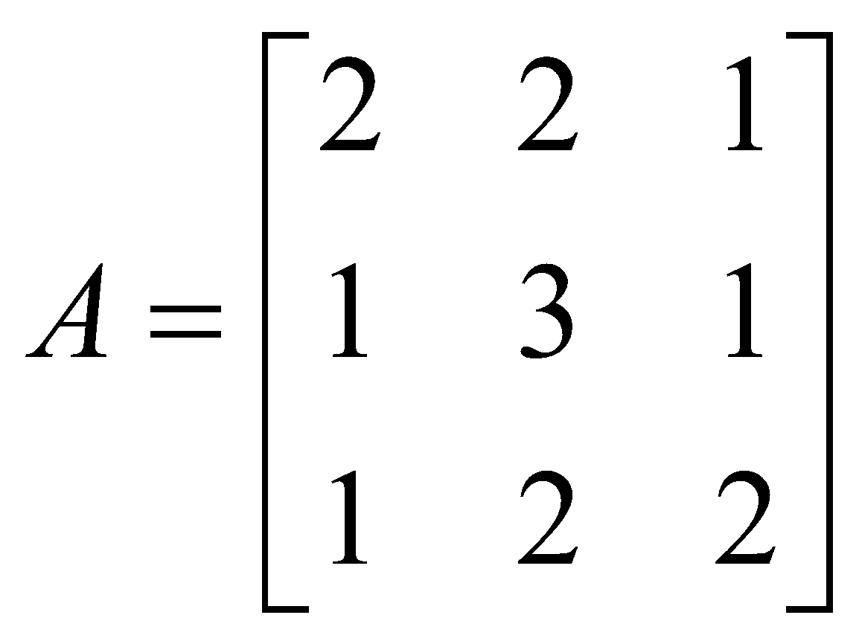
26 | Evaluate by Cauchy’s residue theorem 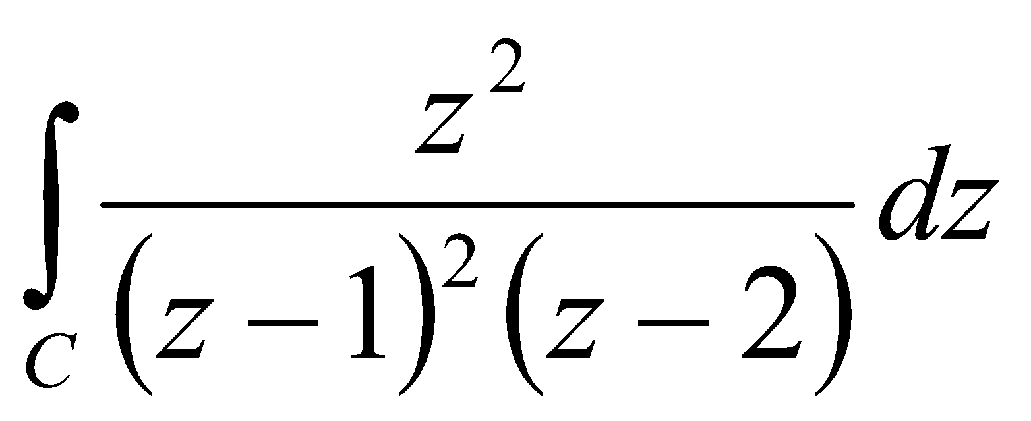; where 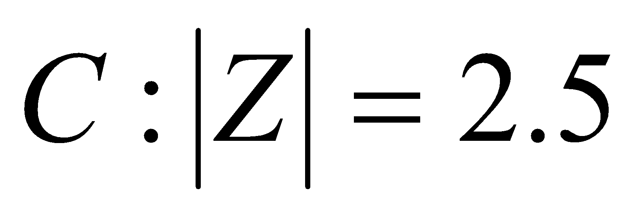
27 | Find the inverse z-transforms of 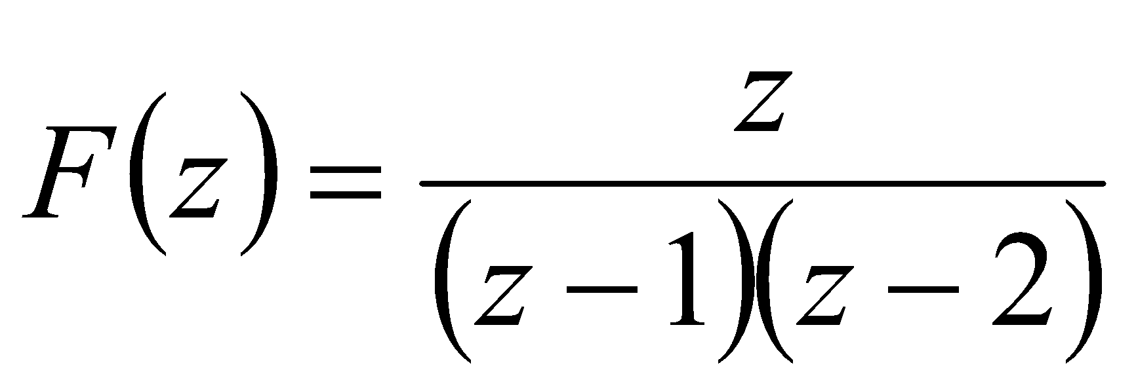; 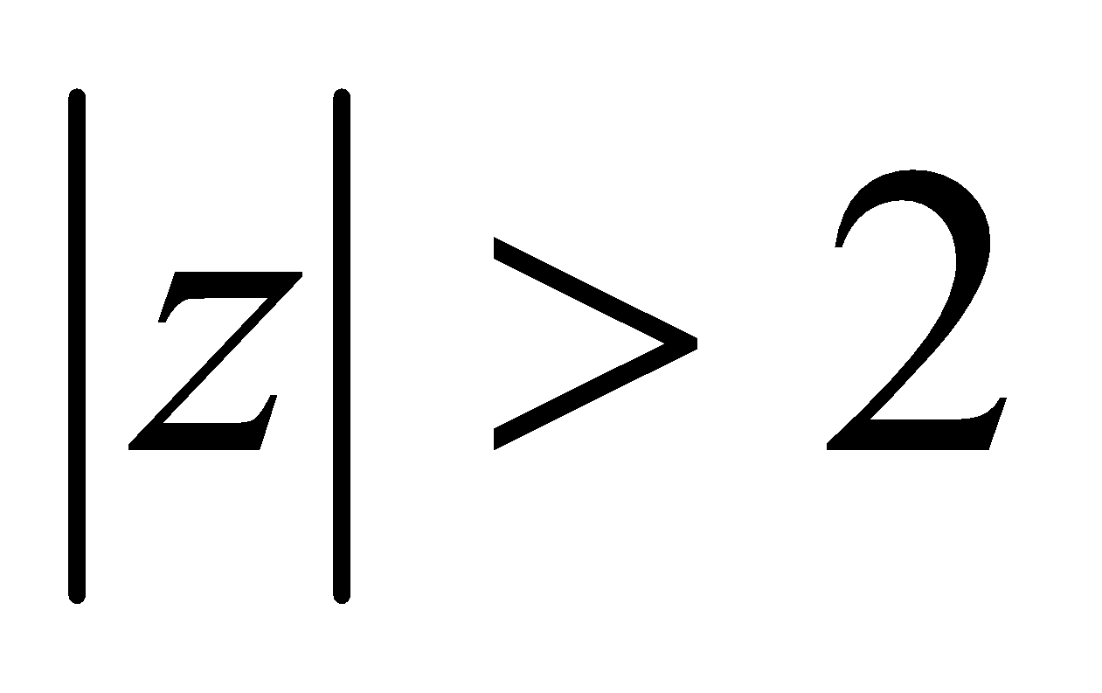
28 | In an examination marks obtained by students in Mathematics, Physics and Chemistry are normally distributed with means 51, 53 and 46 with standard deviation 15, 12, 16 respectively. Find the probability of securing total marks i) 180 or above, ii) 80 or below
29 | Using Simplex method solve the following LPP  Maximize 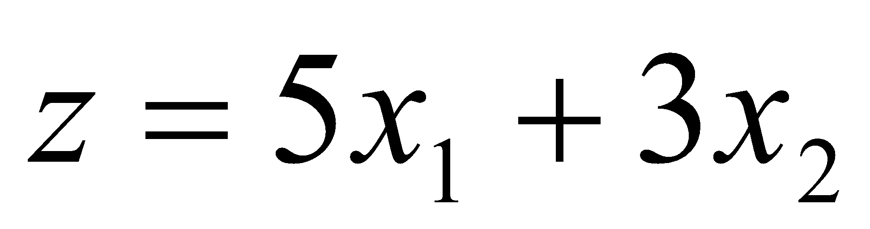  Subject to 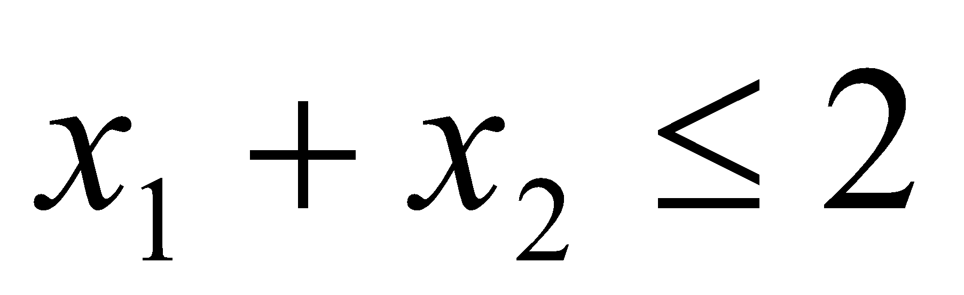  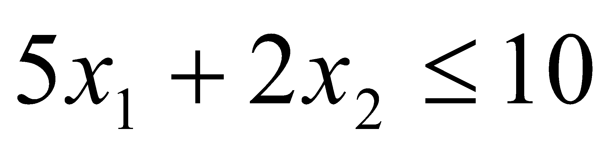  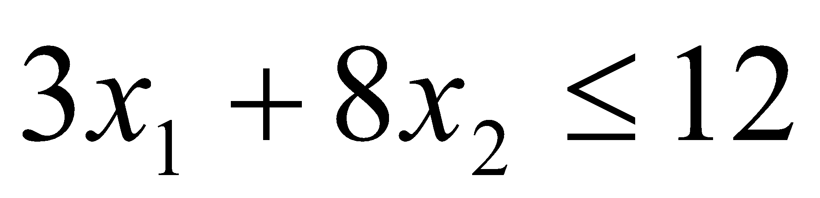;
30 | Solve the following NLPP by using Kuhn-Tucker conditions:  Maximize 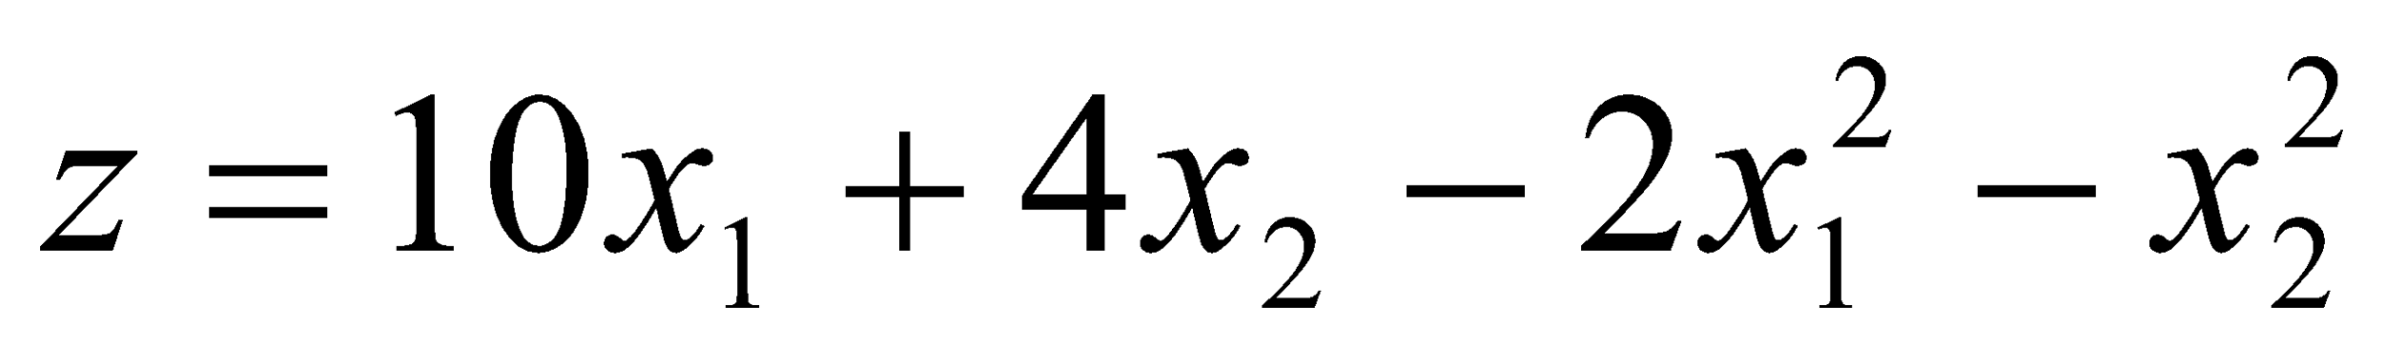  Subject to 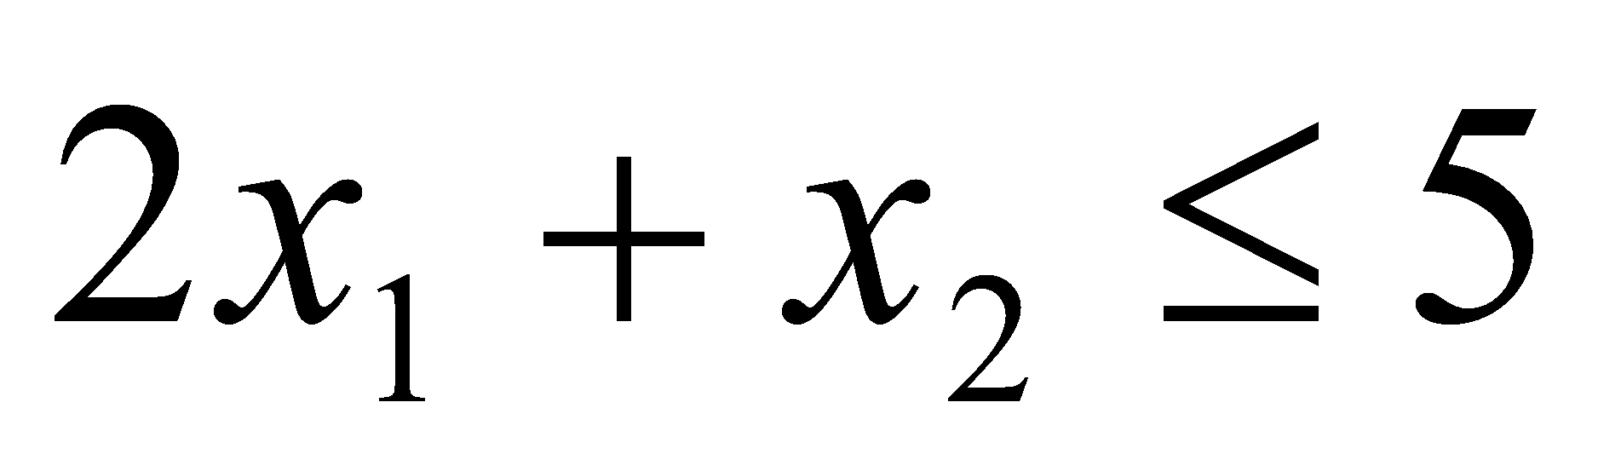
31 | Verify Cayley-Hamilton theorem for the matrix  Hence compute
32 | Evaluate 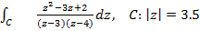
33 | Find the inverse Z transform of
34 | In a competitive examination the top 15% of the students appeared will get grade A, while the bottom 20% will be declared fail. If the grades are normally distributed with mean % of marks 65 and S.D. 10, determine the lowest % of marks to receive grade A.
35 | Write the dual of the following LPP  is unrestricted.
36 | Using Lagrange’s multipliers solve

